Guide to the Sacred Rose Tarot

by

Johanna Gargiulo-Sherman

A special thanks with much love
to Stuart Sherman, my husband,
for his devotion, support, and hard work
in seeing this book to publication.

Acknowledgments

The laws of the universe which govern all of our lives require us not to live in a vacuum but to expand our consciousness through our relationships, to recognize the influence we have on others, and that of others upon us. With this intention in mind I want to thank Stuart R. Kaplan, Elizabeth Kerkstra and the dedicated staff of U.S. Games Systems, Inc. for their individual and combined efforts in the production of this book.
—Johanna Gargiulo-Sherman

Ad Augusta Per Angusta
To holy places (honors) through difficulties

Contents
Guide to the Sacred Rose Tarot 1
by 1
Johanna Gargiulo-Sherman 1
Preface 5
Introduction — Why the Tarot? 6
The Purpose 7
Lesson 1 — Basic Symbolism 8
A Roman Legend 9
Lesson 2 — The Rose Mandalas 10
The Cards' Back Design 14
Lesson 3 — The Four Elemental Powers & Attributions 17
The Four Hallows 18
Lesson 4 — the Roses, the Elemental Powers, 19
and the Nature of the Godhead 19
My Karma Ran Over My Dogma —Anonymous 21
Legend and Speculation 23
The Grail Quest 24
Lesson 5 — Tarot and Magic(k) 26
Lesson 6 — Exercises in Psychic Development 28
Setting Up Your Altar 30
Purifying and Charging Your Personal Deck 30
Lesson 7 — The Major Arcana: The Greater Mystery and The Journey of The Fool 33
0 The Fool — The Youth 35
Meditative Meaning 37
Divinatory Meaning 37
I The Magician — The Manipulator 38
II The High Priestess — The Virgin Goddess 40
III The Empress — The Great Mother 43
IIII The Emperor — The Father 45
V The Hierophant — Social Order As Spiritual Law 47
VI The Lovers — Choices 50
VII The Chariot — Control 53
VIII Justice — The Equalízer 61
VIIII The Hermit — The Seeker of Truth 64
X The Wheel of Fortune — Your Destiny at Work 66
XI Strength — Gathering of Resources 68
XII The Hanged Man — Non-Action as Action 70
XIII Death — The Great Transformer 73
XIIII Temperance — The Alchemical Process 75
XV The Devil — Self-Imposed Bondage 77
XVI The Tower — Ego Destruction 80
XVII The Star — Hope 83
XVIII The Moon — Patterned Responses 85
XVIIII The Sun — Needs Fulfilled 88
XX Judgment — Wisdom 91
XXI The World - The Rebirth of Self 94
Lesson 8 — Introduction to The Lesser Mystery 96
Chart 226

Preface

After much soul-searching, physical pain, and bouts with writer’s terror, I have completed this book, swearing to all that it will be my last. I hope you will find the material to be comprehensive and informative as it is meant to be a work in progress, practical without requiring the reader to make too much of a sacrifice as he or she works toward psychic and spiritual advancement. My many years of tarot study and general metaphysical endeavors were incorporated into this material and are part of this effort to enhance the readers’ experience with the sacred rose tarot.
The task before me:
- to emphasize the role that creativity (yours more so than mine) has in the psychic development experience.
- To record and share—while adding to the text the necessary and obligatory divinatory explanations of the cards—the role that tarot and specifically the composition of the Sacred Rose deck has been to me.
- The laws of the universe are only realized by students through their own experiences, not solely through the dictates of dogma or metaphysical philosophies. Lessons are learned when responsibility for actions and the repercussions that these actions incur are accepted and ultimately resolved. In our attempts to come to terms with the outcome, we accept whatever ensues as an offering to the greater good.
Much of what you are about to study is a compilation of my lectures, workshops, and as previously noted, my experiences. I am, and always will be, a servant to the Light, and in awe of the tarot’s role as the vehicle of enlightenment.

Introduction — Why the Tarot?

Tarot is the study of universal prototypes, commonly referred to as “archetypes.” These prototypes have a history of expression through a culture’s mythology—folk tales, legends, religious figures, and arts. Included in the category of prototypes/ archetypes are life’s major experiences, emotions, and challenges such as birth, death, mother, father, love, and hate. We know through our emotions that archetypal energies are real and are a means of universal expression and knowledge. We find them existing in the ethereal world of the universal mind called the “Collective Unconscious.” Psychoanalyst Carl Gustav Jung adopted this label for the universal mind and believed it is where all humanity’s experiences are stored and ready to be tapped. Who or what force, divine or infernal entity, programmed these archetypes and experiences is still in question. The following theories have been suggested:
Some believe archetypal symbols originated via extraterrestrial encounters with early forms of humankind; another theory is expressed in the Old Testament (Genesis 6:1-4) where (fallen) angels procreated with the daughters of men on earth. Their union brought forth a super-race of heroes, gods, and demons who taught forbidden arts and sciences to humanity. While these super-powers left their legacies and access to “forbidden knowledge,” humankind has continued to struggle with the ethical issues of free will, choice, and outcomes of actions taken.
In order to make the study of archetypal identification and association easier, occultists (especially during the 19th century revival) took on the challenge of setting up a system of metaphysical correspondences.
The purpose of such a task was to aid the practitioner internalized thought and process. The best example of such a system is found in the book 777 by Aleister Crowley. It is here that the student can find tables of crossed referenced information.
In today’s modern society, much is dependent on the individual’s own interpretation of experiences. Various forms of mental discipline have aided people in surfacing their private and personal archetypal energies. The dark side of the archetype “Mother,” for example, is no longer exclusively in the realm of Hecate, the Greek Goddess of the night, crossroads, magic and witchcraft. Joan Crawford, as portrayed by her daughter in the book and movie Mommie Dearest, is a modern embodiment of the dark goddesses. Eventually, I came to a point in my development when I questioned and expanded on the established archetypal attributions. Many students have successfully found a balance between what is taught as the correct correspondence and what has surfaced as their own truth, as I did. This is the desirable and profitable result. I hope book will aid you in this task walking your magical path toward psychic development.
Furthermore, it is wise to keep the following in mind, as with all talents or gifts in life: it is the singer, not the song, that makes the difference.

The Purpose
Our response to the archetypal energies leads us to the discovery of the who, what, where, and why of the initiatory process. This spiritual initiation is the process of transmutation, and it is often experienced as painful in order to have a lasting effect, similar to the modern adage of “no pain, no gain.” What is transmutation or self-alchemy? The process spans a broad spectrum: from the person who takes a pill to relieve a headache to Christian Flagellants who believe true salvation comes from the painful shedding of their own blood.
Through the ages the process of transmutation has been illustrated using the alchemist’s laboratory of flasks, beakers, signs and sigils. With these tools the alchemist works diligently to change lead to gold. In preparation, he fasted, abstained from any physical pleasures, and prayed. This long, arduous preparation is symbolic of the harsh endeavor and sacrifice required to change matter (lead) to a higher form—spirit (gold). Reputedly, many times this endeavor resulted in failure.
Is it possible that humans have an archetypal energy of desperation, part and parcel of humanity’s “original sin”? Do you remember this bait, “…you shall be like gods, knowing good and evil” from Genesis 3:5? This was the cosmic carrot (or apple, as the story goes) held out to tempt humankind out of Paradise.
This line of Biblical text, in its simplicity, is a treasure. It states that the seeker must first of all understand that one must live through times of prosperity and despair, that the payback for being a “god” does not exempt one from experiencing the hardships of life. People have always attempted to circumvent impending dire results by consulting oracles, shamans, and psychics. These gifted practitioners have used one or more systems of knowledge to relay the workings of the cosmos: astrology, numerology, casting of runes, bones, and entrails. Of all the known metaphysical systems, the tarot has had one of the longest records of sustained use and practicality when applied. Tarot is a key to the doorways of understanding the nature of good and evil. Made up from two separate and distinct mysteries of major and minor influences, this key’s function must be learned before any revelation occurs. As music students must learn their scales, the task of the tarot student is to decipher 78 images which will ultimately lead them through the dark corridors of psyche, and if successful, meeting the Divine Light of the cosmos.
Our objective is to become a guide, or for lack of a better term, an alchemist, of the card’s visual text of the initiatory process.

Lesson 1 — Basic Symbolism

Symbols function as an interface between what is known (conscious awareness) and what can be known (subconscious perception). Symbols act as guideposts showing where you are coming from and where you are headed.
The ancient symbol of wholeness, balance, and completion is represented by the geometric shape of a circle. The continual line without beginning or end also represents harnessed and contained energy. Its function is enhanced by the contents of its center, whether a simple dot or an intricate design. This simple geometric form takes on additional nuances and is thus known as a mandala.
Though a circle, without a beginning or end, a mandala is much more. It depicts the blending of various energies into a pattern of wholeness. By definition, a mandala is a graphic representation of the universe.
A type of functional mandala is our body that contains the energies of consciousness and spirit. You may find that you can read a person's spiritual text by the energy their bodily mandala emanates. The term used to describe this energy is "aura" or "auric field." This is part of psychic development. To initiate true and lasting psychic change, one must gain access to the mandala's core. This is accomplished by recognizing and familiarizing oneself with an array of consistent guideposts as found in the tarot. In my efforts to meditate on the structures and details of the mandala, I experience the ever-changing patterns in the roses that become the four-linking mandalas of the Sacred Rose tarot. From my experience, it embodies the individual existing within a complex maze of matter, spirit, psyche, and emotion.
The rose is a beautiful flower, praised for its scent, symmetry, and strength. Some varieties are centuries old. Any rosarian will testify to the rose's tenacious nature in surviving through the most challenging of environments and impossible conditions. The rose has served as a worthy symbol of certain prescribed attainments in the Western mystical and magical traditions.
The first guidepost in the Sacred Rose Tarot is the symbol of the rose as a mandala.

A Roman Legend

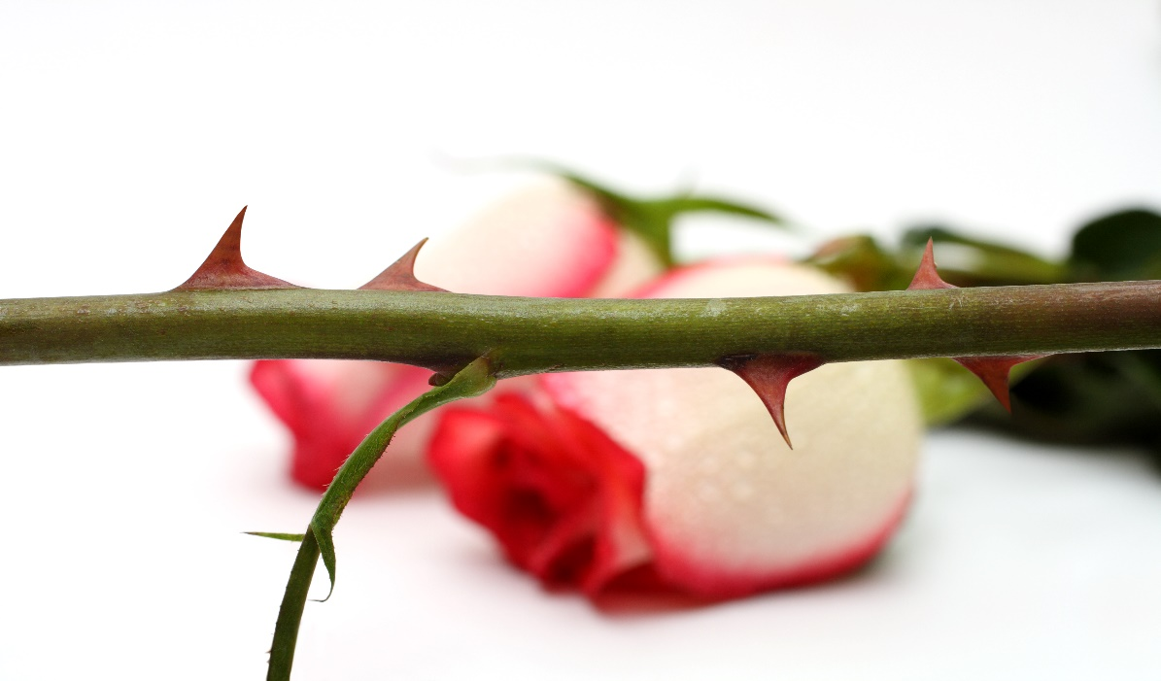
In Rome, a wild rose was customarily placed on the door to a room where intimate matters were discussed. Our phrase “sub rosa” (under the rose) means to guard a secret.

Rodanthe is a young woman of great beauty and a devotee the goddess Diana of the moon and the hunt. She lacked interest in her many male admirers and sought refuge from them in Diana’s temple. They in turn, defiled the temple by breaking through its gates. Furious at this intrusion and rape of her sanctuary and her devotee, Rodanthe, the goddess Diana transformed her into a rose, and to punish the defilers, the Goddess changes them into thorns on the rose’s stem, forever binding Rodanthe and her suitors to each other in a paradox of beauty and pain.

Lesson 2 — The Rose Mandalas

The red rose whispers of passion
And the white rose breathes of love;
O, the red rose is a falcon,
And the white rose is a dove.
—John Boyle O'Reilly

The four roses—red, white, blue, and gold—are the mystical and magical guideposts I studied as a student of art and magic. The western mystery tradition of the image of the rose ensured my successful journey from dualities of perception and conception to the holistic unity of psyche and matter. The journey required me to follow the tarot correspondences of the circle, center, color, tone, and feeling as symbolized by the inner realms of the four sacred roses.
The Red Rose Mandala belongs to our passions and physical reality. The element of fire symbolized in the Sacred Rose Tarot by the suite of Wands whirls into the rose mandala of physical action. Fire pumps our animal drive for survival and sacrifice, energy wisely or poorly used, all represented by the Red Rose.
The White Rose Mandala belongs to our innocence and purity. The element of water symbolized in the Sacred Rose Tarot by the suite of Cups pours forth spiritual and emotional forces, intuitive recollections, and subconscious responses that encompass the White Rose.
The Blue Rose Mandala belongs to our quest for what is impossible. The element of air symbolized in the Sacred Rose Tarot by the suite of Swords pierces the mind and intellect, resulting in communication, analysis, and consciousness as epitomized by the Blue Rose.
The Gold Rose Mandala belongs to our attainment and absolute achievement. The element of earth symbolized in the Sacred Rose Tarot by the suite of Pentacles expresses tangible and material results, rewards received, and the gift of fulfillment as embodied by the Gold Rose.
The gold rose has a special meaning for Roman Catholics. The 4th Sunday of Lent is known as Laetare (Joyous) Sunday because the Pope blesses and offers a golden rose ornament to the faithful in commemoration of the promise of Christ’s Passion and Resurrection.

be like a flower
that gifts its fragrance
to the hand that crushes it
― Iman Ali ibn Ali Talib [translated by Ali Nuri]

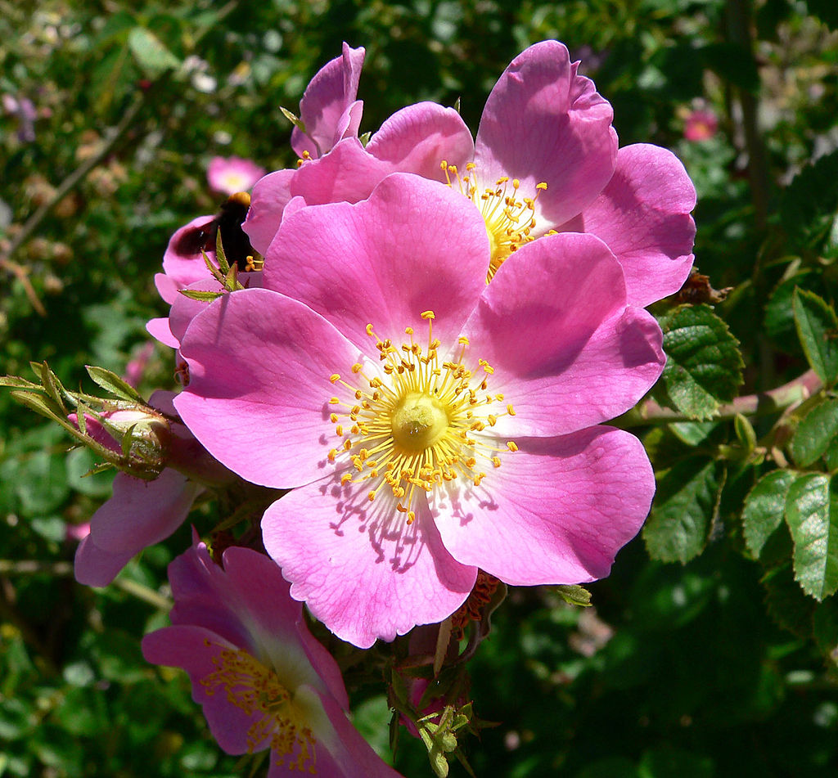
The Briar Rose (Rosa Rubiginosa)
“A rose is a rose is a rose,” as Gertrude Stein languidly pronounced. With as many as 100-150 species of wild roses and innumerable hybridized roses in gardens and greenhouses everywhere, even so, the diverse rose family has a prolific genealogy.
The sweet briar rose is a species native to Europe and West Asia. It was introduced and become naturalized in North America. Like most species of roses, its blossom is light pink with five petals, blooming once in spring or summer. The foliage has a strong apple scent after rain and when crushed between fingers. The amazing Rose family includes all apples, as well as strawberries, raspberries and blackberries. Sweet briar is disease resistant, as are wild berries. The rose is a symbol of love and tenacity, hope and passion.
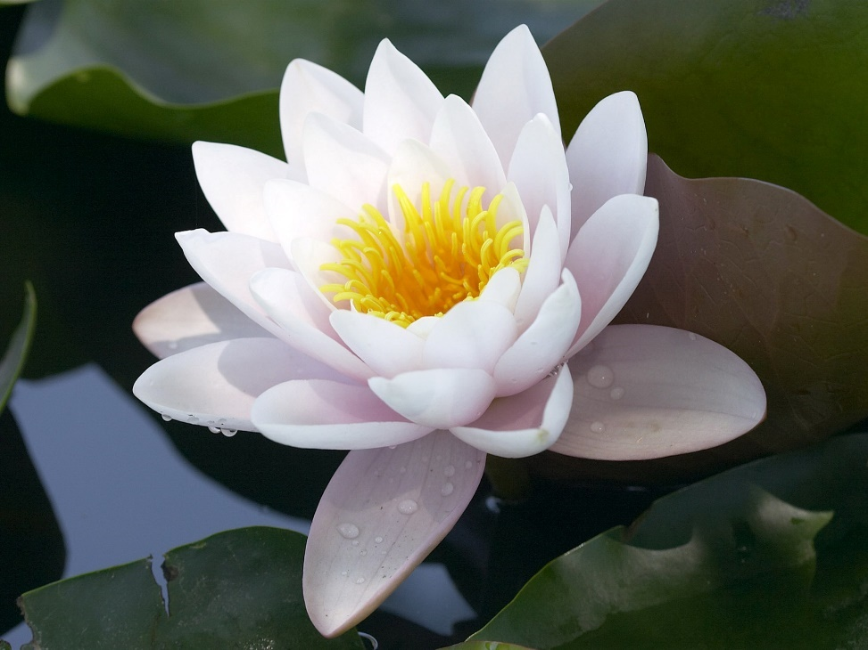
The Lotus is the Rose of the East. Both represent the unifying pattern of the psyche; the stalk: enthrallment through suffering, by thorns or mud; the petals, facets of consciousness; the center: the bud of origin, the pod of end, alpha omega.

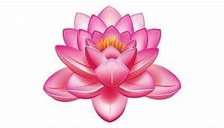

This image of the eight-spoked Wheel of Law is suggested in many cards of the Sacred Rose images. For example, The Wheel of Law holds values through righteous actions and speaks of Dharma (what is passed along from one life to the next) as consequences of our actions. The Wheel of Fortune speaks to the ever-changing fate in our ride on the wheel in the presence of the snake, jackal, eagle, monkey, symbolic of cosmic challenges through the rotation of life. It warns us to be wary in fortune or misfortune, nothing lasts.
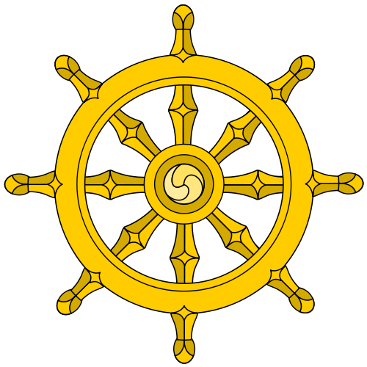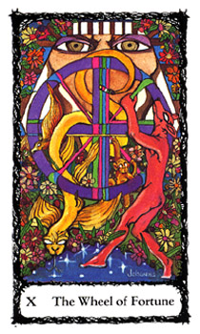
Buddhist Dharma Wheel & The Wheel of Fortune
The Wheel of Fortune shares design and purpose in that both are circular and have eight spokes. Mandalas offer structure to the psyche through the senses to make the inchoate mind objective. The basic mandala provides an orientation of inside and out. The wheel’s circular shape is a natural mandala. The wheel may represent motion, continuity and change. It forever moves as a circular motion over the ground and as the zodiacal dome of heaven. Likewise, the wheel is an ancient symbol for the sun. The Buddhist Dharma Wheel represents the buddha and the dharma and in the sangha. Dharma is the teachings of the Buddha on the nature of suffering and how to end suffering. The hub of the wheel has a 3-fold coil; which means the serpent’s egg of attachment, passion and anger, also wisdom, knowledge, and insight that hatches into the universal processes of birth, death and rebirth.

The Cards' Back Design

The back design of the 78 cards in the Sacred Rose Tarot has great significance for the unifying vision of the deck.
Unlike the unique images that make up the front of the cards, the back design that appears on each card sums up the complete vision of the roses as four aspects of experience. In the middle of the design is a central primordial cosmic rose that gives eternal birth to the four rose mandalas as the keepers of elemental wisdom of the suites. They encircle this central vortex of the indigo and black cosmic rose of time, space, karma, and reincarnation. Indigo epitomizes the third eye, psychic abilities and creative imagination.
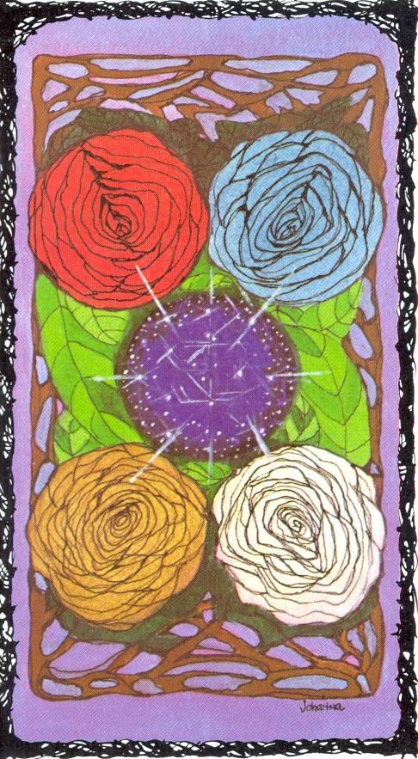
A charcoal shadow edges the outer petals of the 4 elemental roses. The labyrinth of the subconscious is represented by the synaptic lattice of brown branches. The green leaves of the heart and fertility forms a nest around the cosmic rose. Against a violet background is the crown chakra of immanent divinity pervading the fabric of reality in all 78 cards of the deck. The brown branches support green leaves that knit to form a vortex of protection. A cone of energy hovers around the red, blue, white and gold roses ever giving rise to all the possibilities of life. The primordial cosmic rose is the eternal mother.
Black and white bramble frames the boundaries and limits of any experience. Purple is the exalted color of spiritual power. It signifies connection, understanding, knowing, bliss, and oneness. Purple is ambient filter for the colors I use in the deck. It is the color used in the garments of some Christian churches during Lenten season. Brown is earth. As interlaced branches act like a trellis, they shape space and hold things together. For each rose there is a virtue that also has its shadow of vice that stifles. The iridescent green leaves cushion and nourish the five roses of the mandala.
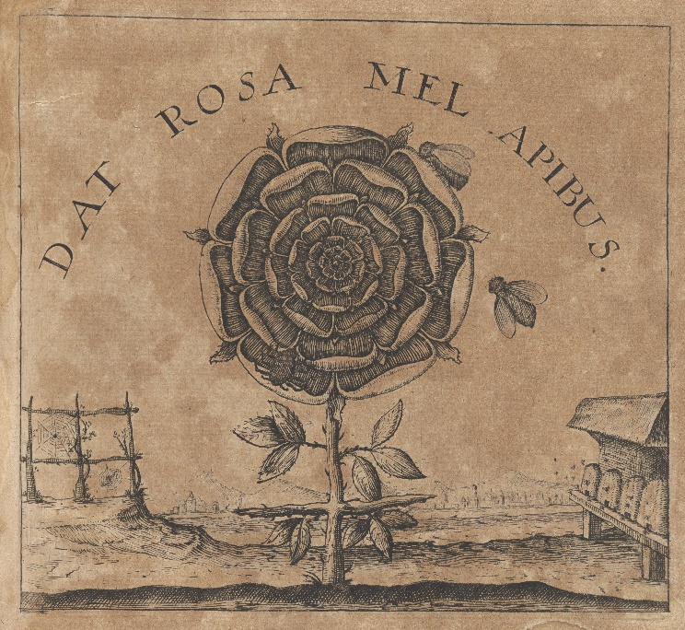
The four tight hundred-petaled rosa centifolia of the red, blue, white and gold elemental suites of the deck symbolize deep love and passion, a heart enflamed and enfolded into the density of lived experience. These alchemical roses are guardians which represent the labyrinth of understanding. Their perfumes, like the music of soul, evoke poignant awareness of emotions in a way that words and images cannot.
IDat Rosa Mel Apibus [The rose gives bees honey] Provenance: Kurt Seligmann (bookplate).
The Sacred Rose Tarot roses are without thorns, they are hidden much as opposites hide their counterpart: like pain hiding pleasure, and pleasure, pain, or attachment, dispassion, or sweet, the bitter.
The Spanish modernist poet, Antonio Machado seems to comment on the alchemical qualities of the elemental roses in his "Last Night as I Lay Sleeping:" as translated by Robert Bly from his book Risking Everything. In my reading of the poem each stanza represents a rose suite: white, blue, red and gold, respectively.

“Last Night as I Lay Sleeping” by Antonio Machado
Last night as I was sleeping,
I dreamt-marvelous error! ―
that a spring was breaking
out in my heart.
I said: Along which secret aqueduct,
Oh water, are you coming to me?
water of a new life
that I have never drunk?

Last night as I was sleeping,
I dreamt-marvelous error! ―
that I had a beehive
here inside my heart.
And the golden bees
were making white combs
and sweet honey
from my old failures.

Last night as I was sleeping,
I dreamt-marvelous error! ―
that a fiery sun was giving
light inside my heart.
It was fiery because I felt
warmth as from a hearth,
and sun because it gave light
and brought tears to my eyes.

Last night as I slept
I dreamt-marvelous error! ―
that it was god I had
here inside my heart.

Lesson 3 — The Four Elemental Powers & Attributions

Each one of the Rose Mandalas can be further attributed to the four fundamental constituents of the universe: Fire, Water, Air, and Earth.
These powers are pure forces that function through and beyond various realms of existence. Let us take our classifications a step further into modern psychological terminology, and what I believe is the present day's offshoot of the great mystery schools. Here we find these forces attributed to the various levels of psychological development.
Rose Mandala | Elemental Power | Mundane & Psychological Realm
Red | Fire | Physical World of Action — Id-libido
White | Water | Emotional World of Intuition —Subconscious
Blue | Air | Intellectual World of Analysis —Superego
Gold | Earth | Tangible World of Matter —Ego

We find that all the functions of life can be categorized or attributed to an elemental power. For example: The areas of sports activities, labor, and sexual action would be listed as in the realm of the Elemental Power—Fire. And our dreams, emotional ties, and intuition are connected to the realm of Water, etc.
The Sacred Rose tarot also embraces an ethical dimension in that the elemental powers blend and shade into one another in a mutuality of expression in the virtues and vices.

Sacred Roses | Virtues |  | Vices
Red Rose – Wands | Creativity | Courage | Stagnation | Cowardice
White Rose—Cups | Innocence | Temperance | Corruption | Dissolution
Blue Rose—Swords | Mindfulness | Justice | Thoughtlessness | Prejudice
Gold Rose—Pentacles | Attainment | Loss | Prudence | Carelessness

The Four Hallows

The four hallows of Celtic lore are gifts bestowed upon people by Tuatha Dé Danann ("the folk of the goddess Danu"). The Tuath Dé eventually became the Aos Sí or "fairies" of later folklore. Each hallow has a divine purpose like the Elemental Powers as defined by the Sacred Rose Tarot's four rose suits.
TAROT SUITS | HALLOWS
Wands | Spear
Cups | Grail
Swords | Sword
Pentacles | Paten

Lesson 4 — the Roses, the Elemental Powers,

and the Nature of the Godhead

Now that you have committed the preliminary symbology and correspondence to memory, you may be wondering where it originated. The general consensus is that the principles of the Western Mystery School originated in Egypt, and possibly as far back as the lost societies of Atlantis and Lemuria. It has been speculated that some of the great teachers, such as Joseph, Moses, Aaron, and Joshua ben Miriam (Jesus, son of Mary) were allowed access to the secret and mystical order of priesthood that became known as the Essenes (the word is Greek for the Aramaic hasen, and Hebrew for hasidim or "pious ones"). The origins of this mystical sect are unknown. They may have been the progeny of the lost school of Merkabah Mystics (merkabah translating to "chariot throne") whose chief goal was to experience a vision similar to the prophet Ezekiel, that of the splendor of the Divine Mystery of the Throne of God, or seeing and experiencing the Godhead face to face. The Merkabah Mystics also assumed that this process could only come through the suffering of the "perils of the soul." Written accounts concerning the Essene sect state that they may have been a group of pious ascetics who founded a community in the wilderness of the Dead Sea in the second century B.C. The authorship of the Dead Sea Scrolls is attributed to the Essenes. It was a community founded for cultural preservation due to the infiltration of other cultures (Greek) and secularism that permeated Judaism during the Maccabean Wars.
Whether the Essenes were the true teachers of the Great Mysteries is only speculation, but they surely were shielded in a cloak of curiosity, if not mystery. They taught their knowledge to the worthy, chosen, and willing few. Remnants of their original teachings can be found in the Hebrew mystical tradition called Kabbalah. Here too, we find the belief that Moses, upon receiving the Ten Commandments, was taught—from the mouth of God—the sacred teachings known as Kabbalah. Through the ages, attempts have been made to record, document, and disseminate this knowledge to many who would not have been considered candidates worthy of the teachings. The teachings were only for a privileged few and were taught orally, through question and answer dialogues between student and teacher/rabbi. This form of conveyance of sacred knowledge brings up a very interesting concept. Could this mean the power was as much within the student's question as in the sage's answer? (This is an important point that will be referred to later in the text.)
In Kabbalistic teaching, all humankind, its offices and other living and non-living (animal, vegetable, and mineral etc.) beings exist through various levels of vibrations (it is worthy to note that in Kabbalism one seldom, if ever, uses the term "God," which is written as "G_d," for Who's nature cannot be known or labeled, and to utter The Ineffable Name or to write it down is forbidden). Instead, to describe this power they use the term "the Infinite," "the Absolute," "EIN-SOF"—the first or crown sephirah (emanation) on the Tree of Life, which means "Without End." To summarize the Godhead's influence on our lives: all life forms and experiences are created and allowed to exist through the Infinite's Divine Emanation, and subsequent vibrations.
Divine Emanation dictates whether you are a male or female, tall or short, rich or poor, healthy or sickly. What images are conjured up—when you truly reflect on the Emanation—a vibratory master DNA molecule or "super atom"? The mind boggles at the vastness of possibilities when one attempts to comprehend this power.
In contemporary literature, we find a visualized concept of this power source as depicted in Arthur C. Clarke's book (and Stanley Kubrick's motion picture) 2001: A Space Odyssey. (It is interesting to note that 2001 is the true, man-made year of the millennium.) The Godhead's energy emanates via its structural nature, i.e., the vibrating monolith. Who or what created this vehicle of power is unknown, but its effects are certainly felt from death through rebirth (everything is part of its make-up) yet its true identity and ultimate purpose remain a mystery.
A Kabbalistic prayer speaks of this power:
"Holy art Thou, Lord of the Universe
Holy art Thou, whom Nature hath not formed
Holy art Thou, the vast and mighty One
Lord of the Light and of the Darkness, Amen"

In pagan or earth deity religions, the vehicle to spirituality is "more down to earth" or at best identifiable. The Godhead is a duality—both male and female. Its nature is Nature, the powers of the Universe as explained through the forms that the Godhead expresses, its male or female personas, hence the pantheism of gods and goddesses. Their power is defined through their legends and functions within their culture's mythological system. Their personalities and characteristics, including their virtues and vices, describe their role within humanity's consciousness.
With the development of our modern school of psychology (which many believed would take the place of spirituality, if not organized religion), the Infinite's vortex of Divine Emanation and the Pantheist's Universe/Nature as Godhead took on another label—"The Collective Unconscious," the realm of archetypal energies.

My Karma Ran Over My Dogma —Anonymous

The tarot and its symbols are a key to The Collective Unconscious. In the study of the tarot, one must draw from all philosophies, and refrain from getting entrapped in dogma for the sake of winning an argument and possibly jeopardizing the learning experience. Neither philosophy nor religious (social) dogma can totally be considered a pure vehicle of Divine Knowledge. In fact, I do not believe there is any one pure road.
Let me give a basic example:
In Kabbalism, the unspeakable name of the Godhead is attributed to the Hebrew letters Yod (יִ ), Heh (ה), Vau (ן ), and Heh (ה). These letters, read right to left in Hebrew min..), correspond to the four Elemental Powers accordingly:
Yod = Fire, Heh = Water, Vau = Air, Heh = Earth. Together they are known as the Tetragrammaton.
It is important to note that the final letter Heh (ה), according to the grammatical rules regulating the Hebrew language, is feminine in its application. Does this allude to a duality? The Godhead or Infinite is neither male nor female, but a combination of both positive and negative forces. Is this the Yin and Yang, Yoni and Lingam of the Orient, translated and symbolized in Hebraic letters?
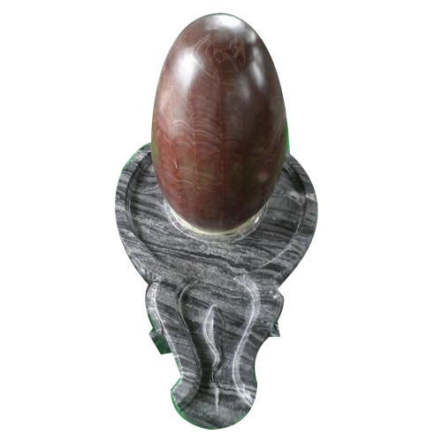
Yoni & Lingam
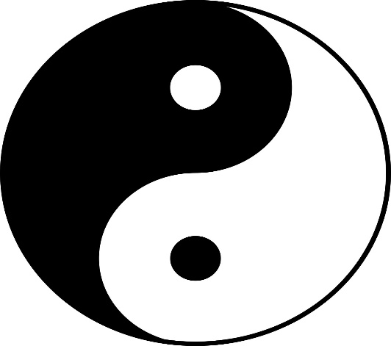
Yin & Yang

Legend and Speculation

During the Middle and Dark Ages (500-1400 A.D.) little if any knowledge was allowed to be disseminated amongst the populous. The Church was a somewhat benevolent dictator to those who shared its doctrine and succumbed to its power. Those who didn't were named heretics, and targeted as deer are at the beginning of the hunting season. Knowledge is power; the few groups that obtained it, or were the stewards of it "had to be" eradicated. The heretical sects came from different regions of Europe; they were the early Gnostic Christians—Cathers or Catheri ("Pure Ones" from the Greek katharos, "pure"). Their belief system was based on dualism: the existence of supernatural and metaphysical polarities and the power of the union of opposites, much of which is found preserved in alchemical texts and the accounts of the Mystery Religions. Of note, were the Albigensians of the Languedoc Province (now part of France) who, similar to fellow Gnostic Christians, were crafts people and guild members.
Amongst their treasures it is speculated that the Cathers of Languedoc had the "Holy Grail" in their possession. An ascetic community (so their need for riches is questionable) they, by most accounts, led exemplary lives. It is reputed that the Knights Templar (1118-1314 A.D.) came into possession of the Cathars' treasures after the sect suffered great losses from the Church's "Albigensian Crusade" (1209-1244 A.D.). Few of them survived this campaign, and by most accounts they were finally annihilated during The Inquisition.
What does this have to do with tarot? After all, we are talking centuries between the end of the Templars and the first tarot trumps in 1440 A.D. But then, look from whence we came (The Dark Ages) to where we evolved (The Renaissance, 14th-17th centuries). The name, Renaissance, is interesting enough; it translates to Rebirth. This rebirth gave us paintings and literature rich in ancient symbolism such as Botticelli's Birth of Venus and Dante's Divine Comedy. Versions of the Grail legend predate the 12th Century and originated in regions north of Italy. Some have speculated that the "Holy Grail" was not only the cup of the Passover Feast that Jesus used at the Last Supper, but the bloodline and descendants of the Christ who fled to Europe. Then again, could it have been a set of images that is known as the tarot?

The Grail Quest

The study of tarot cannot be fully explored without considering the Grail Quest. The legend of the Holy Grail, with its characters and symbols that are part of this metaphysical tradition which has taken on many forms, is subject to different interpretations. This can be confusing to the newly adventurous student. My advice, as previously stated, is to find areas of any system of knowledge that bear up to consistency. Once understood, the student can proceed into deeper and more complex areas of thought. The legend has many tarot symbols. Some are direct, such as the Grail or Chalice/Cup of the Messianic message, characters such as Kings and Knights, a sacred spear (Wand), etc. The tale is so rich in symbology that volumes have been written about it.
I ask the Arthurian fundamentalists to offer me some indulgence in my obvious simplification of the following legend:
In a place of desolation and suffering called "Waste Land," [sic] there resides a royal personage (or personages) identified as the "Fisher King" (named for the activity upon which he seems intent) and/or the "Maimed King," who is injured and cripped. (In some accounts of the legend, the Fisher and Maimed King are the same person, although in other accounts they are two individuals.) As the tale proceeds, it is only through the healing of the King(s) that the Waste Land can be restored to its once bountiful nature. How does this healing process occur? By asking the appropriate question. (Remember the oral tradition of the Kabbalah?)
Persons who quest for the Grail and inadvertently come across the Waste Land and the King(s) are Knights. Some totally fail through ignorance, but some partially succeed by phrasing a partial inquiry or question. But complete success comes
in an unusual form, that of a specific inquiry or question concerning the Grail. In the various tellings of the legend, the Knight sees the Grail and asks the question: "Whom does the Grail serve?" At that moment the King(s) are healed and the Waste Land is restored to abundance, though we are never privy to the answer. In fact, the answer does not seem to be of the utmost importance. It is the question that restores.

"What is the answer...
In that case, what is the question?"
—Gertrude Stein

I prefer to look upon the components of the legend as a personification of one's own initiatory force, similar to the serious metaphysical quest found in the tarot. The King is a crippled individual who, if healed, holds great promise and potential (such as you or I may be if crippled by life's obstacles, one's memories and/or regrets). The King, being male, represents physical energy. The Waste Land that he reigns over is a place of suffering, the dire result of his injury (our mutual lives, functioning through spiritual and psychological turmoil). The Waste Land, being of the Earth, is feminine energy, and of the spiritual realm, as well as a tangible result and substance. (Remember your correspondences?)
The King has the Grail in his midst but cannot activate its energies directly. Yet, there is hope. He must wait for outsiders (objective individuals) to aid him. Enter the Knights, symbolizing attempts and actions taken to find the truth and therefore the remedy. The Grail is a vehicle, the benefactor of Divine Intervention (for better or worse) since its spiritual secrets (or truths) are at times too horrifying to experience. The process is much like our soul searching which requires the dredging-up of old issues and past history, and the re-examination of personal pain. The most fascinating component of the Grail Legend is that the healing process can only come about when the proper question is asked. What is the proper question? One that goes to the heart of the matter. What is the answer? The answer will become self-evident when the proper question is posed. It is then, and only then that the "light bulb" turns on, the realization that Divine Intervention has entered one's life.
A word of advice: according to the legend, there is a caveat to asking the question—only the pure, strong, and worthy need inquire.

Lesson 5 — Tarot and Magic(k)

Over the centuries, the Western Mystical Tradition continued and flourished, developing into complex forms of thought and application. In other words—Magic. Many times it is seen in metaphysical texts spelled with an ending "k" (magick) and is written this way in order to distinguish the process from that found in theatrical entertainment.
Magic is the belief that one can create or manifest a desired result through prescribed formulas and the application of one's will.
Magic and its applications have taken on various forms through the ages, from the medieval alchemist's laboratory to today's schools of positive thinking.
There is a metaphysical philosophy that governs the application of the magical discipline: ritual. Ritual is a disciplinary process, and in turn, acts as the catalytic agent between the practitioner and the cosmic forces. This occurs through the sympathetic use of corresponding symbols and items that may
be associated with the request; for example, a "love ritual" could include items associated with romantic love such as flowers, pink candles, and incense. The ritual could be held on a Friday at the hour associated with the planet and godform of Venus (goddess of love). There is one loophole or trouble spot in all manifestations of will. There is little consideration of whether the underlying motivation is good or evil. That is, whether the end justifies the means. Therefore, the magical practitioner needs to conjure an astral work force (Elementals, Angels, Demons) in order to fulfill the request to overcome or supersede the Greater Plan(s) or Fate that is/are already in action.
In Western Magical formulary we find the Four Elemental Powers "characterized" as servants to the practitioner of the magical arts. They are beings of spirit that are visualized and take on the form or characteristics of Salamanders, Undines, Sylphs, and Gnomes. This grouping is called "The Elementals."
The Elementals are described as "soulless," yet they are creatures of the spirit which reside in the astral realm. When commanded (through angelic intervention), they bring about a desired result. As they work on an earthy functional level to bring about the desired manifestations, their "trademarks" may be experienced. (Many a practitioner has amusing stories to tell of meetings with Elementals as they go about "doing their thing.") Once the request is granted and the outcome is brought about, for good or evil, for better or worse, the responsibility lies with the requester. Beware of answered prayers, because their gifts will always be wrapped in revelation.
The Elementals are pictured as dutiful servants of the four tarot Kings in the Sacred Rose deck.
Salamanders are depicted as lizard-like creatures (in nature, there are such animals, but please do not confuse the actual animal with the astral being). Salamanders belong to the Elemental Power of Fire and the Red Rose. Fire's cardinal compass point is south, and its season is summer.
Undines are mermaid-like entities (upper body, woman; lower body, fish). Undines belong to the Elemental Power of Water and the White Rose. Their cardinal compass point is west, their season is fall.
Sylphs, fairy-type creatures belonging to the Elemental Power of Air and the Blue Rose, have a cardinal compass point of east, and their season is spring.
Gnomes have human physical characteristics. They belong to the Elemental Power of Earth and the Gold Rose. They are associated with the cardinal point north, and the season: winter.
In the subsequent text ("Purifying and Charging Your Personal Deck"), you will be calling upon the Elemental Powers. This is a simple ritual of consecration which will aid you in understanding these forces.
You will find the tarot to be a valuable tool in ritual, especially for those who can take responsibility for the successful (fulfilled) request. An example is the love ritual which I previously mentioned. When studied and evaluated, the cards offer several effective choices. Any of the cards (e.g., The Lovers, Two of Cups, etc.) deemed to be associated to the result desired by the magical practitioner can be incorporated into the ritual. What makes the use of tarot in magic so unique is that each card has an inherent balance through its positive and negative aspects. Results are more in harmony with the laws of Karma and Dharma. The use of the cards allows an automatic safety valve or fail-safe mechanism to exist.
It is the wise student who remembers that in order to gain access to the motivating drive that governs our expressions of will, he or she must enter, sometimes reluctantly, into the labyrinth of the mind. Properly utilized, the tarot and its symbolism are keys to unlocking the doorways of the labyrinth.

Lesson 6 — Exercises in Psychic Development

Now that you have committed to memory the necessary correspondences, your next step is to examine your conscious and subconscious responses as they relate to the Elemental Powers.
Conscious Response: To discover your conscious response toward the four Elemental Powers is a relatively easy task. What is required is to record your immediate impressions through a random word association exercise. It is very important that you record all exercises in a notebook you have set aside for study purposes.
In this exercise, you will write the chosen Elemental Power word, e.g., Fire, using the associated color pen or pencil; in this case the color is red. Relax by taking a few deep breaths through your nose and releasing them from your mouth. Center your thoughts on a point within a circle as you visualize (day-dream) Fire. You can use a prop such as a lit red candle. Mentally note and record whatever images happen to appear. Do not edit or judge any image as crazy or unworthy. It is these images which may turn out to be the most insightful. List your corresponding associations. For example: under the title "FIRE" you may write: Warmth, danger, force, light, passion, and so on. Do not hold back any association that may come to mind, even if it is of an individual (such as an actor, actress, sports figure, or someone you may know personally or casually). Continue this process for the remaining Elemental Powers of Water, Air, and Earth. Remember to use the appropriate stimuli for each substance.
Subconscious Response: To release your subconscious responses is challenging, but very necessary if you are ever to become a proficient metaphysical practitioner. Remember, your subconscious response mechanism is your sympathetic link into the astral realm and psychic abilities.
The best and simplest means for releasing information from the subconscious to the conscious mind is through your dreams. Before retiring, visualize the corresponding geometric elemental power symbol, commonly referred to as a Tattva. You will be using Tattvas as tools in your psychic development.

Element | Symbol | Color | Description
Fire | A | Red | Solid Equilateral/Equidistant Triangle
Water |  | Silver | Solid Crescent with horns facing up
Air | • | Blue | Solid Circle
Earth | ■ | Golden Yellow | Solid Square

For example, the Tattva for Fire is a solid equilateral red triangle with its apex pointing upward. Within this triangle, picture the numbers 10, 9, etc., counting backward to 0 while you visualize each numeral ablaze within the red triangle.
After completing the series, take a deep breath and say the following affirmation: "The truth is in my dreams, my dreams reveal the truth." You will dream. Whatever your dream, do not dismiss it, record it in your notebook. You may choose to record your findings into a cassette tape recorder and transcribe them later. Continue to do this or any one of the specified exercises until you experience a very vivid dream. You may not generally dream vividly, so take this into consideration and record your morning impressions. How did you feel upon awakening? Were you tired, energized, sad, sexual? Continue this exercise with the following Tattvas: Water=silver crescent moon (horns upward), Air=solid blue circle, Earth=solid golden yellow square.
Please note: If you do not recall any dream image, do not despair. Practice, practice, practice! Proceed with each Tattva exercise until you have established your subconscious response or impression. Update your notebook after each exercise and review your notations. Compare your conscious with your subconscious response. Examine, evaluate, and recall your feelings for a future psychic reference. If, after going through all the Tattvas, you are not completely successful (you were successful with the Air Tattva, but not with the Earth) take a break, and begin again after a Moon cycle (28 days). If, unfortunately, you still have no dreams or any other subconscious response, then I suggest you shelve your pursuits until another time. Your unsuccessful attempts at obtaining any subconscious response can only mean you are setting up an internal block and are not ready for the journey's challenges.

After successfully completing the exercises, you will be ready to evaluate your two levels of response. Compare your notes. Are there similarities or differences? Even if the differences seem off the wall, they are still your impressions. Do not dismiss them. Open your mind, observe, and question everything within yourself. What connection do you make in both realities? Is there a theme running throughout? Do you sympathize with one specific Elemental Power? Does one antagonize you? Most of all, analyze your accounts, decipher the results, and keep your conclusions firmly in mind as you progress in your studies.
I know the previous text seems rudimentary, but be assured that the required memorization and exercises set forth and described have allowed you to fine tune and bring about a new control over your psychic self. Realizing this, you will be ready to meet the challenges on a more serious excursion into the depths of the mandala. Before embarking on the journey, however, we must make sure the road is clear.

Setting Up Your Altar

We now will be using the knowledge obtained in a ritual setting. Find a room with a comfortable atmosphere. You will need to note where the sun rises and sets. This will help you find the compass points of East (sun rising) and West (sun setting). Once you know these two points, you will be able to refer to the remaining two, South and North. Each of the four compass points has corresponding Elemental Powers as well as an item that represents their energies in the mundane world. The compass points and the Elemental Powers are as follows: North = Earth (salt); West = Water; South = Fire (candle); East = Air (incense).

Purifying and Charging Your Personal Deck

You will be using a dish for the salt, and a cup for the water. The item representative of Fire will be a lit candle; for Air you will use burning incense. Take your deck from its package and remove all extraneous materials (like my biography card, etc.). Place the deck in the center of the four cardinal points (see dia-gram page 36). You will also need two new clean pieces of white cotton cloth, one large enough to wrap around the deck (a man's handkerchief or large table napkin will do). The other will only be used for wiping down the deck and may be dis¬carded after the ritual.

SOUTH
Fire Summer Candle Growth

Facing into the circle

From point South, face into the circle toward point North. It is representative of the astral and archetypal realm confronting "death" (see Major Arcana, card XIII Death) and its subsequent reward of transformation.

Ritual procedure is as follows:
Have all items in place and activated. Breathe deeply and visualize yourself within the structure of the circle. You and the tarot deck are there.
Pick up the deck and visualize rays of white, iridescent light surrounding the deck. This is true light, in all its prismatic glory. Lightly pass the deck over the smoke of the burning incense, shuffle the deck and repeat the process eight more times (in total you will be doing this 9x with each Elemental Power).
While keeping the white light visualization active, proceed to the flame of the candle and pass the deck lightly over the heat of the flame, being careful not to burn the deck or yourself. Shuffle the deck and repeat as previously instructed.
Proceed to the cup of water. Dampen your finger tips. You should barely feel the moisture as you shuffle the deck. When finished, you may wipe the deck dry with the designated clean white cloth set aside for this purpose.
Proceed to the dish of salt. Again, lightly sprinkle some salt over the deck and shuffle it. After you are finished, you may wish to do a final wiping down of the deck, making sure that there is no residue.
Wrap the deck in the unused white cotton cloth and place it in the center of the circle. Again, visualize yourself in the midst of the circle. After you have accomplished this, you should allow the incense and candle to burn to completion. Whichever one burns out first will signal you to dissolve the circle. (You may in the future design or write any personal spirit sigils, and/or images with mysterious powers, on the cloth. My suggestion to the novice: keep it simple.) After each consultation using the deck, wrap it in this cloth in order to cleanse it of any residual and undesirable energies.
With your newly consecrated deck, you are now prepared to continue your studies.
For our next lesson, remove the 22 Major Arcana cards (The Fool 0 through The World XXI card) from the deck.

Lesson 7 — The Major Arcana: The Greater Mystery and The Journey of The Fool

The Sacred Rose Tarot has an unusual advantage built into its design concept in order to facilitate the student. Its color patterns are based on a practice used in the Western Mystery School called "Flashing Tablets." These tablets are best described as a psychedelic means of triggering a person's subconscious, thereby stimulating psychic perception. This technique was also utilized in Lady Frieda Harris' paintings for Aleister Crowley's Book of Thoth Tarot deck.
As individual cards, the 22 pictograms of the Major Arcana can each be viewed as subjective mandalas (i.e., the mandala/ pictogram for "Mother" is The Empress card). I have been questioned about my interpretation as to why the figures have such unusual eyes: no iris or pupils. The figures depicted in the deck, especially the Major Arcana, function as masks of archetypal energy. When the student is advanced or comfortable enough to chance a more intense encounter, they may attempt to "place the mask on" in order to experience the energy in a guided meditation or visualization. This technique is similar to still existent ancient cultural practices. Masks are used as a vehicle to empower the mortal with whatever attributes that facade may signify. Be forewarned, this is an advanced metaphysical exercise and should be undertaken with another knowledgeable individual who will act as a guide through the meditative process and to aid you back into your reality.
In studying the cards, and specifically the Major Initiation, we must look beyond the obvious. Just as a gem cutter "sees" the true beauty and potential of a diamond-in-the-rough, you too, must look beneath the surface of the Major Arcana's 22 images for your multi-faceted "gem" of information.
In the following text each Major Arcana card is given a Meditative and Divinatory Meaning. The Divinatory Meaning is divided into two aspects: positive and negative. As with two sides of the same coin, the cards need not be read upside down or reversed to imply a negative aspect. This can be psychically perceived by the reader, or if this talent of observation is not present, it can be developed. The simplest technique is to simply ask (spoken or in thought) the card's function. A perception will arise as to its aspect.
The use of the Meditative Meaning of each card is the key to the overall spiritual remedy. When one meditates on a card, the seeker consciously desires that the card's mandalic energies become incorporated into their own. With time, practice, and sincerity, this process will manifest itself. It is because of the Major Arcana's prime function as a "road map" to initiation that meditative, divinatory and ritual techniques may be used. To sum up, the Major Arcana is the matrix that one may use to decode the labyrinth of synapses that make up the human psyche.
You are about to embark on a very special and unusual journey, a journey of self-discovery. Your guide is an innocent, headstrong, idealistic youth with a definitive taste for adventure. The youth only makes one request of you: to follow and bring along all of your karmic baggage. On this journey, there will be no shortcuts, no saving of time; each guidepost will be examined, its road traveled. There will be moments of darkness and fear, of joy and exultation. The reward is transmutation, the knowledge that after the journey is completed and you have successfully reached your destination, you will never be the same.
"None of us has lived the life he intended."
—Joseph Campbell

0 The Fool — The Youth
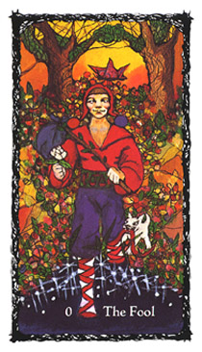
"In youth, we clothe ourselves with rainbows,
and go as brave as the zodiac."
—Ralph Waldo Emerson

Our Fool represents the beginning of a cycle of spiritual life, the conception, the consciousness of innocence, which knows no boundaries or limitations. Its eagerness for adventure is limitless. A cycle of development, as defined by The Fool card, has an unique quality best illustrated as a spiral, a representation of events, once experienced and then recalled with a different perspective. The Fool's path can spiral either upward or downward toward a progressive point to review or repeat a destructive element in life. The end of its journey, if successful, should always be a new spiritual outlook, and in some cases a new physical beginning.

At each level of the spiral, The Fool is renewed and reborn, ready to experience and proceed toward a different level of growth. Hence, the card's attributed number 0, the representation of a constant, its value finite within the universe, with no beginning and no end. It is the ovum as mandala, the fertile and regenerative egg of creation.
The Fool has no gender identification, for it is the budding youth who has yet to experience the physical burden of sexual initiation. As the innocent youth, The Fool represents the forward, dependable movement to life's fruition. He is the believer and exponent in the powers of life, love, and happiness, and is readily available to experience the wonders of being.
The Fool is clothed in contrasting vivid colors, red for budding, physical, sexual, and reproductive energy; purple for the potential of advanced spiritual awareness; green for attraction and balance in nature. In his right hand, symbolic of the transmission of energy, The Fool holds the white rose of purity. And at his heels, a small white dog, representing life's basic physical and material needs and energies (e.g., shelter, food, ego satisfaction, sexual expression), is attempting to hinder or at least be an annoyance to the progress of the journey. The white stockings The Fool wears represent the need to remain pure of intention and to tread cautiously into the abyss of the future. The red straps, which make up a ladder type pattern upon his calves, represent the seven steps to higher consciousness (counsel, fortitude, godly fear, knowledge, righteousness, understanding, and wisdom), for the journey is also a test of the purpose and purity of original intent.

In The Fool's left hand (the hand that is the receptor of energies) there is a wooden stick, alive with fertile (phallic) expectation. At the end of the stick, and balanced over the right shoulder, is a purple cloth of "karmic baggage." This awkward position represents the uncomfortable karmic obstacles and lessons in the journey ahead. The Fool is girdled by a belt that bears the sigil of balance, the rising sun upon the horizon (the astrological sign of Libra, the only astrological symbol that is not represented by a life form). Traveling overhead is a butterfly, symbolic of the soul's ability to transmutate (as does a caterpillar into a creature of exquisite beauty, and as a short-lived reminder of the frailty of life). The landscape is fertile and the cosmos is bright in the starlight. Arched and joined in the fertile background and landscape are two trees, representative of the knowledge of good and evil, the sacred and profane, and that of life. This archway is of nature (the essence of all energies that compose the universe), and natural intent (the actions that emanate from nature). It is the structure of the eternal mysteries, the study of eschatology (the divine nature of death and the purpose of life) that is found in all religions and philosophies. The Fool has begun its journey through this arched passageway between the polarities that govern the laws of metaphysical enlightenment and initiation, the beginning and the end, the resolved outcome of the process. It is the renewal of lost innocence through childlike forgiveness.

Meditative Meaning

"Allow me to be receptive to the cycle that leads to atonement."

Divinatory Meaning

Positive Aspect: Past obstacles are no longer present; the opportunity to begin again and start anew. Clarification of a situation, childlike wisdom, compliance and acceptance lead to success; visions of the young, dreams of the old coming to fruition.
Negative Aspect: Naive attempts, foolish actions, obstacles, and hindered development. Gullible and egocentric individual. A spoiled brat attitude toward a challenge or test. Frustration, low tolerance, anxiety. Confusion, doubt, possible madness, and insanity through misuse of energy.

I The Magician — The Manipulator
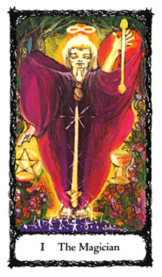
"Be there a will, and wisdom finds a way." -George Crabbe

A figure of a young man, ablaze with energy, commands the universe to do his bidding. He is the practitioner of control, the magus of will and manifestation. The Magician, his aura iridescent, seems to float above the fertile landscape. Defying the laws of nature, he is suspended in space, emanating power and energy. He represents a contained energy source, a universe unto itself. Above him shines the double nimbus representing the infinite, the joining of male and female powers which he harnesses for a desired result.
Surrounding him are symbols of elemental power (Wand, Cup, Sword, and Pentacle). These symbols are refined and glorified by his use of discipline and dedication. Nothing he sets his mind to can be denied. As pictured, he draws up and in the elemental energies as symbolized by the smooth and polished double headed Wand of Fire (unlike the roughhewn Wands of the Minor Arcana) suspended before his left—receptive of energy—hand. The Cup, or chalice (Water) is placed below the Wand as if to receive it within its reservoir. The Sword (Air) is centered and balanced within The Magician's form, indicating a middle, or neutral grounding of energy that is needed before performing the magickal activity. The Pentacle (Earth) is stationed near his right—disbursement of energy—hand, forming a sign of benediction, or blessing.
The wise Magician is aware of human potential toward folly, and the pitfalls that the misuse of power and ego may bring. Therefore, he wears a talisman bag around his neck for protection from the fulfillment of the light which cannot be contained, lest it shatter the vessel of his body. It is also a constant reminder that he must demonstrate the blending of power tempered with respect and humility toward the forces he commands.

MEDITATIVE MEANING
Healing through will and dedication. Energy resulting in Divine Manifestation. Creative will, its resultant power. "I am a vehicle of the Light, help me to recognize my follies and discipline myself."

DIVINATORY MEANING
Positive Aspect: Initiative, skill and self-discipline leading toward attainment of goals. Healing through the exertion of willpower and desire to overcome all hazards and obstacles. Clarity of purpose bringing about desired results. Self-determination.
Negative Aspect: Blind ambition, with disregard for playing by the rules. A manipulative, crafty person, not to be trusted. Caution; examine motivations before proceeding.

II The High Priestess — The Virgin Goddess

"All women are not Helen... but have Helen in their hearts." -William Carlos Williams
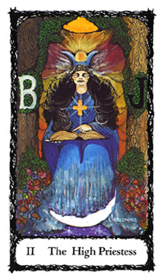

The High Priestess sits enthroned between the trees (pillars) of sacred and profane knowledge that once graced the Temple of Solomon. Inscribed upon the trees are identifying sigils: "B" for Boaz (Hebrew for "manly, strong"), interpreted as the essence of Strength—it is placed at Her right hand, the pillar of positive polarity—and "J" for Jachin (Hebrew for "foundling, God confirms"), to be interpreted as the essence of Beauty. This is at Her left hand, the pillar of negative polarity. (Hence, view Jachin at your left, Boaz at your right on page 214 and 218 diagrams.) Draped between the pillars/trees is Her veil, the only obstruction into the world of hidden and sacred experience. The High Priestess is the personification of equilibrium accomplished through the use of knowledge.

This aspect gives Her another title. She is referred to as the "Middle Pillar." In this form, the High Priestess becomes the direct route from mundane to enlightened experience. That is why I chose Her face not to be veiled, nor covered, for to behold Her beauty is to "die" (to be transformed, or to cease existing in the present circumstance). Therefore, to know Her secrets is to be reborn. It is here as the Middle Pillar that Her placement in the Major Arcana is important. In order to penetrate Her veil and gain access to its knowledge, the seeker must integrate the energies of the two previous cards: The Fool and The Magician.
As we delve further into Her symbolism we find Her left hand pointing toward Her lap and at Her "child," the sacred record of all Fate, the cosmic account of all personages and activities, and the balance sheet for Karmic and Dharmic law: the Akashic Record. This document holds all accounts of past lives, actions, and future incarnations and subsequent lessons. Her only utterance: "All that ever was is, all that will ever be is" Her gown is a vivid sea blue upon which an equidistant golden solar cross—representing the conjunction and blending of polarities or opposites—blends into a glorious product, the cosmic void. Her headdress, a crown of Mercury, represents the arts of healing, communication, art and commerce, all subject to a changeable temperament. The dark pigment of Her flowing hair represents the abyss of hidden knowledge and sacred mysteries. And at Her feet, the ever-changing moon is in its crescent form. Her gown and She become fluid—the unconscious link between matter and spirituality, representing power through the acceptance of the laws of nature.

MEDITATIVE MEANING

Healing through acceptance and the following of Divine Law. Spiritual maturity through merging with the ebb and flow of the universe. Peace. Assurance of action, of doing the right thing. Divine Protection. "I am part of all that is central to the cosmos."

DIVINATORY MEANING

Positive Aspect: Secrets, intuition, and dreams hold answers. Karmic law governs outcome. Going by the book brings results. Observation, neutrality. It is proper to seek council from a woman. Spiritual education to take place (possibly within the next Moon cycle).
Negative Aspect: Gossip, over-reaction, emotionalism. False council. Do not trust a woman's motives or advice. A poisoning atmosphere, with ill effects. Sexual excess.

III The Empress — The Great Mother
"Judicious mothers will always keep in mind,
that they are the first book read, the last put aside,
in every child's library"
—C. Lenox Remond
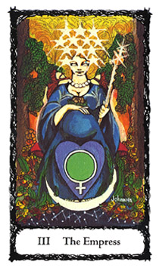
We continue our journey. As the Great Mother, The Empress is the virginal High Priestess transformed in the vehicle of life, from the abyss of the cosmic sea into the nurturing Mother Earth. This transformation occurs through the mating of the energies of The Magician (will with knowledge). As the maiden or High Priestess, She is the Middle Pillar on the Tree of Life. As The Empress, She is the fulfillment of that journey's end, existing no longer in Her hidden, secretive, or dark aspect. This renewal, a different type of glorious existence, is illustrated and symbolized by The Empress' light golden hair and auric luminescence. The Empress is pregnant, bearing the fruit of the union of opposites. As the symbolic image of passage, She is also the forebearer of great potential, as suggested by the Gold Rose of Absolute Achievement resting upon Her pregnant belly. The Empress encompasses the great mystery of the womb and astral "doorway" (both womb and the grave) leading to resurrection, reincarnation, or just a different life and attitude.
In Her radiant wisdom, She is still aware of Her original maiden nature. Though transformed, She is and always will be the High Priestess. This face is confirmed and attested by the crescent moon at Her feet and the blue color of Her gown. Her pearl necklace represents the eternal sea of universal life and obtainments. At Her feet rests a heart-shaped shield. Upon it is inscribed the sigil of universal femininity and of the goddess Venus. Such as the oyster which takes a grain of sand (a painful and therefore "negative" experience) and produces a treasured object (a pearl) while shielding it in its shell, so does the Great Mother protect with love Her treasure, though its birth may bring pain. She is crowned in twelve stars, representing the twelve houses of the zodiac, and sits upon a cushion representing the foundation of physical desires which, when well used are no longer a burden but a comfort. Her dominion is both of the heavens and of the earth, confirmed by Her bare feet, and royal scepter (the combined form of wand/globe and cross: male, female joined at the intersection of the spiritual and physical energies) held in Her left hand of receptivity.

﻿MEDITATIVE MEANING
The purpose of all life is creation. The creative process require; strength of purpose to be fulfilled. The Godhead in Its feminine aspect. "Help me to seek out and fulfill my blessec nurturing spirit."
DIVINATORY MEANING
Positive Aspect: A rewarding project in the making. Fulfillment of an obligation or fruition of a goal. Nurturing of self or project. Divine protection for a desired goal. Blessings of comfort and ease in labor.

Negative Aspect: Aborted attempts at reaching a goal. Lacking the willpower, knowledge, and stamina to succeed. Rebellion Project or goal "dying on the vine." Shelve any future attempts, go back to the drawing board and start anew. Time to cul the umbilical cord before it strangles you. "Don't fool wit'. Mother Nature."

IIII The Emperor — The Father
"You don't have to deserve your mother's love. You have to
deserve your father's. He's more particular."
-Robert Frost
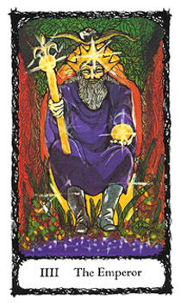
As previously described, The Empress is The High Priestess who became transformed by Her union with The Magician. The Magician, in turn, has also experienced a transformation as a result of this union; He is now The Emperor or Solar King. In this form, He is the ruler of the outer world, the conqueror of matter, and the window which functions as the perception of the law, the creator and holder of its authority.
The Emperor holds a golden scepter in His right hand. The shape constitutes His authority—the phallic rod topped with the fleur-de-lis (the flower of light)—is similar to the Hindu symbol of the union of opposites: the yoni (female energy/ vulva), and the lingam (male energy/phallus). The Emperor is the godhead in its male aspect and as Father.
In His left hand He holds a golden orb representing the mandalic energy of valued completion. His crown is of seven points of light, symbolizing the passage of sexual energy through its conversion into the psychic and spiritual realms. This energy is often referred to as the Kundalini (or Serpent Power of Hindu metaphysics) which travels through the seven auric spheres of contained psychic power within each individual, known as the Chakras. Above his head is an eagle, the alchemical symbol of the union of the elemental Powers of Air and Fire. The eagle, according to myth, is able to travel nearest to the Sun without incurring injury; hence, it is capable of contemplating Divine Splendor. It is also the symbol of Zeus, the Greek pantheon's patriarchal god. In Wicca, the eagle is an animal companion to "The Hunter" aspect of the Godhead. The Emperor's robe is purple, representing spiritual power. His boots are planted firmly upon the earth, symbolizing foundation of strength and purpose. They act as a barrier against unsolicited elemental influences, as does His golden cube throne, strategically placed between the archway of two fertile trees representing the foundation of His strength here on Earth through the Four Elemental Powers.
MEDITATIVE MEANING
I will govern wisely, using my energies within the structure of law dictated by the Divine Plan."
DIVINATORY MEANING
Positive Aspect: Authority and protection. Paternal father or father figure, a mentor, leader, an employer or a man in authority. Following the leader's rules will bring material and tangible benefits.
Negative Aspect: Dictatorship and treachery. A pompous attitude or individual. Anger. Stagnation. You have traveled too close to the sun without any protection and now will be burned. Warning: the punishment will fit the crime.
The Fool, The Magician, The High Priestess, The Empress, and The Emperor are unique in placement and function, as fundamental prototypes of Child (The Fool), Suitor/Bachelor (The Magician), Virgin/Maiden (The High Priestess), Mother (The Empress), and Father (The Emperor). They are the spiritual family, and a very special asset in the process of initiation. They represent the innate qualities which are inherited (through the collective unconscious) and past incarnations.
From this point the Major Arcana will now take on a different aspect. We will be confronting life experiences and challenges which are meant to test us and challenge who or what we believe to be reality.

V The Hierophant — Social Order As Spiritual Law
"Virtue alone is not sufficient for the exercise of government;
laws alone cannot carry themselves into practice."
-Menicus
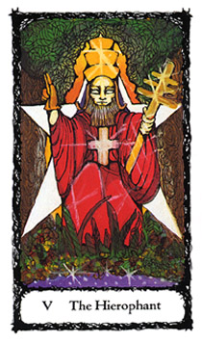
A mature man, dressed in priestly robes extends His blessing. He is a somber and authoritative individual. Upon His head is a triple-tiered, golden crown of three-fold enlightenment, representing solar power that emanates through the blessings of the creative (emotional), formative (mental), and material worlds of existence. He sits upon a pentagram throne, a symbol of earthly power. We are reminded of the proper use of our power of thought, and how thought can effect and eventually evolve into matter. His right hand blesses and sanctions, while hidden and protected under its glove of authority. His left is exposed to the surrounding elements and holds the staff of obedience and the knowledge of opposite and opposing forces. The six rungs and crossbar of the staff represent the seven ancient and original planets of power and attributed sins and virtues that are sanctioned or damned through His authority.

PLANETARY BODIES PLANETARY SIN PLANETARY VIRTUES

The Sun Pride Power
The Moon Sloth Grace
Mercury Envy Ethics
Mars Wrath Courage
Venus Lust Love
Jupiter Gluttony Benevolence
Saturn Avarice Honesty

The Hierophant is the social establishment and securer of the law, the dispenser of rewards both positive and negative. His golden scepter signifies the manifestation of both vice and virtue, good and evil, positive and negative; the established standard which all are judged by in society. He signifies spiritual law as manifested through our everyday existence. The rules—the "thou shalt not(s)"—therefore, prevent chaos and provide social stability.
MEDITATIVE MEANING
"I am a vehicle for the fulfillment of the Divine and Universal Law as others are to me, and Ito them."
DIVINATORY MEANING
Positive Aspect: Social grace and blessings. Stabilizing of a project through an authoritative figure. Conformity and following the rules or what is assumed or expected of you and/or the situation will assure the desired results. Combined with other cards: partnership, contracts, or a marriage.
Negative Aspect: Weakness and rebellion lead to failure. Dissolution of a partnership. Civil punishment or persecution, ostracism.

VI The Lovers — Choices
"What man wants is simply independent choice, whatever
the independence may cost and wherever it may lead."
-Fyodor Dostoevsky
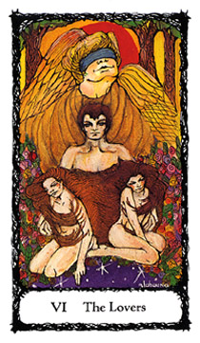
In this series of enigmatic images, The Lovers is profoundly significant. It depicts Adam in the Garden of Eden, and on either side of him, Lilith and Eve. Lilith, who is better known in her demonic guise as "slayer of children," started out as one of "his"-tory's (excuse the pun) first feminists and, according to Jewish folklore, the first wife of Adam. Her character is not only found in Judaic folklore but has been cited in cultures predating Judaic lore such as Babylonian and Sumerian mythology where she is a demoness that seduces men in their sleep. On the other hand, Eve was created after Lilith left the "happy nest" to be Adam's faithful and dutiful wife, and is credited with the primary cause of the fall from grace. Poor Adam; he should have kept the independent-thinking Lilith!
Lilith, who was her own person, would have given the serpent a formidable confrontation. She may have even questioned the serpent's motives. Lilith didn't play the submissive role; she was aware of the great responsibility that duty calls for and recoils at the thought of her cosmic task. Eve, on the other hand, coyly tested the cosmic waters, and through her actions both she and Adam were cast out of the Garden of Paradise. Thus, one is tempted to re-evaluate whose definition of Paradise we are accepting; is it a place of independent selfhood, or of subjugation to an unreasonable master? The images of Lilith and Eve are purposely depicted as interchangeable energies, and depending upon the issues surrounding the consultation, can and should be interpreted accordingly.
The Lovers card illustrates a fusion occurring between Lilith and Eve, a blending of energies as depicted through the entangled strains of their wind-swept hair. Adam is faced with the confrontation of what he perceives as his spiritual fulfillment: his anima (soul) projection. Lilith is thought of as the energy-sapping and negative aspect of his spirituality which is not supportive, but independent and rebellious; whereas, the submissive Eve is thought of as the spiritually supportive aspect. (Though in all honesty, I do believe that Lilith would have given the serpent in the Garden a good run for its money before submitting to temptation. But then, we wouldn't have to go through all our soul-searching for answers, or would we?)
The archangel Raphael (Hebrew: "God is Healer") or Adam's higher spiritual presence (God consciousness) is blindfolded. It is not in the angel's realm of power to cast judgment upon the choice about to be made. The blindfold's fabric is blue, representing the realization of an impossible vision. The Divine Presence is definitely there, but detached; its only participation is to guarantee humanity's free will and subsequent choice. Hence, Adam's choice will dictate the next step in his development; he is cautioned (for he is aware of Divine Law via The Emperor and Hierophant) to do as he wishes, but he must realize that his choice is tantamount to creating his destiny. Therefore, The Lovers card represents the theological theme of manifested destiny or free will. It is a card of crossroads: decisions made and actions taken. What is our everyday existence, but a series of choices?
The Lovers can also be viewed in another context: marriage, or merging of energies from "ME" to "WE."
It is the "WE" that requires both parties to accept the positive and negative anima/animus projections of the other, to vow to honor these projections (for better or worse, richer or poorer, sickness and in health) and permit the dissolution of former self and ego. Having made the choice to do so, the merging creates an unique separate entity, a marriage. The institution of marriage is the representation of the alchemical process at work within our everyday lives.
To illustrate this point, when we have an undesirable project to start, most of us are resentful and confirm our lack of enthusiasm by uttering the phrase "I have to go to work, feed the children, clean the house, and visit my parents." In doing so, we are labeling our project with a distasteful attitude. Just a change of phrase can make all the difference: "I choose to," sets aside the immature reactions to any challenges, and affirms your spiritual dignity.
Similar to the vows freely taken by clerics and holy orders, your chosen paths are acknowledged and become part and parcel of the expression of your Higher Self.
MEDITATIVE MEANING
"May I truly understand the consequences of my choices."
DIVINATORY MEANING
Positive Aspect: You will face a challenge of free will and choice. You have chosen or will choose wisely, and will reap the benefits.
Negative Aspect: Spiritual weakness and inertia. The destiny is one of trial and tribulation, poor evaluation of prospects.
You learned the law and its rules of conduct (The Hierophant) and made your choices (The Lovers). The Divine Gift of free will, and the road taken now require you to muster up all your resources and demonstrate control.

VII The Chariot — Control
"Any man can hold the helm when the sea is calm." —Publilius Syrus
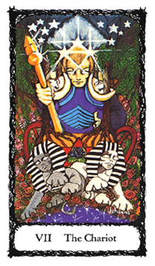

The Charioteer ventures forward without fear. His stature evokes confidence, awareness, and understanding. Above and on either side of his head are five stars; crowning him are an additional three. Five is the number representative of risk and attributed to the planetary godform of Mars. Three is the number representative of the trinity of life (mother, father, child). In total there are thirteen stars. When the double digit is reduced to its single digit power (13 = 1 + 3 = 4) we have the card number of the Emperor. An additional insight into this card's mystery is through the key of number 13. The thirteenth card of the Major Arcana is Death. The Emperor rules, The Chariot controls, and Death transforms.
The power of numbers plays an important role in the riddle of the sphinx: "What creature has four legs in the morning, two legs in the afternoon and three in the evening?" Answer: Man (as a child crawling, youth standing erect, and in maturity, frail, needing support as with a cane). The Fool, The Emperor, and The Hermit—which will be discussed later on—are tarot depictions of the riddle's answer.
In his right hand, the Charioteer holds a golden scepter of power. This scepter is topped with the geometric forms representative of the symbolic components which make up accomplishment: pyramid (emanation of energy), cube (foundation and structure), and sphere (completion and wholeness). The scepter is not just another phallic symbol of male power and authority, but the responsibility this power demands ("no guts, no glory"). The Charioteer's left hand rests upon his hip, representing a firm stance and realization of what he has willingly chosen and the course he must take. His mission (to succeed by controlling opposing forces) is symbolized by the two sphinxes which seem to be heading in different directions. They are black and white, symbolizing life's contrasts, and are the constant reminders of the questions life poses. They remind us of the nagging areas of doubt and suspicion which exist within the psyche. The Chariot is the energy that harnesses and controls these aspects within ourselves, and allows them to proceed forward.
On both shoulders he displays a crescent moon, symbolic of emotional inconsistency. They are badges of honor, for he has controlled his emotions in order to reach his goal. Uniformed in purple (spiritual power) and blue (imagination), his chariot is flanked by two fiery red wheels (cycles of physical energy and endurance). Centered within the body of the chariot is the Blue Rose of the Impossible—attainment; surrounding the rose is a red pentagram of physical protection. All are necessary implements of power and assurances for success. The Charioteer is aware that the sphinxes are, at any given moment, ready to leap into the cosmos, wreak their havoc, and be true to their names: "Irresponsibility" and "Doubt."
MEDITATIVE MEANING
"I have chosen, and will proceed forward in my course of action. May my Higher Self give me the qualities necessary to succeed."
DIVINATORY MEANING
Positive Aspect: Exploration leading to success, need for mastery and control. Challenges await you. Possible travel.
Negative Aspect: Scattered energies leading to irresponsibility and doubt, failure of projects, false intentions, lies, excuses and stagnation.
INTRODUCTION TO THE REST OF THE JOURNEY

Throughout the centuries, students of the occult have held various opinions concerning the origins of the cards. Whatever lent an air of mystery and forbidden powers was assimilated into tarot mythology. Mind you, this did not hurt business, and maybe a story or two are true. And I must confess, occultists do love a good yarn; it keeps their energies flowing. As much as we want to believe exciting and mysterious tales, history demands its own audience. Documentation of the cards' origins is veiled in its own mystery. Therefore, the serious student must examine with an open mind what historical findings have led to scholarly conclusions.
The first record of the cards appears in the 14th century, and the origins of the 22 Major Arcana and 56 Minor Arcana, or suited cards, to this day remain obscure. The word arcana is defined as something difficult to explain and comprehend. Within the tarot we have but two enigmas. The Major Arcana is representative of Spiritual Initiation, while the Minor Arcana represents the mystery found in mundane life experiences.
Specifically of interest is the placement of our next study card, Justice. As indicated historically, the original placement of the card was positioned as number VIII (8), not number XI (11). The attribution to position XI only occurred within the last ninety years. Arthur Edward Waite (author of the Rider-Waite Tarot) felt it was necessary to compose a rectified tarot system. Choosing to do so, he exchanged the positions of Justice with Strength.
Waite, with artist Pamela Colman-Smith, redesigned the ancient interpretations into a modern, subtle visual imagery. This is one reason that the Rider-Waite deck is still one of the most popular decks among beginning tarot students. But, confusion is not far behind the student's serious efforts. Since tarot symbology can be considered etched in stone, it is at the same time open to individual interpretation. Whether the ancient Hebrews thought that the visual image of Justice was a serpent or an oxgoad, we may never know for sure. The confusion for the student and earnest practitioner of esoteric philosophy begins with the recent adaptation of the Major Arcana symbology to the Hebrew alphabet and Kabbalah's Tree of Life. Great occult scholars like Levi, Mathers, Papus, Case, Wirth, Waite, Crowley, and most recently W.G. Gray, have "juggled" with the placement system. All have endeavored to unlock the door that separates modern man's psyche and the role of participation in the ancient mysteries.
I chose to work within the original attributions. I hope to illuminate my rationale for your benefit and allow you to come to your own conclusions.
HEBREW ATTRIBUTIONS TO THE MAJOR ARCANA

Letters of the Hebrew alphabet are shown with their attributions according to Levi, Papus, and Wirth, as compared to Waite.
HEBREW LEVI, PAPUS, & WIRTH WAITE
Aleph (Ox) I The Magician or Juggler 0 The Fool
Beth (House) II The Female Pope I The Magician
Gimel (Camel) III The Empress II The High Priestess
Daleth (Door) IIII The Emperor III The Empress
Heh (Window) V The Pope IIII The Emperor
Vau (Nail) VI Vice & Virtue or The Lovers V The Hierophant
Zain (Sword) VII The Chariot VI The Lovers
Cheth (Fence) VIII Justice VII The Chariot
Teth (Serpent) VIIII The Hermit VIII Fortitude or Strength
Yod (Hand) X The Wheel of Fortune VIIII The Hermit
Caph (Palm of Hand) XI Strength X The Wheel of Fortune
Lamed (Oxgoad) XII The Hanged Man XI Justice
Mem (Water) XIII Death XII The Hanged Man
Nun (Fish) XIIII Temperance XIII Death
Samech (Prop) XV The Devil XIIII Temperance
Ayin (Eye) XVI The Tower XV The Devil
Peh (Mouth) XVIII The Moon XVI The Tower
Tzaddi (Fishhook) XVII The Star XVII The Star
Qoph (Back of Hand) XVIIII The Sun XVIII The Moon
Resh (Head) XX Judgment XVIIII The Sun
Shin (Tooth) 0 The Fool XX Judgment
Tau (Cross) XXI The Universe or The World XXI The Universe or The World

The Major Arcana cards can be further explored by laying them out horizontally in ascending order, from left to right, into two rows of nine, with four remaining cards in the third row. Row one starts with I The Magician, and ends with VIIII The Hermit; row two begins with X The Wheel of Fortune, and ends with XVIII The Moon; row three begins with card XVIIII The Sun, and ends with 0 The Fool.
HEBREW ATTRIBUTIONS TO THE MAJOR ARCANA

Letters of the Hebrew alphabet are shown with their attributions according to Levi, Papus, and Wirth, as compared to Waite.
HEBREW LEVI, PAPUS, & WIRTH WAITE
Aleph (Ox) I The Magician or Juggler 0 The Fool
Beth (House) II The Female Pope I The Magician
Gimel (Camel) III The Empress II The High Priestess
Daleth (Door) IIII The Emperor III The Empress
Heh (Window) V The Pope IIII The Emperor
Vau (Nail) VI Vice & Virtue or The Lovers V The Hierophant
Zain (Sword) VII The Chariot VI The Lovers
Cheth (Fence) VIII Justice VII The Chariot
Teth (Serpent) VIIII The Hermit VIII Fortitude or Strength
Yod (Hand) X The Wheel of Fortune VIIII The Hermit
Caph (Palm of Hand) XI Strength X The Wheel of Fortune
Lamed (Oxgoad) XII The Hanged Man XI Justice
Mem (Water) XIII Death XII The Hanged Man
Nun (Fish) XIIII Temperance XIII Death
Samech (Prop) XV The Devil XIIII Temperance
Ayin (Eye) XVI The Tower XV The Devil
Peh (Mouth) XVIII The Moon XVI The Tower
Tzaddi (Fishhook) XVII The Star XVII The Star
Qoph (Back of Hand) XVIIII The Sun XVIII The Moon
Resh (Head) XX Judgment XVIIII The Sun
Shin (Tooth) 0 The Fool XX Judgment
Tau (Cross) XXI The Universe or The World XXI The Universe or The World

The Major Arcana cards can be further explored by laying them out horizontally in ascending order, from left to right, into two rows of nine, with four remaining cards in the third row. Row one starts with I The Magician, and ends with VIIII The Hermit; row two begins with X The Wheel of Fortune, and ends with XVIII The Moon; row three begins with card XVIIII The Sun, and ends with 0 The Fool.

Aces BEGINNINGS
Deuces PARTNERSHIPS
Threes ENDEAVORS
Fours FOUNDATIONS
Fives MOTIVATIONS
Sixes ADJUSTMENTS
Sevens LESSONS
Eights REGENERATION
Nines CONSCIOUSNESS
I The Magician II The High Priestess III The Empress IIII The Emperor V The Hierophant VI The Lovers VII The Chariot VIII Justice VIIII
The
Hermit
X XI XII XIII XVII XV XVI XVII XVIII
Wheel of Strength Hanged Death Temperance The The The The
Fortune Man Devil Tower Star Moon

XVIII XX XXI 0
The Judgment The The
Sun World Fool
The headings shown above the columns of cards describe 9 levels of mundane initiatory forces (with their governing planetary symbols), as explained in the Minor Arcana (see page 112). Directly below is the row of primary archetypal energies (The Magician, High Priestess, Empress, Emperor, Hierophant, Lovers, Chariot, Justice, and Hermit). The second row (Wheel of Fortune through The Moon) represents the tests or initiatory experiences. The third row (The Sun through The Fool) lists the rewards.
Please note the number on any card in the top row you care to examine. Now, examine the number on the card directly below it; adding the digits will reduce them to a single digit that corresponds to the top card. The difference between the double-digit number and the reduced number will always be nine. The next card in that column will yield the same result.
As an example: under the column title of Endeavors, the card III The Empress = 3; directly below, the card XII The Hanged Man = 12. By adding The Hanged Man's 1+2 you will arrive at 3, corresponding to The Empress. The difference between 12 and 3 is 9. The next card down that column, XXI The World = 21. By adding 2 + 1 you arrive at 3, the number of The Empress card; there too, the difference (21 minus 12) is 9. The consciousness of each primary archetypal energy (row one: Magician, High Priestess, Empress, etc.) is brought to a new level by the addition of the number 9, the number of enlightenment and revelation.
Review the diagram, and ask yourself the following: What do Beginnings, Will Power (The Magician), Fate (The Wheel of Fortune), and Needs Fulfilled (The Sun) have in common? Do this exercise with each column of cards.
If you add the final (third) row to the second row you get a numerological reduction to the first row's number and primary energy of spiritual initiation, along with its mundane counterpart.
As you proceed in the text of the 22 Major Arcana cards you can observe a pattern of support.
For example: The fifteenth card is The Devil. Reduce the digits to one single digit (15 = 1 + 5 = 6). The numbers reduce to 6 or The Lovers.
Now ponder this: What does Self-Imposed Bondage or The Devil card have to do with Choices/The Lovers? How do both cards refer to Adjustments, the designated title of the Four Sixes in the Minor Arcana?
BACK TO THE JOURNEY
You have made your choice (The Lovers) and have the matter somewhat under your control (The Chariot). You can see your goal before you, but now you will be asked to balance your use of this power.

VIII Justice — The Equalízer
"Justice is a great gift of God."
—Amen-Em-Apt
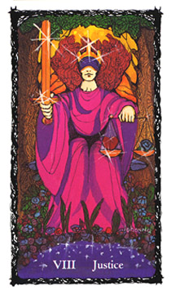

The figure representing Justice is of a blindfolded woman. She holds in Her right hand a large and cumbersome double-edged sword; Her left hand holds a perfectly balanced scale. She is an aspect of the goddess and exemplifies spirit, emotion, and intuition in balance within the law. The Justice card symbolism is of equilibrium, balance, and the courage to face truth. Her crown signifies that Her energies are regal and authoritative. As bearer of the gift of equilibrium, through adjustments, the triple-barred crown represents the value of discretion, intuition and discrimination. Her flaming-red, wind-swept hair is representative of enlightened and active analysis. She is also symbolic of the balance between the triple aspect of the
feminine godhead: Virgin, Mother, and Crone. She is the delicate adjustment between maidenhood (the High Priestess) and motherhood (the Empress), as represented by the scales She holds. She is clothed in bright crimson and purple robes representing royal rank. The Crone, or Wise Woman, is the benefactor of secrets, sacred and profane. As Justice, Her sword is carried forward and held outright, a physically challenging task. She is the dealer of the final blow, the cutting away of illusion, the enforcer of the Cosmic Plan.
Justice functions on three levels of existence (in the worlds of the creative, formative and physical). Across Her eyes is a purple-colored blindfold which signifies that "not all of what is perceived is truth; only through spiritual development and use of its gifts are our perceptions rid of prejudice."
Upon the sword's hilt are three fiery red stones forming an inverted triangle, another type of sigil, representing the element of Water. This arrangement signifies the precious alchemy when Fire and Water coexist. The hilt's message confirms that emotional creativity leads to true adjustment and balance. In Her left hand, She delicately holds the crossbar of a scale. Within each of the scale's pans are objects to be tested: a heart (or the heart of the situation) against the Blue Rose of the Impossible. Both, for this moment, appear to be in perfect accord. As the holder of the scale, She is keeper of the knowledge of good and evil, the regenerative power of the nature of truth, and in its fulfillment—the justice to follow. She is the unbiased initiator of the Law's order into fruition. A warning for the seeker, it is wise to remember that the scales have a tendency to go to extremes before settling into equanimity.

MEDITATIVE MEANING
"I realize my part in the Greater Plan. May I not be one-sided in my perception of what is just and right, and accept the consequences of justice at work."
DIVINATORY MEANING
Positive Aspect: A test of truth will prevail in your favor. A lawsuit or court action will be resolved. Past life karma and present life lessons are now evident, so keep your perspective and balance. Adjustments lead to success.
Negative Aspect: Motives are unbalanced. The truth is hidden by prejudice. Reconsider your request for justice; you may live to regret it; imbalance with serious consequences.
You have chosen (The Lovers) and controlled the circumstances surrounding your choice (The Chariot) and balanced your energies (Justice). Your truth, the truth, is not yet self-evident. Humbled, your journey continues into the deep recesses of the subconscious.

VIIII The Hermit — The Seeker of Truth
"The truth is cruel, but it can be loved, and it
makes free those who have loved it."
—George Santayana
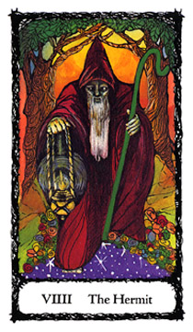
The Hermit is the enlightened individual persevering through the dark night of the soul. When the rules no longer fit, rhyme takes the place of reason. Justice has no pity, life has no mercy, and the world continues on its merry way as you cower and suffer the humiliation of spiritual doubt. No longer will the patronizing axioms you adopted as your personal mottoes bring their superficial comfort. Symbolic of the Godhead, the lantern illuminates the (cosmic) path; to what extent, you do not know.
The Hermit, an old man burdened with many questions, walks into the cosmos. His face is weary from his many journeys and many a day has passed in his quest. His only solace is the lantern of enlightenment he carries in his right hand and the green shepherd's staff of fertile and past accomplishment, which is his support and protection. This staff is an incomplete caduceus (the symbol of the healing arts and medical profession). It is the magical staff or wand of the god Asclepius and the god of communication, Mercury (Hermes). It is with this symbol that the Hermit strives to complete the incomplete, the eternal struggle for not only knowledge, but a resolution and realization of a tangible truth. This struggle, his journey, never seems to end.
The Hermit is our Fool. He has grown old and weary in his quest; the once adventurous journey has now become a sacrificial act. He travels from the light into the darkness. His robes are a ruby and blood red, the knowing aspect of the need for physical sacrifice and humility. He is the I Ching's persevering man, and the Biblical Job.
MEDITATIVE MEANING
"Wherever my quest leads me, may the journey's end be one of enlightenment."
DIVINATORY MEANING
Positive Aspect: A time for the gathering of inner resources and demonstrative humility. Perseverance brings reward, inner truth revealed.
Negative Aspect: Self-deception, false humility, self-righteousness and maniacal actions leading to failure. Denial and rejection of the truth found in present and past experiences may lead to manifestation of a physical illness.

As the Hermit you are not only the lonely seeker of truth, but a spiritual person realizing the value of choices and the proper use of personal power. These realizations give you the ability to glimpse into the Greater Cosmic Plan. Now you are prepared to ask: "What role am I meant to play in this plan?"

X The Wheel of Fortune — Your Destiny at Work
"Don't envy men/Because they seem to have a run of luck,/ Since luck's a nine day's wonder. Wait their end."
-Euripides

Before the watchful eyes of the discerning and questioning sphinx, we are privy to a cosmic mystery play. The ever-turning Wheel of Fortune continues its function at the edge of the cosmos and generates a result which, by chance, may be in your favor. But whatever the result or outcome, The Wheel represents a cosmic challenge, firm and set within the Akashic Record. The Wheel is a mandala of these forces—spiritual and mundane activities and interactions of time, space, and thought. The abundant flora surrounding The Wheel suggests fertile possibility and everlasting life.
The Wheel is purple, the color that signifies spiritual power and intuition. The green in the card denotes nature and fertility; blue points to intellect and the impossible task, and pink is the elevation of emotions and sacrifice.
The creatures of The Wheel include: The Egyptian jackalheaded god Anubis, the bearer of constructive knowledge and the "Keeper of the Gate" to the astral realm, a guide to the dead. The golden serpent is Typhon (from the Greek pantheon), god of evil, representing the powers of forbidden knowledge—sex and death—and ultimately, destruction. The serpent is the totem animal (or animal-formed alter ego) of the god Set (also known as Sethi) from the Egyptian pantheon, brother and destroyer of Osiris, the resurrected godform.
At the base of The Wheel, the monkey shows how the forces of fate, or the gods mockingly view humanity's mischievous, infantile, and humorous involvements. This symbol says that we should not take what trials fate has in store for us too seriously. The soaring eagle in flight represents humanity's hopes of redemption, as it soars above the chains of matter through lofty accomplishments and glory. Therefore, The Wheel of Fortune represents the ebb and flow of both positive and negative forces similar to the Yin/Yang (I Ching) symbol of the Orient.
The sphinx, part woman and lion (see cards VII, The Chariot and XI, Strength), poses the question(s) and watches hypnotically for your answer. Which creature will represent you in your quest? Which one is of your calling? Is it Anubis, Typhon, monkey or eagle? More than likely it is all of them.
MEDITATIVE MEANING
"I am one with the cycles of the universe, I am servant to the Cosmic Plan."
DIVINATORY MEANING
Positive Aspect: Be adaptable, for no matter what you are presently experiencing, it and you are part of a Greater Cosmic Plan. Forces at work: karma, destiny, fate. A karmic test of awareness, leading to fortitude—gain after trial.
Negative Aspect: Reality is confrontational and there are hard lessons to be learned. Do not act in haste; improper action(s) will lead to further troubles. There may be ill-fated projects, the need to question further the part others play in your destiny.

XI Strength — Gathering of Resources
"Strong men can always afford to be gentle. Only the
weak are intent on `giving as good as they get."
—Elbert Hubbard
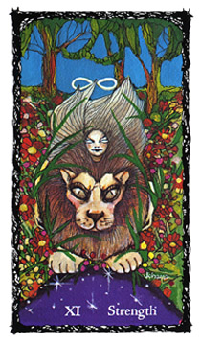
The picture is one of playful, yet direct, confrontation. A powerful but gentle woman is astride the back of an alert lion readying for attack. The woman displays signs of courage and control. In the background, the Trees of Knowledge and Life are distant, suggesting that sometimes one must go beyond one's preconceptions in order to realize goals. In other words, we must prepare to "go the distance."
The woman's hair is swept up in a whirl of energy which seems to meld with the lion's mane, thus indicating unification of both spiritual and physical power. Above her head appears the sign of the double nimbus oo symbol last seen in the card of The Magician. The double nimbus (or infinity symbol) represents both spiritual and psychical power unified. Its definition within this card is a message that without strength there is no willpower.
The female figure embodies the strongest emotional and intuitive natures in the spiritual realm. (This is best illustrated by our general amazement at individuals who overcome physical adversities through spirit.) The lion is our physical world of matter and survival. Regal in nature, it is still a carnivore awaiting its prey and represents a purpose to one's actions in the everyday world. The card's underlying message: spiritual stamina (strength) will exalt the mundane and physical.

MEDITATIVE MEANING
"I realize that I am being tested for my endurance, both spiritually and materially. I seek harmony with the forces about me and reconcile my differences."
DIVINATORY MEANING
Positive Aspect: Test of spiritual grace and physical challenges. Spiritual needs must be addressed in order to dominate in your favor. Strength through forgiveness. Forgiveness brings reconciliation. The spiritual will overcome the physical.
Negative Aspect: Unbalanced attitudes and vanity; spiritual weakness lacking in resolve. Rage, stubbornness, and false pride. Destructive emotions at play. Baser instincts overwhelm the situation.

XII The Hanged Man — Non-Action as Action
"Nowhere can man find a quieter or more
untroubled retreat than in his own soul."
—Marcus Aurelius
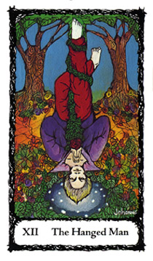
This card can be referred to as "the way of the sacrifice or path of the yogi." The seeker may find several mythic analogies given to this card: the pagan sacrificed Sun King(s), the Norse God Odin hanging from Yggdrasil the "World Tree," or Christ at the crucifixion. Another concept is that of the betrayer of Jesus, the Disciple Judas Iscariot. (Myth has it that Judas committed suicide by hanging.) Whatever allegory you attribute, you may want to keep this in mind: these allegories are part of an explanation of the Divine Plan. The pagan Sun King knows he must die to assure the fertility of the land; Christ, too, pondered the mortal coil and the suffering of death in the garden of Gethsemane. And Judas was a tragic figure indeed, for someone had to be cast as the betrayer in the scenario. It makes one truly ponder whether Judas' suffering, which allegedly led him to commit suicide, did not offer him a special place, not in hell, but in heaven.
The Hanged Man card depicts a young man, complacent in the midst of such unusual circumstances, as he hangs by one foot, his hands clasped in meditation and prayer. He appears to be blessed by his suffering, as symbolized by the radiant lights about his head. The Hanged Man symbolizes one of the highest levels of mortal sacrifice, at all times consciously aware of what he must do and in turn experience in order to achieve his goal.
His purple shirt suggests power flowing downward, manifesting into intuition. The red trousers represent strong physical foundations and the reality of physical sacrifice. In his praying hands he holds the red rose, symbolic of the discipline and sacrifices to be made in the physical and mundane world. He hangs by his right leg from a thick, fertile vine representing the entanglements of human nature (the seeking of comfort, the influences of family, friends, and society). His left leg is free and crossed behind him to indicate spiritual release and potential freedom. The Trees of the Knowledge of Good and Evil support his endeavors and sustain his quest. The scene is bountiful, as his physical sacrifice brings about a desired result.
MEDITATIVE MEANING
"I will suspend all action and re-action as I await the message and guidance from my Higher Self."
DIVINATORY MEANING
Positive Aspects: Faith in one's own chosen course of non-action will bring about desired results. New and old beliefs are put to a physical test. Good intentions despite unconventional behavior.
Negative Aspects: Stalemate, stagnation, "no news is good news," physical suffering, illness, and pain are part of The Plan. Living in limbo.

You have come to terms with your fate (Wheel of Fortune). You have reexamined your physical and spiritual needs (Strength), and developed the ability to meditate and not react to life's glitches and upheavals (The Hanged Man). You're feeling pretty good right now, aren't you? Yet, the journey is not over; a new manifestation, something unknown, unexpected, will be taking over and humbling you as never before.

XIII Death — The Great Transformer
"Death is the supreme festival on the road to freedom." —Dietrich Bonhoeffer
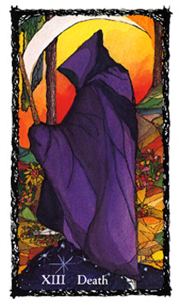
A shrouded figure, awesome in its powerful presence enters our world from the cosmos. This guest is usually not a welcomed visitor to our realm of matter. It is the destroyer of matter, the dreaded caller to the unknown, and the conveyor of Divine Intervention. All-powerful, it represents not only earthly transformation of your material realm, but the cause and effect which can be astonishing.
The figure of Death is clad in a purple robe, the color of spiritual power. Its face and form are hidden within the dark recesses of its shroud. It enters our world from the right side of the pictogram, which represents the physical realm, and faces left to the future, suggesting that a material death is necessary for the fulfillment of the spirit.
Its scythe looms large over the figure. It is held in Death's left hand of receptivity and intuitive manipulation. It is a symbol of the lunar and feminine, the climax of events, the cutting down of one's prime material motivation. The landscape shows the power Death holds over the cycles of nature; where it steps there is withering of matter and decay.
A card of awesome power, Death signifies an evolution of untold events on the material plane. Its cause and effect cannot be altered. The best piece of advice: "I hope you did your homework"
MEDITATIVE MEANING
"May whatever it is I am to experience be to my betterment and Thy glory."
DIVINATORY MEANING
Positive Aspect: Time of transition and transformation. The past is meant to be left behind and with no regrets. New experiences, new cycle of events, and possible new life. Freedom from the old. Matter and physical reality transformed.
Negative Aspect: Do not hold onto the past, it no longer exists. Inertia. Failure. Living in fear of the inevitable. Depression through stagnation. Confronting an unpleasant reality which calls for change.
The world and reality you thought you knew has suddenly shifted. You are now required to temper your actions and reactions, for Fate has dealt you a chance at renewal through transformation. Be very mindful of your next steps. The truth will set you free, but only at a price. For we now must venture into the deepest and most unexplored recesses of the labyrinth.

XIIII Temperance — The Alchemical Process
"The interval between the decay of the old and the formation
and the establishment of the new constitutes a period of transition, which must always necessarily be one of uncertainty,
confusion, error, and wild and fierce fanaticism."
-John C. Calhoun
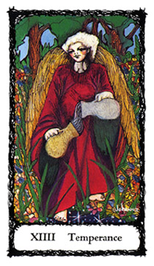
An angel standing within a fertile landscape appears preoccupied. It gazes rapturously into the future, as if listening intently to some Divine Instruction. It is the Archangel Micheal (Hebrew: 'Who is as God") which holds in its hands two vessels—crucibles of change: One silver (representing the lunar qualities of emotions, intuition and feminine aspects), and the other, gold (representing matter, physical and masculine aspects). Amazingly, not one drop of the vessels' contents is spilled. Only a smooth, flowing stream of liquid is transferred from one to the other—and back again, and on, and on, ad infinitum. This is the
ebb and flow of the universe, the constant infinite flux and reflux of cosmic energies.
Temperance speaks of the difficult but necessary revolution to follow. This change goes beyond material evolution (as illustrated in the Death card), into the transmutation of spirit to matter and matter to spirit, a conversion process.
The Temperance card speaks of this process in its earthly and human potential. The angel, as always, symbolizes Divine Inspiration and Intervention. The angel is pictured in reverie, listening to its instructions. Within its actions, no accident of man or circumstance can hamper its purpose—the forging of a renewed soul and physical being.
MEDITATIVE MEANING
"I will resolve to be part of the universal tide of change, to heed my intuition, and to carry out my calling, no matter how arduous a task it may be."
DIVINATORY MEANING
Positive Aspect: Your task is at hand; you are going to experience a definite conversion. Do not fight the inevitable. What you wish for will be granted, but with a definite and possibly high price. If physically ill, a cure or better health may come after the necessary conversion.
Negative Aspect: Not heeding the need or call for conversion will bring you a great deal of humiliation and compounded illness, the very dark night of the soul, the eleventh hour, a split in reality. Are the messages divine or demonic? A breakdown of all systems.

Even though the past cards can be considered to be valued, though harsh, harbingers of change, nothing can be more frightening than the necessity to face the following two Initiators: The Devil and The Tower. These cards illustrate what is in store when only lip-service is given and insincere efforts are meant to be means in making a deal with the Forces of Destiny.

XV The Devil — Self-Imposed Bondage
"Our greatest evils flow from ourselves."
-Rousseau
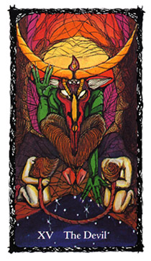
Hovering over the landscape, the "God of Matter" declares its purpose: your bondage to him. This is accomplished through your addictions to the material and compliance to the harmful. Its crescent horns glimmer in the light of its flame of truth. The knowledge it offers is of self-hate, denial, stubborn argument, and lack of responsible action. The Devil is more that a competent opponent; he is physically strong and demanding in nature, coldly confrontational and mockingly aware of your weaknesses. The power he harnesses is an unique combination with the lunar horns, the active spiritual flame, the exulted pentagram upon its forehead, and its half-human, half-animal form. He is not a figure of comfort nor is he meant to be.
The Devil's gestures proclaim a well-known metaphysical adage: "As above, so below," indicating this is not the Devil of our childhood religious dogma, but the ruler of thought and its projection which exists in the hidden recesses of mind and spirit.
The Devil card represents our own individual aspect of evil incarnate within ourselves—our shadow, the hidden Mr. Hyde to our public Dr. Jekyll. Most of all, The Devil is the evil we accept and protect, because we believe it is part of our self-expression. Our self-imposed bondage may manifest itself in such forms as drugs (whether socially acceptable ones such as alcohol or tobacco, or illegal varieties), the expression of sexual appetites, or destructive relationships. How or what defines your Devil? Its guises are many, but by recognizing its main function as the Lord of Illusion you can begin to identify its power in your life.
The Lord of Illusion and Matter prevents you from questioning motives or actions taken. By its nature, the Devil never intends to honor humanity for its own purpose; it only offers the illusion of ego gratification to keep you bound. It grabs onto our needs and distorts their meaning into wants of satisfaction. This is accomplished by addicting us to the belief that our soul's true expression can only be released through our bondage. This hold is so strong that before long we believe that this expression is a means of self-identification. Once the Devil is confronted, it is to our chagrin that this entity of self-hate was allowed to become an ally through our compliance.
Our Devil is just a mirror of our spiritual ills. As the mirror can reflect a hideous image, it can also offer a means of confrontation and eventual change. We must embrace our Devil and accept its message of potential enlightenment.
The Devil is flanked by a woman and a man who represent the slavery of our lunar (emotional) and solar (physical) natures. Both figures are kneeling in subjugation, she with her right hand (disbursement of energy) bound to her partner's left hand (receptive of energy). Their other hands remain hidden from our view, free to untie the cord that binds them. Yet, they are reluctant to meet the challenge. Are they adamant, or simply unaware of how to proceed? In order for them to be released they are required to look into their Devil's face and confront the illumination it offers. This is represented by the crowning flame issuing from the Devil's forehead. Looking into this flame of enlightenment is truly a frightening and painful process. In this realm, pain is pleasure and pleasure is pain. Our human and animal instincts prevail; we are addicts of choice, and we choose to bury our heads and be bound to negative and demeaning relationships. The Lord of Illusion and Matter reigns and eventually destroys all who are bound to him.
MEDITATIVE MEANING Choose to confront and learn from my Devil and make it an in my spiritual development."
DIVINATORY MEANING
positive Aspect: Recognition of the role one plays in the creation of a problem or situation. The solution is in breaking ties with unhealthy relationships to people, places, or things. Vampirism, liars and their lies—but who is the victim, who is the perpetrator? Confrontation and responsibility will destroy the bondage.
Negative Aspect: Hopelessness, confusion, hidden truth, or lies and denial. Corruption of innocence. Forcing of one's will (even with good intentions) will lead to ultimate destruction. Obsession, compulsion, paranoia. Revenge. Do not pass go, do not collect your reward, you have failed this test. Back to the drawing board!
So, you believe that you have confronted the Devil and therefore have the right to move on. Not so fast, for confrontation is not enough. Your next step leads you into the realm of the royal thump-on-the-head. The protective ego mechanisms that allowed your Devil to control you are now going to crumble. My advice: sit back and enjoy the ride; it may be your only means of survival.

XVI The Tower — Ego Destruction
"Do not seek so anxiously to be developed, to subject yourself
to many influences to be played on; it is all dissipation.
Humility like darkness reveals the heavenly lights."
-Henry David Thoreau
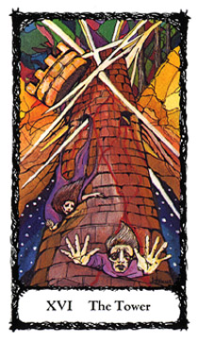
Our woman and man are no longer tied, but are now falling into the cosmic abyss. The structure that once secured and housed them is being destroyed by a heavenly force. The head or crown of The Tower is severed by lightning bolts and the landscape is a myriad of jagged rocks and colors as the figures fall to their demise, their expressions registering shock, fear, and panic. Their earthly foundation and reality is crumbling and the universe prepares to devour them. As they fall they are leaving a trail of bloody sacrifice, which etches itself into what is left of The Tower's structure.
The Tower card is meant to illustrate the need for ego restructuring. This is Divine Intervention in its harshest reality, a sort of metaphysical "thump on the head" This may come in many forms, but more than likely, it is not a welcomed and voluntary experience. This card is one of fate handing you a tremendous blow to your old belief systems. It always speaks of an unexpected, severe event to one's life structure. The Tower is a card that cannot be totally interpreted, for its power lies in the unexpected. Some examples of possible, but not foreseeable Tower consequences are eviction, or loss of home, accident, physical illness, death, or losing a job.
Most of all, The Tower is the card of forced change via The Fates.* Why? You have been judged as not doing something correctly to accomplish a predestined goal. So the forces intervene and literally destroy your protective mechanisms, forcing you to rebuild them or find new ones.
It is important to remember that this is a card of the Divine Intervention through harsh and sometimes violent action. It follows the prerequisite of your confrontation with the Shadow (Devil) and is now enforcing the necessary ego changes that must occur for you not to repeat or be bound again to your illusions and destructive nature. It's like hitting rock bottom as taught and experienced in the various twelvestep programs for self-help.
A word to the wise. Do not resent The Fates for dealing you this blow; it may just work out to your advantage.

*The three goddesses of Greek & Roman Mythology, sisters who govern human destiny; Clotho, the youngest, prepares the Thread of Life; Lachesis spins the thread; Atropos, the oldest, cuts the thread.
MEDITATIVE MEANING
"I will not fight the changes around me. My strength is in my resolve to accept the challenge and make the most of whatever circumstances are placed in my path."
DIVINATORY MEANING
Positive Aspect: Revolution, forced change leading to renewal. The road is cleared for action; pick yourself up and start all over again. Build up your courage, bravery and valor.
Negative Aspect: Physical illness, death, eviction from home, loss of job, depending on the nature of the inquiry. Stagnation and resentment may lead to ruin. Do not hold onto the old, for you will be destroyed.

You have, as they say, "been through the mill." After all, a decided change calls for a confrontation of your devil, but that too, is not enough; you have to experience the wrath of The Fates and be humbled in the process. You may be asking: "What now?" Consider the next step as a reprieve, an oasis in the desert.

XVII The Star — Hope
"If it were not for hopes, the heart would break." —Thomas Fuller, M.D.
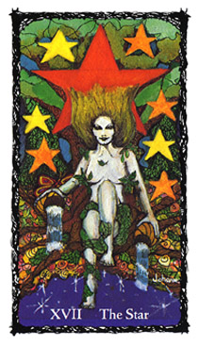
A nude figure of a woman sits under a huge and fertile tree. She is draped in fauna and surrounded by stars of fiery tones, her skin is luminescent. A butterfly rests itself upon Her right hand; this is the same butterfly seen in The Fool card. In each hand, She holds a vessel filled with an elixir pouring from it. The
elixir is hope, aspiration of changes for the better, and She is its
bearer. The Star is an additional, unrecognized aspect of the Goddess. Here, She is without the regalia of robes and throne; Her nakedness is simplicity and truth. Her words of comfort: "This too, shall pass."
The Star reminds us of the ebb and flow of life, that all is not darkness, and that we should persevere through trying times.
It is very important to remember that The Star follows your confrontation with The Devil and The Tower cards. This placement has a very significant message. It emphasizes the need of faith in troubling times, and the resourcefulness of the human spirit.
MEDITATIVE MEANING
"I have been tested—and survived. Now is my time for meditation, contemplation, and the enlightenment self-evaluation brings."
DIVINATORY MEANING
Positive Aspect: All is not lost. Have hope for the future. Do not despair; be flexible and self-nurturing. Rewards await you. Aid and help are on the way.
Negative Aspect: Hopelessness, depression leading to inertia. Loss of all controls. Despair and negative thinking can lead to traumatic results. Depletion of resources.

There is a light at the end of the tunnel, a glimmer of hope and redemption in the horizon. But watch your step; a trap has been set. Will you again fall victim?

XVIII The Moon — Patterned Responses
"After people have repeated a phrase a great number of times,
they begin to realize it has meaning and may even be true."
-H. G. Wells
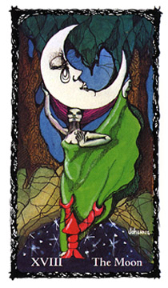
A moonlit night, and oppressive conditions surround a figure of a woman seductively dancing. She is attempting to mesmerize you into Her realm of lunacy. Clinging to Her gown is a shelled sea creature; it wants to transfer into the realm of the Earth, but cannot—by nature. The waning moon is tearful a; it crowns the dancer's movements. The colors are vivid anc clashing, the dancer's gown is a vivid green; Her magenta-colored hair conforms to the tearful moon's shape. The landscape is heavy with a tropical and swampy setting. The air is humid and oppressive.
The Moon card depicts our patterned response, the program that creeps into our lives when we let our guard down. It is our comfortable reaction to life's challenges, the usual and easy way out. The dancer represents our emotional and repetitive self, hopelessly whirling in an attempt to disguise motivation. The shelled creature bravely clings onto Her gown for salvation, but it is in vain, because its refuge is to go back to the comforts of the waters it came from. Its attempts at evolving into a land being are futile. It is a sad story, for its pattern of existence dictates its nature and the ultimate outcome.
The moon overhead is captured within the trees' branches and tearfully observes the power of its influence upon the situation.
Similar to The Star, The Moon shows itself at darkness. This card represents our set ways, our patterned responses which will ultimately destroy our psyches. It warns that conditioned responses are a destructive solution. Salvation cannot be attained until the individual has dealt with the responsibility of stepping back and not reacting in the usual way.
The Moon card reminds us that we are creatures of habit and that old habits must be broken—and conquered—in order to be saved. A typical example is the recovering addict. He or she may be coasting along, free from addiction, until a crisis occurs and the addict falls back into a conditioned pattern of perceived comfort and self-destruction. Once examined, the revelation is that the events leading up to this fall from grace were choreographed by the victim.
Just as the cycles of the moon are evident in the sky above, so are our patterns. The message of this card is the responsibility of the Initiate to observe and rectify his or her destructive actions.
MEDITATIVE MEANING
"I give myself permission to not be a victim of my past mistakes. In doing so, I allow myself the power to alter my negative patterns and reactions."
DIVINATORY MEANING
Positive Aspect: Testing of the Initiate. Recognition and identification of recurrent negative cycles and responses; developed insight and intuition. Heightened sensitivity. Control exerted over threatening situations. Survival.
Negative Aspect: Hysterical response. Going around in circles with no result. Destructive emotions, paranoia. "Female" troubles. With a female subject this could mean gynecological problems, or eating disorders such as anorexia, and/or bulimia, etc. With a male subject: rivalries, jealousy, stalking, etc. Regardless of gender, a conflict with one's mother, or a mother figure.

Your new resolve is to study and recognize your life's self-destructive tendencies through pattern recognition. This is the psychic realm of unconscious response, made evident to you through the journey's initiatory process. What is your reward—diamonds, riches, power, fame? Sorry, none of these, but possibly simple contentment.

XVIIII The Sun — Needs Fulfilled
"No living being is held by anything so strongly as by
its own needs. Whatever therefore appears a hindrance
to these, be it brother, or father, or child, or mistress,
or friend, is hated, abhorred, execrated."
—Epictetus
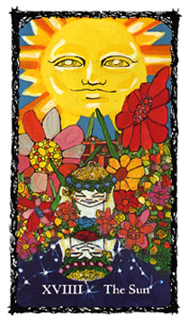
Dear Reader,
The above quote may seem severe for such a joyful and uplifting card. I chose it to reflect on the differences between The Sun and The Devil cards, especially the corrupting of needs into wants and wants into needs. While keeping in mind that we have yet to reach our journey's end, rest assured, you will understand the reason for this choice of text by the time you are finished reading the following section. —J.G.S.

A huge sun dominates a very fertile landscape, as a child reflects into the cosmos its sense of wonderment and joy. The physical and astral realities are made evident via the depiction of the Solar Twins (male and female) which represent humanity in its innocent and receptive form. It is here, within this reflection, that one experiences the combined energies of two of the Sacred Roses: the Blue Rose of the Impossible and the Red Rose of Physical Reality. These reflect upon the quest for the near impossible: needs fulfilled, and the abolition of want, and liberation from the physical and mundane limitations of this world.
A brick wall represents these limitations, but here it only acts as a support for beautiful flowers. The wall is to the background of the Solar Twins, and is all but hidden amongst the abundant flora. This sturdy structure represents reality and the astral "other side" of one's consciousness, a realm of what even¬tually will be experienced as physical death.
Our Solar Twins represent the nature of all dualities. Positive and negative magnetic poles, light and darkness, male and female, etc. No longer representative of two contending forces, the twins are reconciled, at peace and supportive of each other. Representing the cessation of conflict, you are no longer at odds within yourself. They represent: whatever is needed for your sustenance will be provided. Needs, not wants, are the quality of life standards that now rule your psyche. For it is in the translation of these needs into materialistic, covetous and manipulative behavior that we become tainted, our moti¬vations questionable. Recognizing the core of our needs assures attainment of life's greater destiny and future goals. For you are no longer wrapped up in your conflicted patterns (The Moon card) and poor reactions. The key message of this card is for you to value the gift of life as the ancients valued the sun's warmth and energy. And in appreciation of this contented state, sustain and protect the child within. This spiritual dignity is the blessing of things to come.
MEDITATIVE MEANING
"Allow me to know my needs, dispel my wants and be reborn."
DIVINATORY MEANING
Positive Aspect: A solution is at hand, obstacles surmounted, renewal of self. A wonderful liberation from the old. A wish granted.
Negative Aspect: Selfish desires hinder progress, creating insurmountable obstacles. A negative and spoiled, childish attitude will prove detrimental. Insurmountable limitations and obstructions block the way of happiness.
You have recognized your self-destructive tendencies and through this knowledge you are now able to address and fulfill your needs. Does this mean that happiness is assured? Not quite yet, for you must secure these revelations and proceed to the next level of spiritual development.

XX Judgment — Wisdom
"Knowledge is the treasure, but judgment the treasure of a wise man."
—William Penn
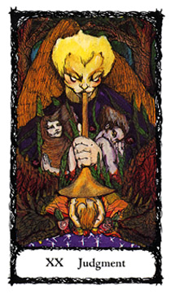

Our solar children have grown and matured in this card of pivotal change. The messenger angel is Gabriel (Hebrew: "God is my strength") who announces a new cycle of being. The angel's message reminds us that preparing for Divine Judgment is of the utmost importance; not doing so will be costly. On either side of the picture is a woman and man (our matured Solar Twins, or our spiritual parents) as represented by Eve and Adam. Whichever guise they may take on, the message is forthright: their time has come to face the music, the consequences of their actions, the summation of their lives. For our Eve, it is a time of resolution, to never repeat a destructive emotional pattern, or to be seduced by the promises of godlike power. For our

Adam, it is a time of facing responsibility for his plans and actions. The child, born to the trumpet's sounding bell, is the fruit of their new consciousness, and benefits from this act of Divine Intervention.
What is in store for these three can only be foretold through past lives and rectification of karma. Our twins have been made aware of their needs. It is with this knowledge, and their actions taken in life, that they will be judged.
The Judgment is the value and virtue received in the course of initiation. The wisdom it provides is of realization that the way of this physical plane is a test, a road of obstacles toward one's spiritual completion and happiness. Everyone is tested.
The Judgment card represents the initiate who is now aware of the various obstacles and tasks, as well as the energy needed to surmount them. These tests are made easier via the gifts this card bestows.
MEDITATIVE MEANING
"I am of this earth and therefore know of my certain mortality. Allow me to be spiritually wise, and bring about my evolution through personal consciousness and the gift of discernment."

DIVINATORY MEANING
positive Aspect: Resurrection. A review or replay of a past inci-dent. An awareness that you've been given a golden opportuni-ty—a second chance, so to speak—to amend your life, to atone for past indiscretions. Wise actions lead to renewal of a project, and success. A pivotal moment to be surmounted. The resolve of a lifetime. A call to serve. A judgment in your favor.
Negative Aspect: Hasty actions and unresolved desires lead to ruin. Death of a project. Failure to recoup energy. A judgment not in your favor...maybe next time.

You have asked for and received the valuable gift of Judgment and the resurrection of potential. You now have the ability not to resent, or react, but to perceive on a totally new level. The path is clear and you will never repeat destructive behavior. What is in store for you now?

XXI The World - The Rebirth of Self
"The world is round and the place which may seem like the end may also be only the beginning." -Ivy Baker Priest
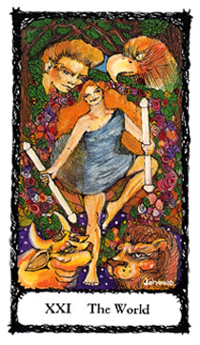

The child (fruit) of Judgment has grown and the alchemical process of transmutation has occurred and matured. You have reconciled the emotional and physical and are now a being of spirit, the seed of cosmic consciousness. This is represented by the figure of a woman dancing, draped in a veil (the veil of The High Priestess?) holding two smooth double-ended phallic wands (first seen in The Magician card). These refined wands represent the four opposing Elemental Powers joined and working in harmony: Fire to Water; Air to Earth.
In each corner are four observers of the dance. The male (human emotion as embodied in physical reality), the eagle (thought and higher communication), the bull (earthly power and stamina), and the lion (fierce courage and honor-able action). These figures represent the Four Elemental Powers in exultation, and in later Christian symbology they were adopted as the symbols for the Four Evangelists of the New Testament. The Trees of Life and Knowledge's branches are now woven into a lattice design, representing the cosmic web of destiny.
Our dancer is surrounded by a fertile wreath, representing fruition and accomplishment. This garland is a metaphor for the passage of one state of being to another: a metaphysical and astral womb and birth canal, the sacred sperm and ovum which leads to reincarnation. The Initiation is complete, the integration of opposing forces is now wedded. The promise of prosperity in mind, body, and spirit may be finally realized.
MEDITATIVE MEANING
"Energy never dies, but is converted. I am energy, therefore I am a universe, everyday reborn"
DIVINATORY MEANING
Positive Aspect: Doorways opening to a new life. Healing. Opportunity. "Birth" of ideas and of opportunities. Well deserved luck. You have passed the test. New cycle of achievement through cosmic and spiritual consciousness.
Negative Aspect: Doorways closing before entering. Aborted projects. Lost or short-lived opportunity that leads to despair. Missed chances for change. Self-destructive actions causing death of opportunities.

The journey is over, yet only beginning. You should give yourself some credit, for it was no easy task. You will begin your spiral cycle again, but now with a little more wisdom. If the Fates allow, what will be dealt to you on your new journey will not be so difficult.
Let us now attempt to study and realize the forces which govern our everyday existence, the mundane world of our physical reality: "The Lesser Mystery," or the Minor Arcana,

Lesson 8 — Introduction to The Lesser Mystery
"Familiar things happen, and mankind does not
bother about them. It requires a very unusual mind
to undertake the analysis of the obvious."
—Alfred North Whitehead
DEFINITION OF THE MINOR ARCANA
The Minor Arcana cards represent our everyday experiences on this earthly plane. Their message is that the drudgery of living one's life is not as trivial as one might expect. These experiences are part of the realm and mechanics of spiritual truth. Life itself is the spiritual vehicle. It is the quality of one's mundane experiences that influences one's development. In brief, it all matters: How you love, work, play, invest your time, effort, and money, and of course, interact with each other.
Comparing the fatalistic nature of the Major Arcana cards, which act as doorways of spiritual initiation, with the Minor Arcana cards of mundane experience, it is beneficial to think of the Minor Arcana as the paving blocks that constitute the road leading to and through the doorways of initiation. Each one of the pavers reminds us that the repercussions and consequences of everyday acts are measured on the astral realm. If one paving stone is faulty or askew, the traveler may trip and be injured, and the journey then becomes more of an ordeal. Therefore, it is the initiate's consciousness of the underlying power of their mundane activities which separates those who are from those who think they are "evolved." One example of this thought is in the New Testament: the humble life and death of a carpenter who sought to change a peoples' experience of their God.
In the Minor Arcana the forces at work are divided into the Four Elemental Powers: Fire, Water, Air and Earth. Each one of the Elemental Powers is given an identifying symbol corresponding to, a card suit: Fire/Wands, Water/Cups, Air/Swords, and Earth/Pentacles.
WANDS
"We take our shape, it is true, within and against that cage of reality
bequeathed us at our birth; and yet it is precisely through our
dependence on this reality that we are most endlessly betrayed."
—James Baldwin
Elemental Fire Power should be viewed as raw, male, phallic energy, untamed and reactive—its quality, direct and projected as the male erection is. The tarot symbol that best describes its power and its use is the Wand. Wands in other tarot decks are sometimes substituted with rods, torches, scepters, or staves.
The element of Fire has historically been very important to a culture's survival. Presently, we take this element for granted. We turn a switch and "fire" appears. Before our modern conveniences, it was the torch, dipped in pitch, that illuminated the night, that kept wild animals away from resting places, and heated the surrounding cold air. It was a means of healing wounds in battle, and it cooked and warmed food. It made tools, as well as weapons, stronger and better. A society needed to keep its sacred fire alive. With this in mind, one can easily relate to the importance of male offspring, because they too, were considered important to the sur¬vival of a society and designated heredity.

Another interpretation is the Wand as a staff. In medieval folklore, the Virgin Mary had many suitors. Confused, she asked God to designate the suitor worthy of being the earthly father of the Christ Child. At a courtship reception, all her suitors attended, each holding a staff (commonly used in negotiating rough terrain). Only one staff flowered in her presence, that of a humble carpenter named Joseph. It is interesting to note that the Wand, being wood, is also the material of the cross and crucifixion. Therefore, in more than one scenario, its nature corresponds to physical sacrifice. The Wand represents the body, sacrifice and action, and in the realm of the mind it is the id, though this energy (when improperly used), could consume and destroy. Fire (Wands) is also a delicate medium and element due to its need for another element to sustain it, namely Air. The Red Rose Mandala belongs to the suit of Fire/Wands. Therefore, Wands are symbolic of our physical reality.

CUPS
"The heart is forever inexperienced."
—Henry David Thoreau

The suit of Cups should be viewed as the receiver of energy, feminine and receptive. The liquid (Water) that is contained in the Cups represents the emotions. Cups are vessels. Vessels can take many forms as a container. Its purpose is to safely encompass a cargo. The womb and the coffin are forms of vessels. Water, being fluid, can lose its effectiveness if not contained or controlled. This suit represents the control or containment of the emotional, intuitive, spiritual, and subconscious energies. The White Rose Mandala belongs to the suit of Cups, representing our emotional reality.

SWORDS
"The mind is its own place, and in itself
Can make a heaven of hell, a hell of heaven."
—Milton

Swords are weapons, or tools. They are representative of the double-edged weapon of the mind, and therefore bisexual in nature. Air, in its ethereal nature, is the vehicle of communication, analysis, and ultimately dissection. It is, at best, the informative mind in its rational and productive nature. It is also a harsh suit of logic which tells of the toughening process necessary to fashion molten metal into a functional form. As an Elemental Power symbol, Air is elusive: it needs other elements to complement it in order for it to attain tangible results.
This suit represents the intellect, fantasy, the impossible dream, thought, and the superego. The Blue Rose Mandala belongs to the suit of Swords, representing our mental reality.
PENTACLES
"By their fruits ye shall know them."
—Matthew 7:20
Pentacles are disks or coins, and because of their shape and structure they can be considered a form of mandala. This suit is of Earth and one of integration of energies, fruition, and ful-fillment. It is the tangible outcome and grounded result of all suits combined. Pentacles govern the material and in the realm of the mind, the ego. The Gold Rose Mandala belongs to the suit of Pentacles, representing our tangible and earthly reality of absolute achievement such as reaching a goal (and not to be confused with the suit of Wands).

MINOR ARCANA
THE ACES - BEGINNINGS
"Men perish because they cannot join
the beginning with the end."
—Alcmaeon
The Aces are solar (solo) energy and are ruled by the planetary and godform energy of the Sun. They influence individual life aspects of adventure and enterprise. Great in force, these cards allow and tell of a new perspective in one's life and can be considered along with the Major Arcana as doorways into a new beginning.

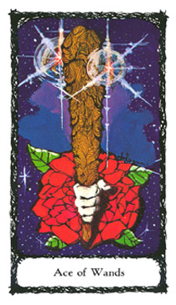
Ace of Wands
Physical Renewal
An emblazoned Wand juts out of the center of a red rose, surrounded by the primal fire of creation. It is held by a strong male hand. This card's image is an interpretation of the first letter of the Tetragrammaton—the Hebrew codified name of the godhead—Yod `I (Hand). It represents the aspect of the godhead as the creator of the heavens and the earth. Its power represents physical presence and activity, potency, leadership and natural law.
DIVINATORY MEANING
Positive Aspect: New venture, energy and conquest, creative flow via routing of sexual energy. Obstacles removed. Recoup forces and charge ahead with a more creative approach. Physical sacrifice will pay off. Challenges met, physical change for the better.
Negative Aspect: Consequences of actions. Be watchful of anger (own or others') and direction of this energy. Haste makes waste. Onset of an illness; especially of concern—the reproductive system. Untimely, violent death; accident.

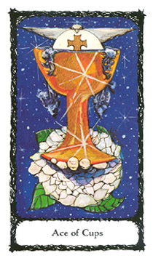
Ace of Cups
Emotional Renewal
A hand gently supports a chalice as it issues forward from the center of a white rose. It offers spiritual fulfillment, peace, and a gift of emotional renewal. A perpetual overflowing of life-sustaining Water brings a messianic blessing. It is the symbology of Divine Inspiration and blessing as the dove, chalice, and Eucharist are offered to the seeker. The Ace of Cups is representative of the second letter in the Tetragrammaton—Heh ri (Window), and signifies the aspect of the godhead as manifested through emotional perception, and intuition. It is the container or holder of prophecy, a portent of spiritual renewal.
DIVINATORY MEANING
Positive Aspect: Intuitive insight, emotional renewal. The heal¬ing heart of the matter made evident. Nurturing and sustenance in order to begin again. The loving mother's womb.
Negative Aspect: Grief, depression, death (from heart attack, pulmonary complications, lymphatic or blood-borne diseases). The vessel is a coffin.
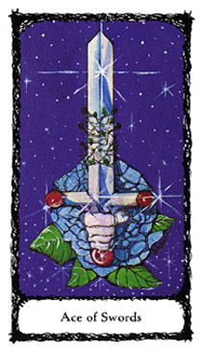
Ace of Swords
Mental Renewal
A hand gripping the hilt of a double-edged sword juts forth from the center of a blue rose. It challenges the seeker to grasp it and do battle. Three rubies adorn the sword's hilt (the birth¬stone of the astrological sign of Leo, it is also the warrior's stone, reputed to warn the wearer of danger). These stones form the shape of an inverted triangle (the alchemical symbol for Water) representing how we, in our frailty, confuse and diminish rationality and logic, and its inherent power, with our emotional conflicts. The cutting edge of the sword is hindered by an additional growth of thorns, nature's own sharp objects of defense. The universe's message: "Take the sword if you dare." This is no easy task, for the sword must be rid of its entwining thorns to be of any use.
The Ace of Swords is attributed to the third letter of the Tetragrammaton—Vau (Nail or Hook). It is the forces of the godhead that demand the use of the tools of sacrifice (as the nails and a spear were used in the crucifixion, and knives for circumcisions).
DIVINATORY MEANING
Positive Aspect: Trial and tribulation bring about a new outlook. Survival of the fittest, separation or dissection from unbeneficial influences. Awareness. Constructive criticism. A well-thought out plan. Cutting away of ties that bind.
Negative Aspect: Stubbornness, prejudice, and stagnation. A no-win, situation; options denied. Anxiety, mental or communicative breakdown. Murder, death by attack or surgery. Mental problems, illness of the spinal column or nerves.

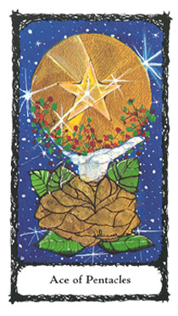
Ace of Pentacles
Tangible Renewal
An open hand gently supports an offering of a gold coin pentacle. This gift issues forth from the center of a gold rose. The pentacle is surrounded by symbols of the Earth and fruition (plant life and berries). Achievement and its reward bring you to a new and higher level of completion. Results are tangible and material in nature.
The Ace of Pentacles is representative of the final letter of the Tetragrammaton—Heh Ì (Window). It signifies the godhead in its worldly feminine aspect, the Earth Mother, or "the Shekinah," literally, "The Dwelling," in Hebrew. It is the earthly
reflection and human perception of godly power as nature.
DIVINATORY MEANING
Positive Aspect: Material and substantive beginnings. Recognition from your peers and those held in your esteem. Financial reward. Totally new cycle based on integration of body, spirit, and mind (Fire, Water, Air) grounded by Earth.

Negative Aspect: Resources needed to achieve success denied.
Resentment leads to failure. Caution, do not take risks, do not
trust the counsel or actions of others, including friends and family. Life at loose ends, poverty, unable to get one's act together. Disease or illness of the digestive system.

THE DEUCES - PARTNERSHIPS
"Can two walk together, except they be agreed?"
Amos 3:3

As the Aces are ruled by the Sun, the four Twos are ruled by the female godform as symbolized by the Moon and its changeable nature. As illustrated, all four suits have male and female figures, the nature of each partnership representative of that between each Elemental Power and its solar and lunar principles. The objective: the interaction and the blending of these energies. As with all partnerships there are forces and dynamics at work, some comforting, others challenging. Whether the partnership is empathic, sympathetic, parasitic, or symbiotic in character is a value judgment. In brief, you cannot have a sadist unless there is a masochist close by.
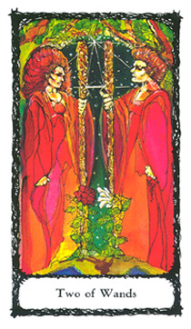
Two of Wands
Partnerships of Fire/Dominion
Proud and powerful, a female and a male figure confront each other. Clad in red robes, they hold firmly onto their Wands. They seem to be facing off as if preparing for battle. Both are exerting control over themselves as symbolized by their demeanor and the strength each exudes. Whether they have dominion over each other is another matter. At their feet flowers are growing, indicating complimentary, but opposing natures. The red rose of the female figure represents the reality of her physical nature such as her passions, monthly cycle, and child bearing. The white lily of the male denotes his spiritual potential. What type of partnership is this? Dynamic and charged with sexual energy. To summarize: "Who's on top?"
DIVINATORY MEANING
Positive Aspect: Physical partnerships, sometimes with sexual overtones, but always aggressive and competitive in nature. Power over one's self will result in power over the other party. Strength is needed and indicated. Confrontation leads to positive result.
Negative Aspect: Caution. Retreat to safety. Anger, leading to aggression and the potential to harm. Battering. Sexual harassment. Physical obsession.
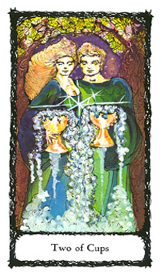
Two of Cups
Partnerships of Water/Love
A female and a male figure are standing side by side. Each holds an overflowing cup. Facing forward, the figures assert the power of their emotional and spiritual alliance. They have recognized in each other a spiritual projection of themselves. This emotional projection can take on different forms, such as friendship between two people of opposite or same sex, brotherhood or sisterhood. Therefore, this card does not connote an overtly sexual nature, but an emotional dependency. As with all emotional projections and partnerships, these figures have their dependence, and when not satisfied, they can be cruel and jealous.
DIVINATORY MEANING
Positive Aspect: Fulfilling, emotional ties. Cooperation, understanding, and good intentions, as long as the projection lasts. Emotional and spiritual commitment.
Negative Aspect: Short-lived enthusiasm for a person, place, or thing. Troubled relationships. Expectations shattered; jealousy, cruelty.
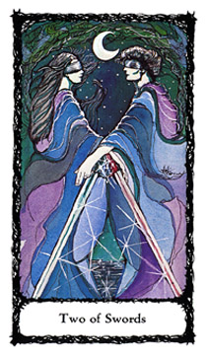
Two of Swords
Partnerships of Air/Peace Restored
Two blindfolded figures dressed in flowing robes proudly face each other in the moonlight. Their swords in repose, the male figure's resting left hand forms a sign of benediction. Is his peace offering and blessing sincere? In the background a calm sea and a cool refreshing breeze envelop the figures. At the present time our couple have their eyes shielded from the reality of their prejudices. An understanding has developed and differences are accepted, not challenged. Though wary of possible conflict, both parties are willing to work things out.
DIVINATORY MEANING
Positive Aspect: Resolution after conflict, contracts and mental agreements, communicative partnerships. Understanding of conflicting influences. Reconciliation. Renewed trust.
Negative Aspect: Unresolved emotions and prejudices will ruin any compromise or understanding. Distrust, suspicion. Do not sign on the dotted line until you read the fine print. Caveat emptor.

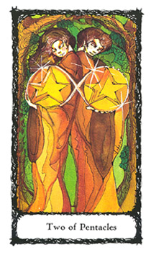
Two of Pentacles
Partnerships of Earth/Harmony
A woman and a man lean backward and toward each other in mutual support. They face outward, looking over their shoulders. Each holds and presents to the viewer his and her own Pentacle, symbols of integrated individuality. The landscape is drenched in golden hues of brown and citrine. The pentacles are uniquely connected through a flow of golden amber energy. This energy forms the symbol of beneficial exchange, the double nimbus. Our figures are in resonant harmony within themselves, each other, and the world.
DIVINATORY MEANING
Positive Aspect: Efforts are supported, partnerships fruitful. Individuality is respected and cultivated. Each party has its own unique gift to bring. Reliance. Powerful alliances.
Negative Aspect: Discord through stubbornness. Difficulty in handling challenges. Sabotage of projects, undermining of efforts. An undependable alliance, deception.

THE THREES - ENDEAVORS
"When we do the best we can, we never know what
miracle is wrought in our life, or in the life of another."
—Helen Keller

The Threes are ruled by the planet and energy of the ancient godform, Mercury, which rules communication, commerce, business, and travel. Reactive in nature, Mercury is always in a state of flux and reflux. It cannot be held to follow through in a steady, non-reactive course of action. It dances to a different drummer and many times is its own musician.
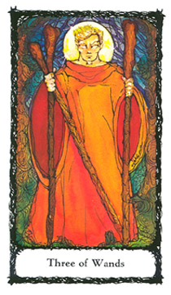
Three of Wands
Endeavors of Fire/Established Strength
A man stands firmly and majestically. He is haloed, therefore blessed or divinely inspired. He appears to be holding three Wands. The two Wands positioned near his right hand are tentatively supported. In fact, only one of the two is truly held, the other is balanced across his forearm near the wrist, and crosses him diagonally. If he were to move, he would loose the third Wand. He represents courage and the physical conquering of one's fear. He strives forward though all may not be in place; things might be tentative in nature. Through curbing his fears and worry, he evokes newly found strength, demonstrating fortitude when facing turmoil.
DIVINATORY MEANING
Positive Aspect: Stronghold on fears. Courage brings about desired result. Necessary to show a strong physical presence and required endurance. "Facing the music."
Negative Aspect: Fear, anxiety, cowardice and procrastination. Overwhelming circumstances take a physical toll. Sacrifice required to overcome obstacles. Are you up to it?

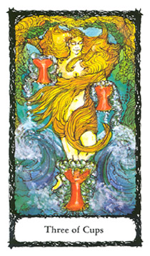
Three of Cups
Endeavors of Water/Abundance
A nude woman dances through a wave of emotional energy, her golden hair abundant and flowing. As the ocean's waves part for her dance, she shows no sign of fear; she and the sea are one in the same. In each hand she holds an overflowing Cup, representing gifts for the asking. At her feet is another Cup, overflowing and unjostled by the surrounding activity. Joyful emotions and creativity prevails.
DIVINATORY MEANING
Positive Aspect: Emotional endeavors rewarded. Heights in creativity and recognition of talents. An auspicious card for the artist, creative individual, or project.
Negative Aspect: Emotional upheaval. Uncontrolled passions can lead to project's ruin. Do not show your emotions to others; they will use them to destroy you. Delayed gratification.

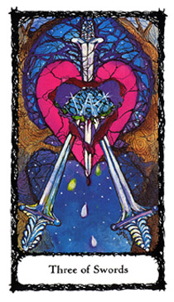
Three of Swords
Endeavors of Air/Sorrow
A heart is pierced and dissected before the reader. In its open wound is the Blue Rose of the Impossible. Droplets of blood stream as nectar from the wounds. The background is barren, except for a fine network of spiders' web-like branches. These branches entangle the heart, rose, and swords in a web of intrigue and unproductive patterns. This card tells of intense suffering and hurt from circumstances that are out of one's control.
DIVINATORY MEANING
Positive Aspect: Well-meant communications go unheeded, or are stymied, leading to death of a situation or project—it's not your fault. Expressions of rejection are finally accepted, and subsequent wounds are healed. It is over; suffer no more. "Time heals all wounds." Creativity is blocked until expression of grief occurs.
Negative Aspect: Devastating thoughts and the expression of mourning. Confusion, sacrifice with little or no reward. Tears, depression and morbidity. "Mea culpa." News of a death, serious accident, or illness.

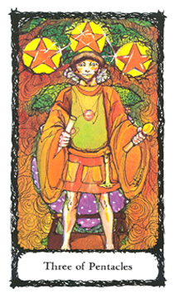
Three of Pentacles
Endeavors of Earth/Work
A strong young man stands proudly before you, holding the tools of his trade. He is a craftsman and has completed a project as displayed within the framework of the trees' branches. Three pentacles have been formed and are glistening overhead. He has successfully utilized his surrounding conditions to craft, and benefit himself and others. His endeavors are evident, and have come to fruition as he awaits eagerly for your approval of his work.
DIVINATORY MEANING
Positive Aspect: Careful planning, diligence, and proper acumen lead to success. The success of the project is in the cunning and craft of its initiator. Work and career are on the upswing. Depending upon other surrounding cards, news of a marriage or rewarding partnership.
Negative Aspect: Carelessness leads to failure. Mediocrity. Scattered and useless expenditure of energy. Separation or denial of potential rewards. Unrecognized efforts. Loss of acumen.

THE FOURS - FOUNDATIONS
"There is no fruit which is not bitter before it is ripe."
—Publilius Syrus

The Fours represent structure; its most important feature is that of a support system or foundation. Ruled by the beneficent and expansive planet and godform, Jupiter, the Fours first present us with the challenge of proving our worth by how we set the groundwork. It is well established that nothing can stand or weather turmoil better than a structure or project built on a good foundation. The task of building a solid foundation is hard work. It requires discipline, sweat, sacrifice, and responsibility. Ask any architect or laborer and he or she will tell you—there is only one way of doing a job, and that is the right way.
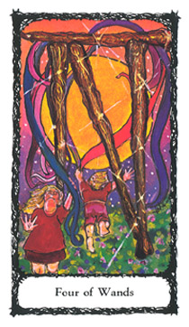
Four of Wands
Foundations of Fire/Perfected Work
Two children, a girl and boy, play joyfully in a field. The landscape is energized by the sun's light. Their Maypole is made up of four Wands from which various colored ribbons stream forth. Each one of the four Wands braces itself against the other. The structure is strong. This card represents physical and expressed sexual energy. It is passion well utilized such as that found in the support system of a family and happy home. The products of this foundation are children (projects), family (friends), and home (self). The work of elevating the root (sexual) energy into its higher spiritual expression is perfected.
DIVINATORY MEANING
Positive Aspect: You are off to a good start; project(s) will be fruitful. A joyous, shared experience with those you love will be realized. A new foundation is yours to build upon. A happy home is in the offing.
Negative Aspect: Weakened foundation; a structure is threatened. Energies are not being properly utilized. Physical obstacles. Discord within family and home.

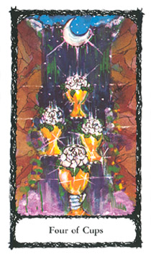
Four of Cups
Foundations of Water/Blended Pleasure
A moonlit waterfall fills four Cups. Three of the four rest on open palms, and the fourth Cup is grasped; all of the Cups issue forth from the waterfall's stream of energy. The setting is dire, dim, and foreboding. The waterfall's energy cannot be contained; it is so strong that it creates a cloudy mist at its base and seems to draw in and engulf the sky's moon. All of the Cups can no longer retain their liquid contents, now displaced by four White Roses of purity.
This card identifies foundations based on emotions, which can only be made strong and worthy if kept pure and untainted by excess. It represents the unceasing quality of emotional extremes, and how they must be held in check, lest the structure's foundation will fail.
DIVINATORY MEANING
Positive Aspect: Muddled emotions must be worked out before proceeding. Be cautious of any emotional involvement, or being lured into any intrigue. Overindulgences in food, drink, drugs, or emotional situations are to be recognized and dealt with as destructive expressions. This card is a warning of illness; the emotional will soon manifest in the physical.
Negative Aspect: Feelings of foreboding and nightmarish consequences are correct. Get yourself to a doctor, fast! Too late for a change in attitude; the damage is done. Emergency measures must be put into force. Refuse to base life decisions on fickle desires.
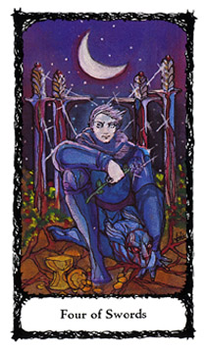
Four of Swords
Foundations of Air/Rest from Strife
A crescent moon shines above a handsome soldier. At his feet is his warrior's blood-streaked mask and its horrible visage. Two cups are at his feet: one whole, the other shattered. His left hand—receptive of energy—is still shielded; his right hand—disbursement of energy—is bare, except for its gentle holding of the Blue Rose of the Impossible. Behind the soldier are four bloodied Swords staked into the ground. Though he must always be prepared for the inevitable battle, the struggle is now over. It is now time to reflect.
DIVINATORY MEANING
Positive Aspect: Worries are laid to rest. Conflicts are resolved, but for a price. Your strength evolves from experiencing the extremes; build upon this knowledge. Healing brings about enlightenment.
Negative Aspect: Little resolve or peace. Continued activity, exhaustion, and confusion. Illness due to worry. Paranoia.

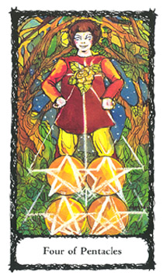
Four of Pentacles
Foundations of Earth/Earthly Powers
A youth proudly claims his turf as he plays "King of the Mountain" atop four Pentacles. He wears the emblem of the Gold Rose of Absolute Achievement. The rays that shine from the four Pentacles and reflect onto his garment's embroidered gold rose create the alchemical symbol for Fire: an upright triangle. This card signifies material, tangible, foundations and accomplishments.
DIVINATORY MEANING
Positive Aspect: Status, obtainment, and initial acceptance
which can be further developed. Entrepreneurial activities
meet with success.
Negative Aspect: Selfishness, leading to failure. Unwise handling of funds. Obtainment is short-lived. A humbling experience.

THE FIVES - MOTIVATIONS
"The Light of Lights/
Looks always on the motive, not the deed,/
The Shadow of Shadows on the deed alone."
—William Butler Yeats

Ruled by the planet and godform, Mars, the Fives are action-oriented, and indicate the true agenda of the subject or situation. They represent motivation, the underlying nature and inspiration of an action. The Fives are the proverbial road of good intentions, which may truly lead to hell.
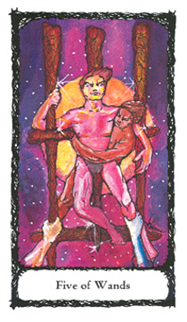
Five of Wands
Motivations of Fire/Strife
A struggle ensues as a man grasps for support while others attempt to wrest him from his position. His concentration is steadfast, and cannot be diverted by any one of the opposing and competitive adversaries. He remains focused on holding his ground. The sun shines brightly on our contender, for he needs all the help he can get, as other alien hands are aiding the opposition.
DIVINATORY MEANING
Positive Aspect: A competitive person or situation. Power struggle, ordeal, and test of endurance. Do not get caught up in the rivalries of others.
Negative Aspect: A lover of confrontation, a troublemaker. Intrigue, and instigation—at your expense. Examination of the motives of self and others; all is not what it seems.

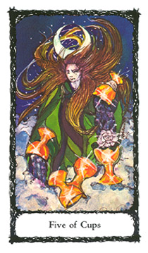
Five of Cups
Motivation of Water/Loss of Pleasure
A crescent moon seems to crown our female figure. She gazes forlornly into the distance. Her abundant hair is tangled and wind-tossed as it merges with the Moon's reflection. Her attire is a green robe, signifying a fertile and potentially productive life, but her actions and surroundings tell otherwise. She is a participating member of her own dissatisfaction as she is surrounded by emotional conflicts represented by the turbulent sea. She holds two Cups and spills their contents into the sea, as two other Cups are emptied of their precious contents by the waves' tossing. Only one surviving Cup holds a promising, blossoming White Rose. Hopefully, she will notice and salvage it before the waves' unrelenting actions spill its precious contents.
DIVINATORY MEANING
Positive Aspect: Prevailing negativity, ennui, and disdain for efforts. Loss of enthusiasm. Underlying, and in some cases, obvious depression. Confusion, and loss of emotional fulfillment. A motive is discovered, and a cure is at hand. Courage, reunion, and peace. All is not lost; actions need to be taken in order to bring about resolve.
Negative Aspect: Uncontrolled emotional upheaval. Attempting to shield oneself from hurt through denial. Constructive expressions of anger are stifled, eventually converting into tears and despair.
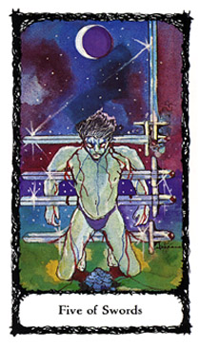
Five of Swords
Motivations of Air/Defeat
The atmosphere is dire and foreboding. A storm is brewing with the oppressively humid and close atmosphere that clings to one's skin before the sky opens up and crashes about you. Overhead, the moon is undergoing an eclipse as it shines its last bit of light on a kneeling, bloodied male figure. His gaze is fixed upon the Blue Rose of the Impossible lying in a pool of his blood. His blood streams before him; he is reminded of his first moments of anguish as four Swords cut into his body. These are the tools of his torture and destruction. A single and fifth Sword is mercifully raised, readying for the coup de grâce.
DIVINATORY MEANING
Positive Aspect: Cruelty and heinous actions abound, better to do unto others before they do unto you. The only means of survival is heeding impressions of justifiable suspicion. Forewarned is forearmed. Injury to head or teeth, medical operation or procedure. A violation of one's body, a robbery, mugging, rape, burglary, or theft. The survival of self and dignity, despite such actions.
Negative Aspect: A trip to the executioner's block. Theft, rape, accident, injury. Sacrifice beyond the call of duty. Victimization, imprint of the heinous act on one's psyche.
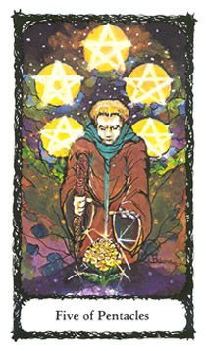
Five of Pentacles
Motivations of Earth/Material Trouble
A man dressed in beggar's garb kneels in adoration before the Gold Rose of Absolute Achievement; he is attempting to reach for its bounty. The landscape is bleak except for a constellation of five Pentacles which shine above. They are the promise of potential success.
Our beggar's only means of support is the Wand he is holding in his right hand, representing his active, though weak, physical support system. He must be cautious, for he is dependent on this wand to keep his balance and feet on terra firma as he reaches into the cosmos for the prized Gold Rose. Caution is primary, for his reach could fail and have him tumble head first into the awaiting abyss.
DIVINATORY MEANING
Positive Aspect: Lack of funds or money. The gift and objective are evident; all that is needed is to get one's act together. Keeping your eye on the prize, constructive use of discipline, and recognition of responsibilities are tools to bring about desired results.
Negative Aspect: Laziness, unreal expectations, daydreaming. Insufficient funds. Get thee to a therapist, and get thy act together.

THE SIXES - ADJUSTMENTS
"Every new adjustment is a crisis in self-esteem."
—Eric Hoffer

Ruled by the planet and godform, Venus. The four Sixes represent difficult, but necessary adaptations we must make in our everyday lives. Adjustments belong to Venus, the ruler of beauty and harmony, a gift of balance many times taken for granted. In life, we are required to make an adjustment (however slight it may be) in order to realize the gifts of balance and harmony in whatever shape or form they may take. This task, at times, is too difficult to perform; success requires changes in our preconceptions and prejudices.
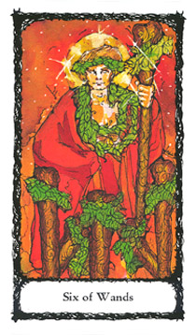
Six of Wands
Adjustments of Fire/Victory
A fair-haired male figure stands elevated above a crowd. The sun shines about him, encompassing him in an aura of glory. He is dressed in a robe that hides his right hand—disbursement of energy—the one scarred in battle. His left hand—receptive of energy—holds a tall Wand decorated with a garland. Our hero is also wearing garlands of honor upon his head and neck. He has accomplished a great task and is being recognized for it. He now has to live up to the responsibility of being worthy of the honors bestowed upon him.
This card's message is of conduct becoming and being worthy of office. One must make an adjustment in order to be victorious and embody the necessary, subsequent behavior to maintain the victory.
DIVINATORY MEANING
Positive Aspect: Adaptability to changes and requirements lead to a job well done. Recognition of efforts. Honors, glory and title. Exhilaration.
Negative Aspect: Fleeting glory, false pride. Arrogance and sacrifice with very little or no reward. Fraud, trickery. The proverbial "fifteen minutes of fame"; a lifetime of desire. In short—hubris.

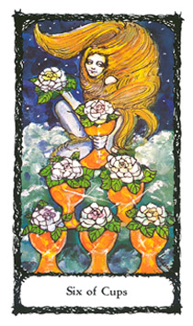
Six of Cups
Adjustments of Water/Pleasure
A young female figure rides the crest of a wave. Her long golden hair is wind-blown and abundant. Six Cups before her are filled with White Roses of Purity, forming an upright, triangular shape. It is the symbol of fire and masculine energy, signifying a strong physical presence within the card's emotional context.
It is the resource of true pleasure existing not only on the emotional plane, but co-existing and mutually satisfying on the physical. Comfortable in both aspects, she invites you to join in her pleasure as she holds an additional rose as a possible reward.
DIVINATORY MEANING
Positive Aspect: Dreams and their offerings are presented. You are required to make the necessary, emotional adjustments in order to fulfill them. Realization of what is truly pleasurable in one's life.
Negative Aspect: Clinging to worn and old emotional ties. Denial; cynical and hardened attitude. The child within is a brat. Grow up!
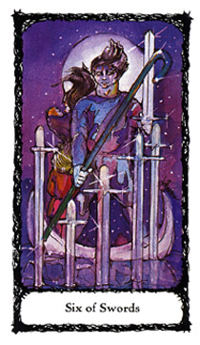
Six of Swords
Adjustments of Air/Earned Success
A family is journeying across a calm sea. At the helm is a man who is prepared for whatever conflicts he may face. He navigates his life away from former tenets, as represented by the five Swords arising from the water's depths. In his right hand he holds a shepherd's crook (last seen in The Hermit card—the seeker of truth). In his left hand he holds an upright Sword, ready to defend his new-found beliefs. His companion and their children look toward the horizon and upon their future.
This card represents the power of intellectual adjustments, resulting in a purposeful change in the path to success. It is a card of changes in consciousness and its subsequent actions.
DIVINATORY MEANING
Positive Aspect: Success, due to changes and adjustments of thought. A journey of the mind, leading to a new horizon. Relocation of self, home, or business.
Negative Aspect: Confessions, declarations that shock. Stubbornness, stagnation, ill will, and the results from these factors. Inability to move forward in one's life, or in a project.

Six of Pentacles
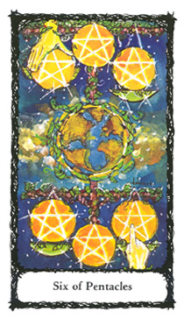
Adjustments of Earth/Material Success
Two hands of great power adjust the position and balance of six Pentacles. The upper hand places a Pentacle upon a scale's pan, while the lower hand gently adjusts the placement of another Pentacle. Both are right hands—disbursement of energies—belonging to two different or separate forces. In the center of this reality is our world, the Earth. This card is of beneficent fortune and charity. It also speaks of the subsequent adjustment that must be made by the receiver of these gifts, lest they offend the two aspects of balance and destiny at work.
DIVINATORY MEANING
Positive Aspect: Opportunity through charity, generosity, or gifts. Luck and shared prosperity. Answered prayers. Negative Aspect: Bribes leading to failure. Harassment. Failure to appreciate, and go with offered opportunities. Pay back—the required "pound of flesh."
THE SEVENS - LESSONS
"Life is a succession of lessons which
must be learned to be understood."
—Ralph Waldo Emerson

Now we come to the force that represents a major belief in most metaphysical studies: karma. We will study the concept as it pertains to lessons and what your spirit must learn in order to evolve. The lessons are ruled by the harsh, and stern teacher, the planet and godform, Saturn; which reminds us, as students we are faced with certain grim realities that only we can address and rectify.
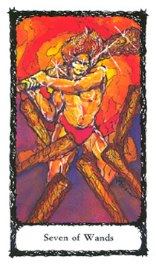
Seven of Wands
Lessons of Fire/Valor
A male figure stands boldly, swinging a Wand to fight off opposing forces. The atmosphere is charged with physical power and prowess. The sun's blazing light in the background seems to erupt into a blast of energy that encompasses our hero. His strong body glistens, and his hair stands upright from the force of the action he has taken. This card's lesson is in actively defending one's beliefs, value system, and integrity. It is a test of stamina and courage, the experience of resolutely facing hardship and danger in defending a belief.
DIVINATORY MEANING
Positive Aspect: A physical trial and test of one's stamina. Be prepared to defend yourself and take necessary action. Benefits resulting from facing and displaying the qualities of valor and courage.
Negative Aspect: Cowardice, anxiety, and refusal to confront leads to failure. A step backward, disappointment, regret in actions taken.

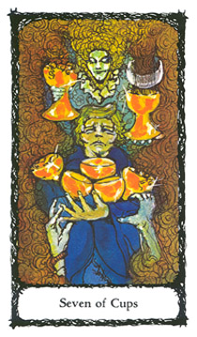
Seven of Cups
Lessons of Water/Illusory Success
A young man in turmoil attempts to hold onto the bounty in his arms; a look of confusion and panic is on his face. A stoic looking woman hovers directly overhead. Displaying her two other faces (aspects)—a scornful one to her right, and a second one of a haggard old lady, to her left—she represents the feminine aspect of the godhead in its harshest form. A smokescreen eminates from the Cup nearest the scornful face while a cresent moon rises out of the Cup nearest the haggard old lady. The stoic faced woman observes our young man with an air of seemingly unemotional, almost amused disdain. In his panic, the young man is attempting to hold onto whatever Cups he can. He tries to salvage five Cups, but two strong hands attempt to undermine his grasp. He has nowhere to turn for help, not even to the forces of the universe.
A card of emotional upheaval teaches the lesson of discernment: what is of value, and what is not. Mixed messages abound from the self as well as from others. Fantasy and emotional investments are subject to question. A test of one's faith and emotional strength may be in order.
DIVINATORY MEANING
Positive Aspect: Hard emotional lessons, when faced and dealt with responsibly, will be diminished. Be prepared to see life through not so rose-colored glasses. Get rid of emotionally draining entanglements.
Negative Aspect: Emotional indulgence and confusion, destructive delusions, wishful thinking, leading to overcompensation and denial. Get your head out of the clouds. Get real!
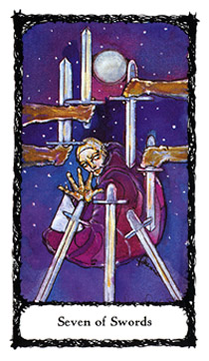
Seven of Swords
Lessons of Air/Unstable Effort
Holding a dunce cap, a clown-like character sits before seven Swords. He is slumped over and very unlike the heroic figures found in other cards; his gesture is confusing to the observer. Is he reaching for the Swords or refusing to take them? Overhead, the shining full moon denotes these fluctuations of the sub¬ject's energies. The Swords before him shine in the casting light. The two upright Swords denote courage and honor; the two handheld, downward Swords denote disapproval and disgrace. He is offered three additional Swords, their purpose yet to be determined. What will he do? His ability to follow through is in question.
This is a card of mindful lessons of intellect and thought processes. One's logic and rational thinking are tested. This card represents communication of ambitions without follow-through in actions, or "lip service." Well-meaning thoughts and talk pave the way to nowhere.
DIVINATORY MEANING
Positive Aspect: Lessons in communication. Recognition of self-sabotage because of unfounded fears, and short circuits in communications. The "what if " syndrome. Only one course to be taken—just do it.
Negative Aspect: Mind games. Lies, thievery, and deceit. Rationalization and justification of harmful acts. The classic behavior and deception of the addict. Dreams and potentials unfulfilled, laziness, fear, and paranoia. A carrousel ride to nowhere—going around in circles.

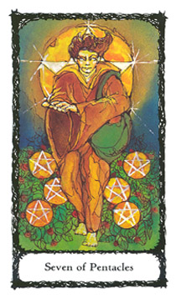
Seven of Pentacles
Lessons of Earth/Success Unfulfilled
Our fourth and final Saturnian card offers the tangible, realitybased and nonesoteric lesson of care and nurturing. Our picture is one of a barefoot young man, a farmer scattering the seeds for his subsequent harvest in the blazing sun. He shows no pain from the heated earth against his bare feet, and the green sack he carries must hold some form of sustenance other than the seeds he is scattering. No water is in sight, and one can only wonder about the outcome of his labors. By sheer luck, some seeds have born fruit, but even a stoke of luck is at best short-lived if not nurtured.
This card represents a test of planning and the ability to nurture what is of value in one's life.
DIVINATORY MEANING
Positive Aspect: Hard work and care are required. Project's success will be dependent on additional efforts and harder work. You may be forced to go back to the drawing board, dismantle, and start fresh in order to obtain desired results.
Negative Aspect: Anxiety over transactions due to lack of proper planning and care. Failure of efforts. Resources dried up due to halfhearted actions or lack of caring.

Dear Reader,
We have defined the mundane experiences of cards Ace through Seven (Beginnings, Partnerships, Endeavors, Foundations, Motivations, Adjustments and Lessons). In the next series of cards, Eight through Ten, we hope to realize the mundane as divine, the ever-present influence of spirituality expressed through our everyday lives. No longer are we to look upon life's drudgeries as punishment, but as opportunity. —J. G.S.

THE EIGHTS - REGENERATION
"He who would learn to fly one day must
first learn to stand and walk and run and climb
and dance; one cannot fly into flying."
—Nietzsche

In the numeral eight we see the unique visual characteristic of the symbol of regeneration, the double nimbus, a visual representation of the constant ebb and flow of energy through a momentary conjunction. As with the twisted length of cord in the child's game of cat's cradle, I like to think of the figure eight (or its metaphysical counterpart, the double nimbus) as a circle, the symbol of completion. But, its form (not function) is manipulated for a purpose, even though the circle is still there. Another viewpoint is that our figure eight/double nimbus is in a three-dimensional form called a Möbius strip, a manipulative mathematical construct which demonstrates the ability to travel on a continuous line covering both sides of the once two-dimensional plane.
The four Eights are our mundane and worldly experiences of regeneration. Spiritual inspiration taking hold and becoming matter, and continuously evolving into various stages of development. In brief, the minute degrees of separation lead to endless possibilities. Because of this correspondence, the Eights belong to the domain of such energies as our planet Earth, and the multiple god-forms that represent the regenerative process.
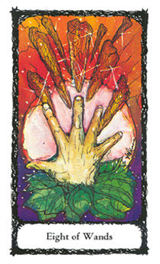
Eight of Wands
Regeneration of Fire/Swiftness
As the universe is ablaze with a burst of cosmic energy, a hand juts outward as if blossoming forth from a base of green leaves. We see a planetary form in the background. Is it the sun or moon, or is it both? Or the birth of a supernova (a star whose energy output is 100 million times greater than the sun's)? From these energies eight Wands are projected forward and outward, and seek an unknown destination, representing active, and somewhat unexpected occurrences. Positive aspects surface with associated negative obligations, resulting in sudden renewal. This regeneration of Fire and its explosion of passion and emotions is compared to an atom bomb going off in one's life. The physical presence of an adventure that will take you to a new realm of existence, e.g., a love affair, sudden marriage or opportunity.
DIVINATORY MEANING
Positive Aspect: Clear the roadway for a sudden change. A revolution in life style or approaching exciting occurrences. Adrenaline rush and excitement. Pace yourself and seek balance. Overall, there will be a positive end result, though there will be some adjustment of temperament. Possible love affair leading to marriage.
Negative Aspect: Circumstances leading to violence. Divorce or sudden unsettling news. Sudden and consuming events destroy. Will the Phoenix arise from the ashes?
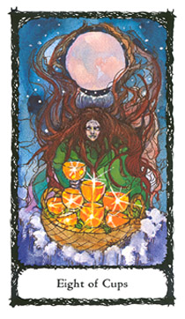
Eight of Cups
Regeneration of Water/Abandoned Success
IA disheveled and anxiety-riddled woman is seeking solace, yet experiencing little comfort for the sacrifice she is making—placing her beloved Cups into a basket, allowing the turbulent sea to claim the bounty for itself. Her life seemingly over, her emotions overwrought, she must make a sacrifice in order to regain her emotional well-being or at least a détente. This card tells of disappointment, or dissatisfaction over once favorable
and valued associations. It represents the need to abandon, or to free oneself from emotional ties. It could mean great disap¬pointment with children, or the disappointing outcome of an emotional investment.
DIVINATORY MEANING
Positive Aspect: Time to "let go and let God." Such action, though extremely difficult, will bring about a resolution.
Negative Aspect: Look out for your own survival. No hope for an amiable solution; one must accept the inevitable, walk away and never look back. You may as well face it...your inner child is an "orphan in a storm."
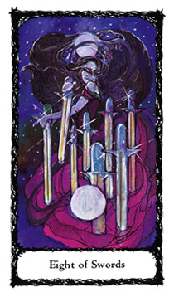
Eight of Swords
Regeneration of Air/Shortened Force
A woman, her vision obstructed by her wind-tossed hair, stands amid six Swords piercing her gown. In her hands are two Swords; above and below are two full moons reflecting opposing emotional forces. Her actions are not clear. Is she releasing herself from the Swords' grasp, or pinning and securing additional Swords into her garb?
Emotional conflict brings about stifled thought processes. Logic struggles to exist in an atmosphere of emotional turmoil; foresight is blinded when it reacts to the demands of self-limiting emotions. The only route to survival is the road to clear and logical analysis. This card may indicate the need for the indi¬vidual to seek counseling or psychiatric help.
DIVINATORY MEANING
Positive Aspect: A release from old, destructive thought patterns. New ways of thinking, and eventual actions will bring about desired results. Freedom. Breaking new ground.
Negative Aspect: Self-limitation, imprisonment, censure of anything that may possibly break new ground. Seek help; you're on the road to losing your sanity.

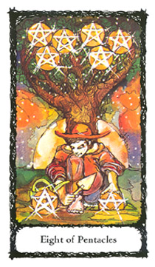
Eight of Pentacles
Regeneration of Earth/Prudence
It is the harvest season; the sun sets on a day of hard work. A young farmer appears pleased to be planning and planting for the next season's bounty. He is prepared with the necessary tools of nurturing objects. Behind him is a tree, fruitful with six Pentacles. At his feet are two Pentacles; one is in the process of being planted and regenerated, the other rests upon a watering can (a container and vehicle representing emotional nurturing). This card reveals the value of care and patience. The need to tithe for future benefit. One is not alone in one's actions. The laws that govern the universe are true for all, not just an isolated few.
DIVINATORY MEANING
Positive Aspect: Skill, craftsmanship and nurturing. Further attention to detail pays off. All details are in place, resulting in a job well done with long-term rewards.
Negative Aspect: Carelessness, avarice. Poor planning leads to little reward. Famine. "Was it really worth the effort"?

THE NINES - CONSCIOUSNESS
"A moment's insight is sometimes
worth a life's experience."
—Oliver Wendell Holmes

The four Nines are ruled by the conjunction of Saturn and Jupiter. These planets/godforms govern the aspects of harsh and benevolent parentage. When combined and reviewed, these planets offer an unique realm of consciousness, that of "knowing." In this, the marriage of experience, realization, and perceptual change become evident and a bonding occurs when one goes through the similar trials of another. Once experienced, consciousness is no longer a dormant energy. In fact, the best term in metaphysics to define it is an epiphany when it is no longer delegated to a robotic process, but becomes an ever present integral part of the psyche. What you choose to do with it (via the gift of free will and choice) is up to you. Be assured, if you choose to ignore it, or devalue the virtue of this condition in your life, it is tantamount to acquiring additional bad karma.
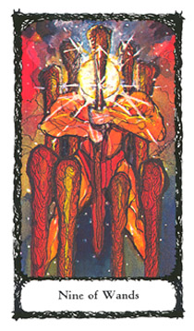
Nine of Wands
Consciousness of Fire/Great Strength
A muscular and strong male figure stands among a circle of eight Wands. He holds the ninth Wand firmly before him. As the Wands' energy melds with his own, an orb of bright light obstructs his facial features. He has become the circuitry between the realms of power, astral and physical, and the holder of "The Force." This energy represents the sacrifice that will be faced for those who request a healing.
This card indicates the consciousness of sacrifices, and the acknowledgement of the task, its physical toil and strain. The will and consciousness are the motivating factors in obtaining physical success. This is the card of acceptance and welcoming of physical challenges and demonstrated prowess.
DIVINATORY MEANING
Positive Aspect: Recovery from an illness. Challenges met, and actions taken toward a desired result. Reservoir of strength now put into action. Healing.
Negative Aspect: Illness with slow recovery. Lack of stamina and conviction leads to failure.

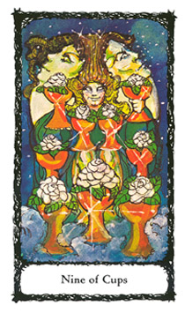
Nine of Cups
Consciousness of Water/Material Happiness
The figure of a contented young person sits among nine Cups filled with large white roses. In the background is the full moon. Incorporated in its surface are the handsome reflections of a female and male face. The seated figure has obtained a fusion or integration of emotional needs and the potential fulfillment of them.
The Nine of Cups is a card of intuitive and emotional awareness. The true fulfillment of the inner child which can be found through the consciousness of one's emotional mechanism, patterns, and responses.
DIVINATORY MEANING
Positive Aspect: A consciousness of one's emotional needs leads to tangible happiness with assured success. The surmounting of obstacles through proper utilization of energies. A "wish granted" card. Sustained happiness.
Negative Aspect: One's moody and infantile expression leads to regret. Uncertainty of actions and motivations leading to doubt. Your wish may be temporarily granted, but results are not lasting. A fleeting moment of satisfaction.
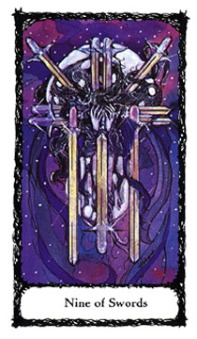
Nine of Swords
Consciousness of Air/Despair & Cruelty
An anguished woman holds her hands to her face, shielding her eyes from a horrible reality. Her hair blows wildly in the wind. Her posture is one of torture and martyrdom. A victim of her own thoughts and regrets, her pain is self-inflicted. She foretells of doom, but is also the survivor of a war of the mind—the rebellion within.
This card is commonly referred to as "the card of the unloved." It is the horrible awareness of physical disdain and coldness that is the bitter reward of the obsessive and compulsive personality.
DIVINATORY MEANING
Positive Aspect: The truth, once realized, will be devastating, but persevere, all is not lost. Survival of a tormented time. Cruel, but necessary awareness of how one's thoughts, and subsequent actions, have lead to the present condition.
Negative Aspect: Going around in circles. Stubborn denial of emotional responsibility. Refusal to recognize or contend with the issues leads to isolation, illness and mental torment. Painful trepidations, living to regret corrective actions not taken. Heartache, futility, and tears. Manifestation of your worst nightmare.

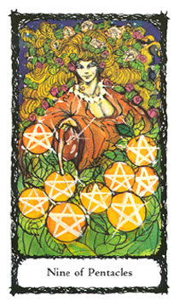
Nine of Pentacles
Consciousness of Earth/Material Gain
A voluptuous woman with garlands in her hair nurtures an abundant garden. She is the persona of nature fulfilled. She is an aspect of the Harvest Queen and Earth Mother; the Empress in her mundane aspect, as symbolized by the pearl necklace and her ample breasts.
A card of realized, tangible gain, the result of efforts well=nurtured through conscious application of talents and gifts received.
DIVINATORY MEANING
Positive Aspect: An ease in the use of all one's abilities to produce a desired result. Attributes of comfort, discernment, and wisdom. A nurturing awareness. A reward received that is far beyond expectation.
Negative Aspect: Deliberate avoidance of what is known to be the proper course of action. Aborted project(s) through bad faith, thievery, and stubborn, effete attitude. An uncooperative person who undermines good intentions.

THE TENS - COMPLETION
"Whatsoever thou takest in hand, remember the end,
and thou shalt never do amiss."
Apocrypha, Ecclesiasticus 7:36

Our mundane journey is now coming to an end; a cycle of life's experiences is about to be completed and assessed. Though many times it is unrecognized for what it really is, you have received a most remarkable gift to be cherished—awareness. This gift has humble beginnings, made up of everyday mundane travails. Within these beginnings dwell the seeds of consciousness that, if allowed to germinate, will unleash a power so great it will cast us into a spiritual awakening. How have you fared? Have you met the challenge? The answer lies within the Tens.
The four Tens are ruled by the conjunction of solar and lunar energies. Representative of these forces are Yahweh and the Shekinah, The Sun and Moon, Madonna and Child, the Gods and Goddesses. You may even think of the Tens as an abrupt ending, but nothing could be further from the truth. They are a stage of completion that spirals into a new beginning.
What are you to do when faced with completion... with newly found awareness/consciousness? The answer, in essence, is "...go, and sin no more."
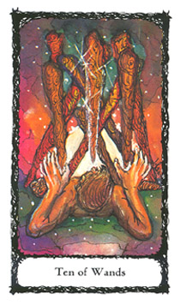
Ten of Wands
Completion of Fire/Oppression
Under the pressure of nine Wands trapping him, and a tenth Wand hovering overhead, threatening impalement, a man is confronted with a difficult challenge. He has ensnared himself into a situation of potential physical harm and must be cautious with his actions, lest he bring the Wands crashing down upon him.
This card depicts a torturous situation, the pressure of a deadline, and the responsibility of accomplishment. Creative endeavors are nearing completion; with each step forward a new challenge arises. It is the oppression of the creative process, the sleepless nights, and agonizing doubts that surround the creator.
DIVINATORY MEANING
Positive Aspect: Harnessing one's energies will aid in realizing completion. Shouldering burdens will be coming to an end. Physical stamina is being tested. Unfounded fears of harsh criticism or the lack of approval from others.
Negative Aspect: Hard labor, unrealistic deadlines. Destruction of the creative process. Illness, possibly leading to an end of a situation. Scars sustained, but not readily healed. Burial.
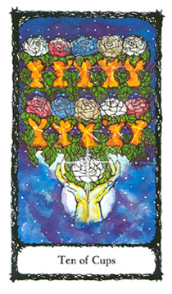
Ten of Cups
Completion of Water/Perpetual Success
Out of the sky, and illuminated by a full moon, two hands make a joyful offering of ten Cups that contain the blossoms of the four Sacred Roses (red, white, blue, and gold). They represent the satisfying emotional completion of a cycle.
This card assures the successful, emotional and spiritual outcome of a project. It is also a creative endeavor that touches a vast range of persons, bringing about historical recognition, fame, or notoriety, as symbolized by the eleventh white rose in the offering hands. The culmination of a great work leads to a life of notoriety beyond the expectations of the seeker.
DIVINATORY MEANING
Positive Aspect: Timeless happiness and emotional satisfaction. Positive and anticipated reaction to a project. Skillfulness, culminating in a masterpiece. Emotional growth cycle completed. A wish may be granted far beyond your expectations.
Negative Aspect: Incomplete satisfaction, criticism, and resentment. Short-lived moment in the sun. Fleeting fame without reward. Emptiness.
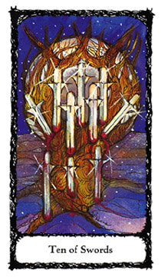
Ten of Swords
Completion of Air/Ruin
The sacred tree is now wounded beyond salvation. It is impaled with ten Swords which cut into its once strong bark; its "blood" pours forth. The barren earth feeds on whatever vital force is left, as a vampire feeds on its victim. The full moon's intensity is a powerful influence; unresolved conflicts are now magnified. A card of tragic and destructive conclusion.
This is the card of recognition and destruction of old thoughts, beliefs, and perceptions. The proper and inevitable slaughter of the past. The need to destroy in order to obtain.
DIVINATORY MEANING
Positive Aspect: Set your mind on expecting the worst, but hope (and pray) for the better. Forewarned is forearmed, there are barbarians at your gate. Mundane psychic influences and structures are to be annihilated. Peace through forgiveness is your only comfort. The sustaining of a tragedy. Death of a loved one, project, or situation will usher in a new beginning.
Negative Aspect: An accident, tragic and unexpected death of a situation. Unpreparedness, leading to torment and anguish. Allow a very long time for healing.
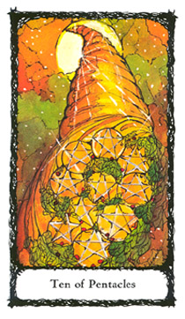
Ten of Pentacles
Completion of Earth/Wealth
The horn of plenty, the cornucopia and nurturer of the gods bares forth riches of fertility. The sky is bright and luxuriant as ten Pentacles issue forth amongst the bountiful harvest. The cornucopia seems to be born directly from the sun shining
overhead, signifying blessings of nourishment and renewal. A
card of a healthy completion, comfort, and retirement from previous turmoil and conflict.
DIVINATORY MEANING
Positive Aspect: Rewards for a project well done. Increased earnings. Prospects are fruitful and will deliver. A bountiful inheritance. Estates and holdings are secure. Respect. A new lease on life.
Negative Aspect: Inherited debts, bad karma, lack of money, and questionable physical well-being. Gambling losses. Scandal, which leads to sudden loss of stature within the community. Dishonor.

THE COURT CARDS
The sixteen Court Cards—Kings, Queens, Knights, and Pages—have been set apart from the previous cards, along with their explanatory text. Their nature as Court Cards is different from the numbered Minor Arcana of Aces through Tens, making it advisable to study the Court Cards as a separate and distinguished entity. What makes these cards so special? The Court Cards function as units of individual energy and means of personal identification.
To aid you in this study, it is best to memorize the following: The Kings and Queens are seated on their respective thrones and represent passive authority by which they declare their intent, or decree a purpose. They are often used to represent the seeker, or questioner. The Knights and Pages are mobile entities and represent active authority. They are goal- or result-oriented. The Knights and Pages can be viewed as catalysts or agents, i.e., messengers or representatives of an official decree (such as made by a King and/or Queen). For example, the King of Swords may represent a lawyer, and the Page of Cups, the outcome of your association with this lawyer.

THE COURT CARDS AND THE
FOUR ELEMENTAL POWERS
Within the Elemental Power structure, all Kings are Fire, or male (active/phallic) energy; all Queens are Water, or female (nurturing/womb) energy. The Knights are Air, and function as the forces that motivate or move these energies to fruition. All Knights suffer the curse of the quest, the trials and tribulations of bringing about a desired outcome into reality. The Pages are Earth, in its androgynous form, and are too young and innocent to hold the dire responsibility that is the burden of the elder Knight. As Pages, they are in an unique position. Having received "instructions" in "cultivation" from the other cards, the Pages may be positioned to indicate the outcome of a situation.
Let us go back to the example of the Page of Cups. The Page connotes a fruitful and emotionally satisfying outcome to your dealings with a lawyer (King of Swords). Taken further, the Page speaks of emotional honesty and use of one's intuition as an asset in this relationship. These qualities should not be ignored by the seeker since they suggest a welcomed result.
As a further example of how the Pages differ from the Knights let us replace the Page of Cups card with the Knight of Cups card. One can then come to the conclusion that there is or was the need for enforcement of the King of Swords' decree.

APPLICATIONS IN A CARD READING
It is important when using a Court Card as a "significator" (the symbolic representative of an individual) that the reader and seeker are firm in their intent of which Court Card best represents the person and situation. For instance, if you are reading an adult male, born under one of the horoscope signs assigned to the element of Fire (Aries, Leo, or Sagittarius), his significator would then be the King of Wands. Let's say the seeker asks a question about his father, who happens to be another Fire sign. There is only one King of Wands in the deck. You can, through discipline, attribute the conflict to another one of the Kings. For example, you draw the King of Cups and state, "Your father is reacting, as attributed to the King of Cups, in an overly sensitive way." But this may not be a totally satisfactory application. A possible solution is to attribute the Fire sign father as the King of Wands and the son as the Knight of Wands. But, this too can become awkward if not agreed to before the reading commences. What would happen if you drew another King? Would it then be interpreted as a male the same age as the father? Or a male the same age as the son? My advice is to set up your parameters beforehand and stick to them.
Another way of defining the roles is to remove the four Kings and Knights from the deck. Among the eight cards have the seeker choose the descriptive qualities that best suit the players in their scenario. As an example: The seeker is an emotionally distraught male, very attached to his family and children. Even though his birth date tells he is an Air sign male and should be represented by the King of Swords, in the context of the reading his role is more like the King of Cups.

Another option, as you get more experienced with the message of the cards, is to experiment by letting the cards set up the situation and dictate the underlying true nature of the seeker. I prefer this method. It allows the cards to dictate the innate truth of the individual(s) involved. This method also allows the layout/spread, and card placement, to indicate the seeker's true nature.

THE FOUR KINGS
AUTHORITATIVE FIRE
As explained, each Elemental Power has its Court Card suit attribution. This is a constant, and holds true with all of your studies. As before, some memorization is required. In the study of the Kings, the following information should be assimilated: All Kings are mature males, therefore, ruled by the Elemental Power of Fire.
All Kings are seated, therefore, passive (not to be confused with weak) in nature. All Kings are leaders (for better or worse) and are concerned with legacies. They are also lawmakers, but do not, themselves, enforce the laws that they dictate; that duty is assigned to other court cards, the Knights.
The Kings are positioned in the eleventh group of the Minor Arcana. They find their complement with the twentieth, eleventh, and second cards of the Major Arcana: Judgment, Strength, and The High Priestess, all corresponding to the first letter of the Tetragrammaton, Yod (ti ).
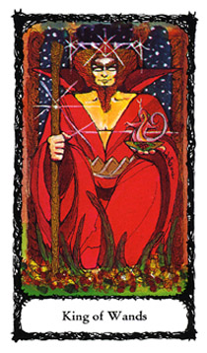
King of Wands
Fire of Fire
A robust man of fiery temperament is dressed in red robes. His crown is a red triangle, and he is girdled in a gold triangular belt. His authority is evident as he holds court. In his right hand is a scepter of his authority, a Wand. In his left hand is a golden dish emblazoned with a red rose. The dish has an occupant, the elemental creature of Fire, an active reptile, a salamander. It is a dutiful servant of the Elemental Power of Fire which awaits the King's decree.
The King of Wands represents a physically commanding male presence whose situation is one of active, creative authority. He can be a benevolent or ruthless leader. Whatever his inclination, he has a tendency to jump to conclusions and can easily be offended. He is charismatic, stands out in a crowd, and may also show some distinct physical characteristics or bodily type, be it tall or short, handsome or ugly. His pleasure is in his physical power or prowess, and the legacy he will leave the world. You know him by his presence; for good or bad, he is definitely there. He is comfortable with humor as long as you laugh with him and not at him. The King of Wands may forgive, but never forgets a slight. A man of action, he is impatient with people who think too much. His decree: `Actions speak louder than words. Creativity is in the doing." The influences of a Fire sign male—Aries, Leo, Sagittarius.
Positive Aspect: A person of action and resolve. A legacy is in the offing. A good marriage.
Negative Aspect: A person of perversion, callousness, and cruelty. Biased judgments and prejudice. Failed partnerships.

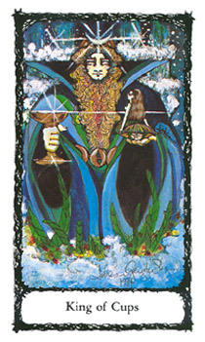
King of Cups
Fire of Water
The fiery aspect of Water is our King of Cups. He is seated on a waterfall throne, where cascades of powerful currents surround him. His crown is of the crescent moon, and his girdle is of interlocking waning and waxing moons. In his right hand he holds a gold Cup, in his left, a dish with the white rose emblem and the elemental creature of Water, an undine. For better or worse our King's emotions run deep. He can be an enlightened healer, or person filled with turmoil. His sensitivity can be either an asset or a disadvantage. Intuitive, and prone to somewhat contrary behavior, he can be emotionally draining to those around him. His decree: "I feel, therefore I know" (better than you). The influences of a Water sign male—Pisces, Cancer, or Scorpio.
Positive Aspect: A sensitive, artistic man. A daydreamer, or person with a keen and creative imagination who needs guidance to become productive. Intuition is correct, feelings will be affirmed.
Negative Aspect: An infantile seeker of satisfaction. A person given to tantrums and emotional manipulations. Vampirism and draining emotions prevail. Run—don't walk—to the nearest exit.
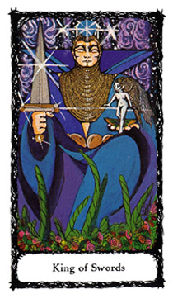
King of Swords
Fire of Air
The fiery aspect of Air is our King of Swords. His throne is of ethereal matter made of vapor and mists. He is crowned with a blue sphere and girdled in golden discs. In his right hand is a double-edged Sword, and in his left, a golden dish which has the Blue Rose of the Impossible etched upon it. It is host to the elemental creature of Air, a sylph, which being true to its nature, steps ever so lightly onto a breath of Air.
Our King of Air is a keen-minded individual, and gifted in language. His authority is in communication, whether spoken or written. He is knowledgeable of all the rules and how to break them. His candor is sharp, and he can be cruel. Clean shaven, he dislikes anything messy or overtly physical. He doesn't like to get his hands dirty, and if he needs to, it better be for a "good reason" such as creating a work of art. When he is angered, he will expose and bring his adversaries not only to justice, but also to ridicule and ruin. It is better to be his friend than his foe because there exists no middle ground. His decree: "Life's a chess game, position is everything; don't get angry, take revenge." Influences of an Air sign male—Aquarius, Gemini or Libra.
Positive Aspect: A good counselor or professional person of service (doctor, lawyer, accountant) acting in your behalf. A clever conclusion to a dilemma. A man with many friends and connections. A person who can "pull the right strings."
Negative Aspect: A cold and cruel individual of power. A corrupted counselor or person of service who is abusing a privilege. A man who values fear and its power over others. A dictator. Warning: your back may have a knife in it soon.
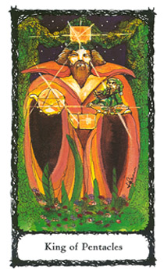
King of Pentacles
Fire of Earth
The fiery aspect of Earth is our King of Pentacles. His throne is made up of nature's greenery. His crown is a golden cube; his girdle is made up of similar and joined squares. In his right hand he holds a golden Pentacle. In his left he holds a golden dish with the Gold Rose of Absolute Achievement etched upon it. The elemental creature of Earth—a gnome—is seated. Our King of Earth is a steady and dependable kind of man. His temperament is slow to anger, but when sparked it can release an earthquake or a volcano of destruction. Though considered slow to grasp concepts and esoteric thinking, he is industrious, practical and good with money matters or figures. He is not a risk taker and loves to comparison shop for the best buy for the dollar. He is noted for his extremes. If stimulated with a project, he can be hardworking, testing his and others' endurance to the point of exhaustion. And, on another day, if the mood strikes him, he can be just as assiduously satisfied with being a couch potato. Withdrawn and shy, he is not confident among strangers, or speaking in public. His decree: "Hard work never killed anybody; hard play—that's another matter!" Influences of an Earth sign male—Taurus, Virgo, or Capricorn.
Positive Aspect: A dependable man and reliable ally. Practical solutions are the best. A down-to-earth application of energies.
Negative Aspect: A brooding and destructive individual. A person of contradiction and confusion, of mood swings and anger. A grave solution to a problem.

THE FOUR QUEENS
AUTHORITATIVE WATER
The Elemental Power attribution of the Four Queens is Water, the ruler of the subconscious, intuition, emotion, and spirituality. The Queens sit on their thrones, and like the Kings are considered mature and passive in nature. Their function is not as obvious as the physical (Fire) reality of the Kings. It is the hidden reality of the sub¬conscious which is expressed through emotions or forms of intuitive communications, clairvoyance, and telepathy. Therefore, the presence of a Queen in a card reading may be interpreted not only as a female individual, but as the hidden side of a person or the anima of a King card.
The Queens are positioned in the twelfth group of the Minor Arcana. They find their complement with the twenty-first, twelfth, and third cards of the Major Arcana: The World, The Hanged Man, and The Empress, all corresponding to the second letter of the Tetragrammaton, Heh (fl).
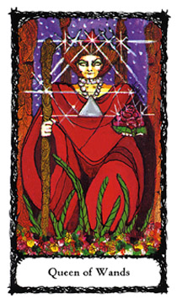
Queen of Wands
Water of Fire
The Queen of Fire is draped in robes of red; her crown is a red upright triangle. Her necklace is of pearls and silver beads. In her right hand she holds her scepter, a Wand. In her left hand she holds a large red rose of physical passion.
She is a woman of honor and unusual tenacity, and very comfortable in her noble position. She can be a warm and attentive hostess, but is intolerant of those who cannot keep up with her in any task. She enjoys the gracious life, especially when she dictates the terms. Her beauty is often in the form of an unique physical presence. Charisma is a charm she wears very well. She can be a prima donna, for better or worse. Her special gift is drawing attention to herself. Some words of caution: Beware her wrath; she goes for the jugular.
Her decree: "Darling, all the world's a stage, and I'm the center of it!" Her influences are of a fiery nature and may represent a woman born under the Sun sign of Aries, Leo, or Sagittarius.
Positive Aspect: Passions, dictating physical reality. Creative opportunity. A strong presence and a gracious attitude bring about success. A strong mother figure, a leader, and a good manager.
Negative Aspect: An overbearing and uncompromising woman. Not easily reasoned with or swayed. Physical illness caused by emotions. Unnecessary competition and jealousy from a woman.

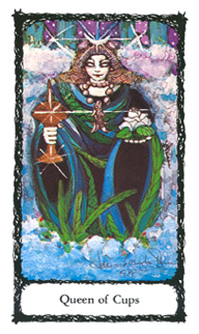
Queen of Cups
Water of Water
The Queen of Water sits upon a waterfall throne. She is enveloped in its cloudlike mists. She is robed in blues and greens, with garlands of sea, lake, and river vegetation. Her crown is a crescent moon; her necklace: golden-hued pearls and a fish medallion. She grasps a covered chalice in her right hand; in her left hand she gently supports a white rose of purity.
A basically good-natured and empathetic person, she is ruled by her emotions and intuition. Dreamy and given to laziness, she prefers to be in the background, yet control from afar, therefore, allowing her to continue her fantasies. She can be unreliable in the simplest task. You take your chances with her if she is the one called upon in an emergency, but she usually makes her best effort to rise to the occasion (after all, an emergency is only a one-time call to arms).
Her decree: "Let Mommy kiss the boo-boo." The Queen of Cups represents influences (of an emotional nature) behind the scenes. She may be a woman born under the Water signs of Pisces, Cancer, or Scorpio.
Positive Aspect: A caring individual, though of little practical action. A very imaginative, creative, and intuitive person who knows the outcome of a situation, without having all the facts.
Negative Aspect: An overly emotional, paranoid, and testy person or situation. Steer clear of being caught in a whirlpool of her/its hysterical reaction.

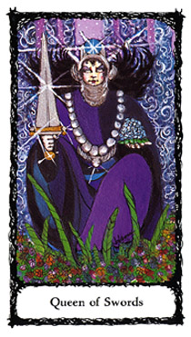
Queen of Swords
Water of Air
The Queen of Air is robed in hues of purple and blue. Her crown is a winged helmet topped by a blue sphere. She is enthroned amongst a whirlwind, her hair billowing in the currents of Air. Around her neck is a silvery pearl necklace with its medallion, the wings of Mercury (the androgynous godform associated with communications, and travel). In her right hand she strongly grasps a double-edged Sword; in her left, she gently supports the blue rose of the impossible.
A keen and cunning individual, she can employ a sharp tongue, humor, sarcasm, and wit in life. She can be cold, calculating and ruthless when setting herself on obtaining the object of her desire. She sees emotionalism and sentimentality as weaknesses, and has little patience for this "foolish" behavior in herself and in others. Though mated to the King of Swords, she needs no man for her comfort, and is many times thought of as the loner or unapproachable member of the couple. She also considers herself an equal, if not the better of the two. Beware her wrath; her words cut to the quick. And if a man is the subject of her wrath, her words can be castrating. Her decree: "Make no excus¬es, tell me no lies." The Queen of Air is represented by the influ¬ences of the astrological signs of Aquarius, Gemini or Libra.
Positive Aspect: Intelligent, highly perceptive forces at work. A confident individual (a professional, i.e., lawyer, physician, teacher). A skillful diplomat. A good leader, able to withstand criticism.
Negative Aspect: A vengeful person or situation, a malicious gossip. A poisoner. Sterility, unhappiness, mourning over loss¬es. The physician with the bitter pill as a cure.

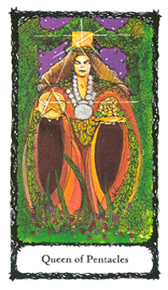
Queen of Pentacles
Water of Earth
The Queen of Pentacles is majestically seated in a natural habitat, enthroned with garlands of leaves. Her crown is that of a golden square. Her necklace is of pearls and its medallion is a round disc. In her right hand she balances a Pentacle; in her left, the gold rose of absolute achievement. A strong and straightforward person, she represents the dependable woman of substance. Not given to frivolity or dreamy expectations, she is a pioneer, ulti-mately practical, seeking solace in home, hearth, and family. A hard and good worker, she is a tower of strength. On the outside she has little patience with others who do not share her ethics or values. She can separate and prioritize the many demands made upon her and get the best result. She seldom takes herself too seriously. Her decree: "Money is only a means, not an end." The Queen of Earth represents the influences of the signs of Taurus, Virgo, or Capricorn.
Positive Aspect: A person of integrity and generosity. For the completion of a valued project, and a job well done: a reward. Happy partnerships. Practicality and work ethics bring about results.
Negative Aspect: Rejection of values, denial of truth. A burdensome person or situation. Drudgery. An ugly and unwelcome outcome.

KNIGHTS & PAGES — ACTIVE AUTHORITY
THE FOUR KNIGHTS
ACTIVE AIR
Knights are active (and sometimes forceful) enforcers of the King's and Queen's decrees. As the Kings and Queens can be considered mature individuals, possibly in a partnership, the Knights are considered single, independent (free) agents or agencies, whether male or female. As a revolutionary agent, they warn the seeker to control their passions in order to obtain a desired result. Their force and mobility are represented by their majestic steeds.
The Knights are positioned in the thirteenth group of the Minor Arcana, and find their complement with the zero, thirteenth, and fourth cards of the Major Arcana: The Fool, Death, and The Emperor, all corresponding to the third letter of the Tetragrammaton, Vau (Ì ).
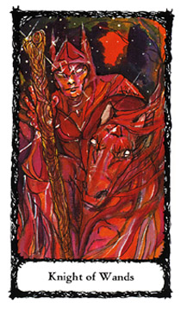
Knight of Wands
Air of Fire
The Knight of Fire races out of the flames of creativity upon his galloping steed. In a confrontational, and forceful manner, his right hand reaching out to "pass the torch," he challenges you to accept his Wand of opportunity. A highly charged, fiery, and forceful atmosphere is about him. He is protector and defender of the decrees that have been issued to him. As the purveyor of physical change and creativity, he uses whatever challenge fate and destiny have in the offing to deliver his gift.
The Knight of Wands is an agent of a Fire influence and can be a person whose Sun sign is either Aries, Leo, or Sagittarius.
Positive Aspect: Opportunity is coming your way. Be prepared for necessary physical changes. Magnetism, charisma, and recognition leading to a positive outcome. A lover, or sexual affair. Be prepared to catch the Wand and run with it. A chance to prove your worth.
Negative Aspect: An opportunity with many strings attached. Sexual misconduct leading to misunderstanding. Haste makes waste. Do not jeopardize your life on a risk, or gamble on a promised "sure thing"

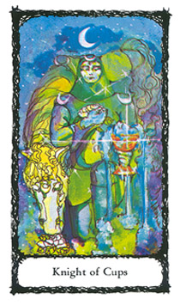
Knight of Cups
Air of Water
The Knight of Water appears out of the mist of twilight, and kneels before you in adulation. He lovingly bears gifts of peace. Our Knight holds the white rose of purity and spirituality in his right hand, bringing it to his chest, and close to his heart; with his left hand he offers an overflowing Cup. His steed is at rest as it partakes of the fragrance of a white rose. Twilight, when the moon and sun share the sky, is part of the Knight's purpose, the repose after the journey's end. He is the bearer of emotional satisfaction and the changes it brings (though many times after the fact).
The Knight of Cups is an agent of Water, a person born under the signs of Pisces, Cancer, or Scorpio.
Positive Aspect: A dream possibly coming true. An emotional person or situation that will bring about great satisfaction. Knowledge and use of proper emotional perspectives. Romantic idealism brought to reality. Poetry; words of romance.
Negative Aspect: An unreliable person or situation that is emotionally draining. Dreams become nightmares, empty words, and unfulfilled promises. Discord. Get out the garlic—there is evil afoot. Possible substance abuser; an addictive personality. Someone who wears emotions "on their sleeve."

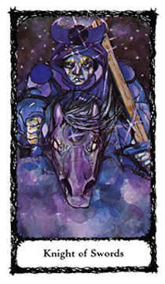
Knight of Swords
Air of Air
Our Knight of Air is a very determined individual. His mind is set upon its goal as he charges ahead at full force. His colors are vivid blues and indigo. In his right hand he grasps at the reins and guides his steed; in his left hand he holds his Sword readying it to strike. His horse's nostrils flare with intensity and mirror the energy of our Knight's intent. He optimizes forceful reaction and defense. As a stormy atmosphere surrounds him, the Knight of Swords is as relentless as a tornado that cannot be altered from its assigned course. All in its wake must pray that they either survive its unrelenting force or only be slightly injured as its energy dissipates. The Knight of Swords is an agent of Air, a person born under the sign of Aquarius, Gemini, or Libra.
Positive Aspect: A defender, hero to the rescue, and administrator of justice in its most extreme sense. Welcome news—the comeuppance of the perpetrator of an injustice. Unscathed, one's war, or battle is won.
Negative Aspect: You are being targeted, so take cover! Sleepless nights, plotting out revenge; obsessive anger, bordering on a nervous breakdown. Psychotic behavior or paranoia; losing touch with reality. A war or battle leading to ruin. A legal or police action.

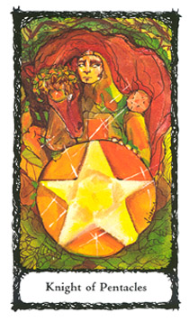
Knight of Pentacles
Air of Earth
Our Knight of Earth is peacefully contemplating the wonders of the fertile grounds about him. His steed is affectionate as it rests its garlanded head lovingly upon the Knight's right shoulder. The Knight, gazing into the distance, reaches back with his right hand, stroking his steed's head as he gently supports his shield with his left hand. His shield, a huge Pentacle which has protected him in battle, now supports him. He has fulfilled his decree, and now bears the fruits of honor, peace, and prosperity. The Knight of Pentacles is an agent of Earth, a person born under the sign of Taurus, Virgo, or Capricorn.
Positive Aspect: Tangible attainment and a repose justly deserved. Protection of resources. Person or situation of mutual benefit. A better solution through integrating forces and seeking resolve. Great satisfaction. A growth of funds.
Negative Aspect: Carelessness and sloppy actions leading to disaster. Intentions of those involved are not true. False acts. Victimization. Facade of responsible intent which leads to destruction. Bankruptcy.

THE FOUR PAGES
ACTIVE EARTH
Attributed to the Elemental Power Earth, the Four Pages represent integration of the previous energies, Fire, Water, and Air, stabilized or grounded in Earth. The Pages are the attendants of the court and act as messengers of evolution and seeds of change. They can be defined as new, youth¬ful energy acting in behalf of a person or situation.
In medieval times, the Page was a young male servant to a Knight of the realm. The Page was also employed in royal courts to handle general tasks or deeds. These tasks were not worthy of the efforts of the higher-ranking court personages such as the Knights.
In tarot interpretation, the Pages are prepubescent youth (male or female) who, through their innocence, are only able to speak and act on the truth, therefore, bringing about an evolution of a situation, no matter what the consequences. Because of this nature, the Pages' messages at many times go unheeded or are considered trivial to the neophyte. But the opposite is true!
The Pages are positioned in the fourteenth group of the Minor Arcana, and find their complement with the fourteenth and fifth cards of the Major Arcana: Temperance and The Hierophant, both corresponding to the fourth letter of the Tetragrammaton, Heh ( rt ).
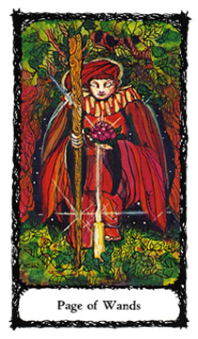
Page of Wands
Earth of Fire
The Page of Fire kneels before you. A candle's flame illuminates the Page's presence against the dark nighttime sky. The Page's garments are blazing reds. The youth's right hand holds a Wand, and in the left hand, a red rose. Though it is nighttime, the brightness of the candle's flame shows us that the forest's surroundings are fertile. This youth is the messenger of physical, creative brio, a conveyer of sensual desire, and/or a courier quick to deliver news of a desirable situation, or person.
A child, or news influenced by the Fire sign of Aries, Leo, or Sagittarius.
Positive Aspect: For a male: news of potency and power, possible fatherhood. For a female: a suitor or lover. For both genders: the potential of productive fulfillment of a project and evolution, rising to a new level.
Negative Aspect: Rivalry and dealings with a creative liar or competitive situation. Beware of the messenger and tales they tell. Unwelcome news or visitors. Anger and tantrums.

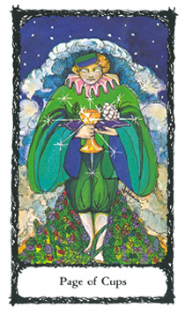
Page of Cups
Earth of Water
The Page of Water is walking toward you on a carpet of flowers and greenery. This youth has been born out of the primordial depths of the subconscious. While the right hand bears a golden Cup, the left hand gently supports a pillow, upon which rests a white rose.
This messenger of spiritual inspiration and intuitive feelings bears news of a service done on your behalf. The evolution of a deeply felt emotional reality and its potential outcome brings a gift of life to a dream or goal.
A child, or news influenced by the Water sign of Pisces, Cancer, or Scorpio.
Positive Aspect: For a woman: the role of nurturer or mother. For a man, connecting with his emotions. For both genders: inspiration and potential fulfillment of a dream by a nurturing person or situation.
Negative Aspect: Abortion of projects through emotional inconsistency and its subversive effects.
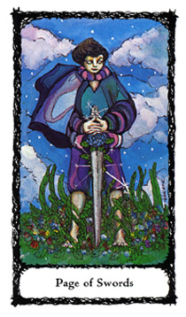
Page of Swords
Earth of Air
The Page of Air stands firmly on a mountain's crest, enjoying the atmosphere. The Earth underfoot is fertile and abundant. The Page's Sword is pointing downward into the Earth as a blue rose rises, growing to meet the youth's resting hands. Our Page, though contemplative, is a sentry, quietly surveying the terrain and readying for necessary action. The Page is prepared to make the necessary sacrifice(s). As symbolized by the destruction of the growing blue rose, the call to arms requires action, and in doing so rips the rose from the nurturing Earth.
A child, or news influenced by the Air sign of Aquarius, Gemini, or Libra.
Positive Aspect: Pleasantly surprising news or communications. Expectations fulfilled, but in an unorthodox manner. Be prepared for the unconventional.
Negative Aspect: Unpleasant and shocking news. Breakdown of or lack of communication, friendships lost, family quarrels. Forewarned is forearmed. Havoc and mockery. Immediate reaction is to "kill the messenger."

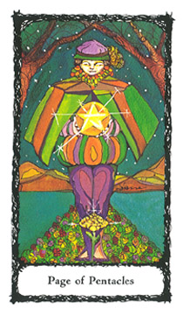
Page of Pentacles
Earth of Earth
The Page of Earth has traveled far to deliver a message. This message is one of great importance, as represented by the carpeted road of greenery that extends from the horizon and into the distant mountains. The night's sky is illuminated by starlight. At destination's end, a golden rose emerges from the fertile Earth at the Page's feet. As if in reverence, the youth gazes down upon the Pentacle he is holding, seemingly offering it as a companion to the rose.
A child, or news influenced by the Earth sign of Taurus, Virgo, or Capricorn.
Positive Aspect: After diligence and hard work, a more than anticipated reward. Acknowledgment of efforts through tangible rewards, e.g., contracts and money. News of position in earthly power. Recognition, respect, notoriety, and "stardom."
Negative Aspect: Wasteful use of energies. Swindlers and charlatans at work. Money-making schemes. False promises, slander, shameful and embarrassing news.
Your next stage of study should be very interesting, even for the more accomplished tarot student. The following chapter promises to be an unique and worthy experiment, that may help merge your previous studies into a new realm of consciousness. The challenge is in the doing, and the testing of how you have integrated your learned information with your intuitive and subconscious responses.

LESSON 9 — THE CARDS AND
PSYCHIC DEVELOPMENT
There comes a time when everything you have studied must be applied. The memorization of a card's meaning is only one step in the process of psychic development. Now the gift of intuition (natural and developed) will make the difference between a great reader/counselor or an entertaining dabbler.
The following exercise is simple, but in its simplicity is its power. The sooner you can gather several people to act as your subjects the sooner you can reap the benefits.

AURA CARD EXERCISE
Separate the 22 Major Arcana cards from the rest of the deck, and shuffle them. Have the subject(s) sit across from you at approximately eye level; if more than two subjects are present, a semicircle seating is suggested. Place the stack of Major Arcana cards between you and your subject(s).
The purpose of this exercise is to incorporate your newlydeveloped perceptive abilities. Have an individual pick one card and place it underneath their chin, pictogram facing outward toward you, the reader. It is important that the subject(s) not move their head(s). You will now look straight into the subject's eyes, registering any intuitive reaction on your part, making mental notes of these reactions. Now, without moving your head, shift your glance upward, right above the subject's head or crown. It is here that you will register the subject's auric energy field. Allow your mind to form an impression. Again, without moving your head, shift your glance, this time toward

the Major Arcana card. Repeat the total procedure until an interpretation of how the individual card's definition synthesizes with the subject's aura or field of psychic energy. Continue the process with the same card, but with the other subjects. You will be surprised how one card's image or message can seemingly change right before your eyes, depending on the subject's auric field.
For example, let us say you have two individuals before you, one female and one male. The card chosen is The Tower. The first subject, a female, holds up the card as directed. You proceed to read the energies of her auric field and card combinations; your intuitive interpretation may be "Illness." You know that one meaning of The Tower is unexpected, shocking circumstances, which call for "restructuring of ego" (see page 97). Keep that in mind as you seek out further information about the nature of the "Illness" and how it pertains to the subject. The card is now passed to the male subject. As you go through the procedure, your interpretation may be "Relocation." Keeping in mind the card's general meaning (unexpected, shocking circumstances...), endeavor to elaborate on what you feel the "Relocation" means to this individual. For example, he may lose his job and be forced to relocate.
The above exercise can also be done with the Minor Arcana cards. Though I suggest using the Major Arcana cards
first, due to their powerful archetypal energies, the Minor Arcana cards focus on mundane energies and may not display the psychic force that the Major Arcana demonstrates for both the seeker and the reader.
Also, many people believe that one must actually "see" an auric field. This is not so, otherwise you may be opening yourself up to a great deal of suffering from migraine headaches. The auric field can, and many times is perceived on the psychic or daydream level of mind response called "Alpha." It is here where you receive an imagined impression of the auric field, the rest is your interpretation.
Remember, any system is just a mechanism for discipline. In total, it should be a tool and procedure that enhances one's abilities. We will now study additional procedures utilized under the heading, Card Spreads.

illustration

LESSON 10 — CARD SPREADS
In order for a tarot system to be effective it needs to be formatted. A format is a structure that reinforces and optimizes the system's purpose. In tarot, the format is the card spread. In a card spread the placement, or position the card holds indicates its function, or purpose in the psychic's interpretation.
SHUFFLING THE CARDS
The novice reader may find it beneficial to be the only one shuffling the deck. I find this suggestion helpful when there is a crisis situation calling for hard, cold facts. The reasoning is simple: avoid as much as possible the "desire force," or "wish expectations" of the seeker that may enter into the energy field of the cards when the seeker or subject handles them. For an effective reading, a state of non-judgment and the ability to be open to the greater good must prevail. Only a person in a neutral psychic state can do such a reading, and unfortunately, many times, the seeker is not that person.
Upon shuffling the deck, the psychic should be concentrating on the subject's auric field, taking deep, relaxing breaths, and clearing their mind of trivial thoughts. A meditative state, with words or prayer for enlightenment and good guidance, is helpful and many times relaxes both the subject and reader.
Prior to any spread, cut the cards after placing the deck face down between you and the subject. With your left (receptive) hand, cut and lift a section of cards from the deck, and place it face down before you. Repeat this process, placing the second section of cards to the left of the first. Place the remainder of the deck to the left of the second section, and then restack the sections—from right to left being sure to place them one on top of the other.

Repeat this entire process two more times. In total, nine (the number of consciousness) sections of cards should have been placed before you.
Your deck is now prepared for the spread of your choice.
THE ELEMENTAL POWER SPREAD
6
LONG-RANGE
FUTURE
OUTCOME
EARTH AIR WATER FIRE
4 3 2 1
INTEGRATION INTELLECTUAL EMOTIONAL PHYSICAL
OR RESULT REALITY REALITY REALITY
5
FOUNDATION/
MOTIVATING
FORCE

I use this spread as a general overview of the subject's use of energies. It helps focus in on where the subject is coming from, strengths and weaknesses, and what improvements they may need to implement.
Using the Hebrew letters of the Tetragrammaton (Yod-Heh-Vau-Heh) and placing them in the correct position of reading right to left (not our customary left to right), you

will start at the far right with the element of Fire (Yod) or Physical Reality.
1 FIRE YOD - This card position represents the state of health or physically surrounding influences. It is the creative
force, or fiery goal, the physical reality. It can be the obvious or apparent motivating force, but not the true underlying energy. It is the actual physical and present reality of the subject.
2-WATER-HEH - The next card position is the element of Water (Heh) or emotional reality, the hidden force that many times motivates us for better or worse. This card can also give a clue to the basic needs of the individual that many times are not expressed. It is also interpreted as the spirit or intuition of the subject.
3-AIR- VAU- The third position is the element of Air (Vau) or mental reality. It is how the subject is thinking, and communicating. It may be an indication of a future agenda or soon to be coming communication.
4-EARTH-HEH - The fourth card position is the element of Earth (Heh, in its feminine influence) or tangible reality. It is the grounding of the combined energies of Fire, Water, and Air that produce their result—Earth.
You can now stop the reading or continue to pull two more cards (5 and 6). Card 5 is placed on the bottom and is read as the foundation or true motivating force behind the subject's inquiry. Many times this is a deep psychological state that is revealed or a phobia that hinders the subject from furthering their growth. Card 6 denotes the final long-range future result, and crowns the cards already laid out. This position indicates the far-reaching consequences, or the ultimate karma.

Need more clarification? Remember the number 9: consciousness? Deal three additional cards from the top of the deck and place them in the formation of an upright Fire triangle.

8
7 6 9

Read cards 7, 8, and 9 as a total arch of influence, keeping in mind the clarification desired.
Cards 7 and 9 explain the foundational energies of card 6. Card 8 is the crown or apex that indicates further insight into card 6; so read cards 8 and 6 together.

6
10 1 11
2
5 3 7
9 8
4

THE ROSE CROSS SPREAD
This card spread is a variation of the trusted and popular Celtic Cross spread. In fact, the Rose Cross outline is based on the images of the Celtic and Rose Crosses. Both crosses are centrally encircled, which represents the power of the SUN or SON/"Child of God," messianic message or rebirth. I personally use the Rose Cross spread in preference to the Celtic Cross, because the symbolism of rebirth and spiritual guidance via the Rose Cross imagery is built throughout the reading. This subliminal message to both the reader and subject can only be an enhancement. This card spread is best utilized for spiritual guidance in solving a problem.
Shuffle the cards (see page 207). Lay out and read cards 1-7 as described below:

1 - Represents the "Significator" or the inquirer. This card can be one of the Court Cards or the first card turned over. I prefer the latter, using the random top card. This card can help focus the energies and set the tone for the reading.
2 - This card is placed slightly overlapping card 1. It is the card of immediate influences; it is the representation of atmosphere about the inquirer.
3 - Place this card on its side, crossing the other cards. It represents a negative force, situation, or obstacle to the inquirer.
4 - This card is the basis or foundation of the situation and can be interpreted as the motivating force.

5 - This card represents past influences or experiences.
6 - The crowning card, it represents the immediate future.
7 - This is the card of lessons or karma, the end result that will be registered in the Akashic Record.
Continue to construct the Rose of the Cross as follows:
8 - The regeneration to be sought by the inquirer based on the lesson as described in card 7.
9 - The changes needed to be made in the inquirer's environment, the living of a new consciousness.
10 - A card of completed expectations, the potential reward of actions leading to realization. This card is one of "baptism by fire," or sacrifice leading to rebirth.
11- The resolution, and final outcome of all efforts. This could be a card of triumph or one of "going back to the drawing board."

SPIRITUAL
REALITY
lemiscate
EMOTIONAL10 PHYSICAL
REALITY REALITY
^ FINAL
(TY) OUTCOME T
(
8
9
UNDERSTANDING 11 o WISDOM
NEEDED
/n!\ _1 NEEDED
_1rß VC
DOORWAY TO SUCCESS
6 0 7
ACTIONS HELP AND AID
NECESSARY RECEIVED
5 )/
THE CORE-CHANGES TO BE
MADE
3 4
COMMUNICATION EMOTIONAL
TRAVEL CAREER ¡ INTUITIVE
yAND FINANCIAL 2 ARTISTIC
YOUTLOOK RELATIONSHIPS
WHAT THE
SUBJECT IS
PROJECTING
81
THE TREE SUBJECTS
OF LIFE PRESENT STATE
OF BEING
SPREAD AND REALITY ED

THE TREE OF LIFE SPREAD
This card spread projects a year's events. Cards 1-4 represent 4
months into the year; cards 5-7 represent 8 months into the year
and cards 8-10 represent the last cycle ending at the 12th month.
Card placement 11 is the area of the hidden realm, a doorway to the dark side of denial and lessons unacknowledged. In Kabbalah, it is referred to as the Abyss. I describe this realm as the "doorway to success;' though the fruit at its entrance may be very bitter.
We are working the cards up the Tree, from our earthly reality to the inspired realm of the godhead or Crown. As opposed to the "Path of the Arrow" that in teachings emanates beyond the Crown and through the spheres (see page 218, The Columns). Our card placements should not be confused with the designated usage of the spheres. Please keep this in mind: the numbered card positions are only card sequences, not to be confused with any system of esoteric or metaphysical numerology.
First, place cards 1-4 in position as described below:
1 - This card placement or position is in the sphere of Earth (in Hebrew: Malkuth, "the Kingdom"). It is interpreted as the burden of our physical reality. Since it is pulled from the top it can be used as the significator card.
2 - This placement is of spirit or Astral Light, the sphere of the Moon (Yesod, "The Foundation"). It represents our spiritual, dream realm and subconscious motivation. What one is projecting, for better or worse. Also, this card aids in the interpretation of card 1, and should be read in conjunction with it.

3 - This position is of the Splendor (Hod, "Reason"). It is the sphere of Mercury and is interpreted as communications, business, career and work endeavors.
4 - This is the card placement of love and the sphere of Venus (Netazah, "Victory"). This card position represents emotional partnerships which can range from the arts through relationships. This card compliments 3 and should be read in conjunction with it.
You have now constructed the first third of the year, or 4 months. Read these cards in total combination.
Continue climbing the Tree by adding cards 5-8:
5 - This is the placement of the Messianic message, the sphere of the Sun (Tipareth, "Beauty"). It represents the necessary sacrifices one must make and endure in order to see a change, and can be interpreted as the true heart of the situation, or the inquirer.
You might think that now all is accomplished. Wrong. Remember, partaking of the messianic message alone, is not enough to fulfill the seeker; in life there are other controls or disciplines that are needed. Any reformed person knows this, the message may be heard, but the proof is in the fulfillment and consistency of action...and so we continue to climb the tree.
6 - This card placement is one of power, the sphere of Mars (Geburah, "Strength"). It represents severity, strategy, force, aggression and destruction. The fears one must face and conquer. It is the warrior self; or what one must battle in order to succeed.

7 - This card placement of positive reinforcement is in the sphere of Jupiter (Chesed, "Mercy"). It represents kindliness, cooperation, charity and overall blessings. This card balances card placement 6 and should be read in conjunction with it.
This completes the dominion of the seven sacred planets.
You have now traveled into the second third of the year (cards 5, 6, 7), or 8 months of earthly experience. Synthesize the information, and ask yourself questions. What is the story the cards and their placement telling?
The next three cards' placement, 8, 9, 10, make up what is called the "Supernal Triangle." Sounds powerful? Yes, it is. For our purposes (and not to get too esoteric) it is the crowning achievement, where all emanates from: your past lives, your karmic lessons, gifts, and talents. In brief, your answerable place in the greater scheme of things. It is in this area that you have either passed or failed. For the power and force within the triangle is unified and cannot be separated.
Place into position cards 8-10:
8 - This card placement is representative of The Primordial Mother, the receptacle of The Light (see page 50, The Empress). Its Hebrew word is Binah, "Understanding," and its sphere is of Saturn (the teacher). It is the unique realm of consciousness, where one is cognizant of how one's actions and total thought and living process is accountable to a Higher Power. It is the crowning sphere on the Pillar of Austerity. The big karmic "R" word in the sky—RESPONSIBILITY. It is the lesson learned, understood, retained, never to be repeated.

THE COLUMNS AND
THE PATH OF THE ARROW (EMANATION)
\./ N!
SERENITY 'I
J •
B
1 Kether
AUSTERITY COMPASSION
Binah 0 2
Chokmah
THE \
ABYSS
Geburah 0 ,
4 Chesed
6 Tiphareth
Hod0 7 Netzach
,

9 Yesod
10 Malkuth

9 - In this card placement we see the area of The Primordial Father (see page 53, The Emperor). Its Hebrew word is Chokmah or "Wisdom"; its sphere, the Universe, crowns the Pillar of Compassion. It represents the giver of The Light. The realm of constant resources and ability to tap into it. The motivating source, sage, and/or mentor. It is here, as one travels through the spheres from Malkuth, the difference between understanding and wisdom is clarified. Wisdom is an innate gift of good judgment. It can be seen in children who make proper choices without knowing exactly why they made a correct choice. Whereas, understanding is the ability to distinguish, define and discriminate about all aspects of experience, including the ones in disguise.
10 - This card placement is The Infinite Creator (Kether, "The Crown"). It is the direct emanating force of the Middle Pillar of Serenity, and represents the summation of all the spheres and previous cards. It is the enforcement of the laws and principles of karma and dharma, Divine Providence at work; recognition of your place in the universe, or your role within the situation.
You have now traveled through the final third of the year. Some may think that the reading is now over with at this point. To the contrary...it is not! Thus far, you have accomplished the first phase of this exercise: leaving your unique "marker" in the astral realm. This is your bridge, or threshold to the second, and final phase in your quest toward self-discovery, explained as follows:
Finally, place the last card in position.
11 - This card placement represents (the hidden) Doorway (Daath, "Knowledge") to success (see page 214). It functions as the entrance leading to other experiences or realities. In Kabbalic texts, it leads or bridges across the area called "The Abyss," the deepest realm of being, and culminating experiences that are the labyrinth of the subconscious mind. It is only through this rite of passage that one can attain access to the powers of the Supernal Triangle. The Doorway card functions as mediator to the energies that compose the Supernal Triangle. It also represents the remedy, or the resolution. The Doorway opens to the hidden answer and area of rectification.
A Wiccan aphorism sums up the premise quite well:
Remember this, for this is law:
For every end there is a beginning
and from once you enter so must you withdraw.
You have traveled up the tree; now get a "God's-eye view" by following the layout as illustrated in "The Columns and the Path of the Arrow" (page 218); follow the Arrow's course of lightning bolt energy. The perspective is definitely different but even more so, enlightening.
In summation, the Tree of Life Card Spread is a very potent metaphysical tool in self-development. Though it can be used on a very mundane level, its nature cannot but dictate the natural spiritual law at work within our lives.

NUMEROLOGY SPREAD
In the Numerology Spread we focus on three individual energies that are assigned to us at birth, and are symbolic of our youth, growth process, and potential evolution. These three levels compose the trine of life; they are:

see triangle
Karma— Past lives' record of good FULFILLMENT
and bad deeds. A
Initiation— The testing ground for th
life, and one's striving to
obtain Fulfillment—
the elusive quality of
contentment.
Expression— How you subsequently
utilize the energies in
levels 1 and 2.
Karma and Initiation, being of the spiritual realm, are assigned to the Major Arcana. Expression is our mundane vehicle, and is assigned to the Minor Arcana cards. It is important to remember that the effectiveness of this spread requires the reader to address the positive and negative aspects of each card. Furthermore, on a mundane level these aspects can be indicative of the "virtues and vices" personality traits, and character of the subject.

SETTING UP YOUR SUBJECT'S CHART AND SPREAD
Before attempting the Numerology Spread, you will first need to prepare, and familiarize yourself with your subject's chart. A sheet of scrap paper, and a pen or pencil for some simple math would also be helpful (or a calculator, or if you're comfortable with it, you can fly solo and stretch your mental math muscles). Now, lets turn the page, look at the chart, and have some fun.
Fix symbols

Sacred Rose Tarot
Numerology Chart and Spread Worksheet
Q Subject's Name
Month Day Year of Birth
/ /
Major Arcana
Level One/Karma
Card
Indicators Numbers Card Names
Month
Day
Year
Destiny
Level Two/Initiation
Card
Indicators Numbers Card Names
Month/Day
Year
Destiny
Turn to page 224 for complete Charting Instructions and some helpful hints.

Minor Arcana
0 Sign Element
Level Three/ Card Suit
Expression
Card
Indicators Numbers Card Themes
Month/Day
O
Year
©
Destiny V Astrological Reference Table
Birth Dates Signs Elements Card Suits
03/21 thru 04/20 Aries Fire Wands
04/21 thru 05/20 Taurus Earth Pentacles
05/21 thru 06/21 Gemini Air Swords
06/22 thru 07/22 Cancer Water Cups
07/23 thru 08/22 Leo Fire Wands
08/23 thru 09/22 Virgo Earth Pentacles
09/23 thru 10/22 Libra Air Swords
10/23 thru 11/21 Scorpio Water Cups
11/22 thru 12/21 Sagittarius Fire Wands
12/22 thru 01/19 Capricorn Earth Pentacles
01/20 thru 02/18 Aquarius Air Swords
02/19 thru 03/20 Pisces Water Cups
Psychic References Card Configurations
Level One/Major Arcana Level Two/Major Arcana Level Three/Minor Arcana
Day 1 Destiny MDay onth/II
Month KARMA Year INITIATION EXPRESSION
- - Destiny -- - ' Month/ Da Y Year Destiny

NUMEROLOGY SPREAD
CHARTING INSTRUCTIONS
Major Arcana
Level One/Karma
Write the Subject's Name, Month, Day, and Year of Birth in ®. Our subject, John Doe, was born 12/23/1996.
Sacred Rose Tarot
Numerology Chart and Spread Worksheet

correct symbols

Subject's Name JOHN DOE
Month Day Year of Birth
112 / 2 3/ 1 9 9 6
Write the Birth Month in ©.
John Doe was born in December.
Major Arcana
Level One/Karma
Card
Indicators Numbers Card Names
Month 1 2
Birth Day. If this number is 22 or less, write it in ©. If the number is greater than 22, it must be reduced (see example) by adding the digits together before it can be written in ©. (This is because in the Major Arcana we only work with numbers 0 through 21. Technically, the Major Arcana's digits range from 1, The Magician, through 21, The World. The 0 card, The Fool, is associated with the number 22.)
John Doe was born on the 23rd day of the month. This number must be reduced. 23 (2+3) = 5
Day 5

Add up all the numbers of the Birth Year. If the sum is 22 or less, write it in©. . If it is greater than 22, it must be reduced (as pre-viously explained in Step 3) before it is ready to be written in ®D . John Doe was born in 1996. We know from our addition the sum of 25 must be reduced. (1+9+9+6). 25 (2+5) = 7.
0
Year 7
Add ©, ©, and @. (Remember, sums greater than 22 must be reduced further.) Write the sum inc.E
John Doe's reduced sum of ©, ©, and OD is 6. (12+5+7) = 24 (2+4) = 6. John Doe has a Karma Destiny Number of 6.
Destiny 6
Refer to the card numbers in ®, ©, ©, and ®. Write in the Major Arcana card names that are associated with them.
John Doe's Major Arcana card names for Level One/Karma are: 12, The Hanged Man; 5, The Hierophant; 7, the Chariot; and 6, The Lovers.
Major Arcana
Level One/Karma
Card
Indicators Numbers I Card Names
Month 1I2 THE HANGED MAN
Day 5 THE HIEROPHANT
Year 7 THE CHARIOT
Destiny I 6 THE LOVERS

Major Arcana
Level Two/Initiation
Month/Day. Refer to OA ; add the numbers of Month + Day. Reduce the sum if necessary, and write it in 0.
John Doe's Month/Day is 8:
Birth Month (12) + Birth Day (23) = 35 (3+5) = 8.
Level Two/Initiation
Card
Indicators Numbers Card Names
0
Month/Day 8
Year. Refer to®. Write the same number in ©.
John Doe has a Level Two, Year of 7.
Year 7
Destiny Number. Add Month/Day ®F + Year ©. Reduce the sum if necessary, and write it in 0. (Remember, sums 22 or less need no further reduction.)
The sum of John Doe's Month/Day (8) + Year (7) = 15. John Doe has an Initiation Destiny Number of 15.
Destiny 1 5
Refer to the card number in o, ©, and g. Write in the Major Arcana card names that are associated with them.
John Doe's Major Arcana card names for Level Two/Initiation are: 8, Justice; 7, The Chariot; and 15, The Devil.
Level Two/Initiation
Card
Indicators Numbers Card Names
O
Month/Day 8 JUSTICE
Year 7 THE CHARIOT
Destiny 1 5 THE DEVIL

Minor Arcana
Level Three/Expression
Refer to the Astrological Reference Table. Locate the subject's Birth Date range and write the corresponding Sign, Element and Card Suit data in ®I .
John Doe's Birth Date is 12/23. His Birth Sign is Capricorn, his Element is Earth, and his Card Suit is Pentacles.
Minor Arcana
® Sign Element
CAPRICORN EARTH
Level Three/
Expression Card Suit PENTACLES
Now, for a change of pace. You will be working with a new set of quantitative numbers specific to the Minor Arcana, Level Three/ Expression. There are two divisions that we are concerned with. The first division relates to the pip cards (Ace or 1, through 10, inclusive), and the second division relates to the Court Cards. In the Guide to the Sacred Rose Tarot you may have noticed that they follow the 10s in this order: Kings (11s), Queens (12s), Knights (13s) and Pages (14s). You may be asking: What does this have to do with the numbers we are about to enter in0, ®, and ©? By knowing what division the numbers belong to-1 through 10 (mundane life occurrences and/or completion, representative of a full cycle in the subject's life), or 11 through 14 (the Expression of leadership and what type of leadership)—the reader's potential for a more accurate interpretation is enhanced. How is this so? The quality of the subject's "Expression" is found in these divisions. This is why all numbers greater than 14 must be reduced to bring them to within this realm of understanding.
Month/Day. Refer to 0, in Level Two/Initiation. If it is 14 or less, write it injQ. If it is greater than 14, it must be reduced first before writing it in (j .
John Doe's Level Two, Month/Day entry is 8. Therefore, it can be written directly in Q with no reduction. (Remember, numbers 14 or less need no further reduction.)
Card
Indicators Numbers Card Themes
Q
Month/Day 8

Year. Refer to © in Level Two. Write this number (reduce if necessary) in 0.
John Doe's Level Two, Year entry is 7. Therefore, it can be written directly in ® with no reduction. (Again, numbers 14 or less need no further reduction.)
Year 7
Destiny Number. Add Month/Day1)+ Year OK . Reduce the sum if necessary, and write it in ©.
The result of John Doe's Month/Day (8) + Year (7) = 15 (1+5) = 6. John Doe has an Expression Destiny Number of 6.
Destiny 6 V
Refer to the card numbers in ®, 0, and ®. Write in the Minor Arcana card names that are associated with them. (Refer to the Minor Arcana Chapter, starting with Ace of Wands, page 116.)
John Doe's card suit is Pentacles, and his Month/Day card number is 8; the card theme for the 8 of Pentacles is "Prudence." His Year number is 7; the card theme for the 7 of Pentacles is "Success Unfulfilled." John's Expression Destiny Number is 6, hence, the 6 of Pentacles, "Material Success."
Minor Arcana
QI Sign Element
CAPRICORN EARTH
Level Three/
Expression card Suit PENTACLES
card
Indicators Numbers Card Themes
O
Month/Day 8 PRUDENCE
Year 7 SUCCESS UNFULFILLED
©
Destiny 6 V MATERIAL SUCCESS
Now, look at the Psychic References Card Configurations area. Set up your Level One/Karma spread (configuration) as shown, and start your reading. After doing the Level One/Karma segment of the reading, prepare the next spread for Level Two/Initiation. You may find that some of the cards for this level appeared in Level One. This is indicative of the influences of Karma on Initiation. Finish the reading with the Level Three/Expression spread.

RECOGNIZING CARD COMBINATIONS
AND HIDDEN MEANINGS
The presence of Major Arcana cards in a reading symbolizes life's spiritual and initiatory lessons and/or changes that are forthcoming. If the layout is devoid of Major Arcana cards, it usually signifies lack of spirituality, initiative and little, if any, perceptive changes in the subject's life.
The Minor Arcana cards symbolize the mundane, and the direction the subject should assume in order to deal with the vicissitudes of life. The dominant suit in a spread is the determining factor behind developing a "blueprint" for the subject to follow.
The following compendium is divided into categories, each of which focuses on influences the Primary (Major Arcana) and Secondary (Minor Arcana) cards have on one another. These influences may vary, depending on the spread, the placement of the cards, and how to—if two or more of them are conjunct—recognize and resolve life's circumstances. In short: A reader's years of accumulated experiences, and burgeoning skills are key factors in determining the depth of their interpretation.

DOMINANT SUIT INFLUENCES
Wands — Physical surroundings, use of sexual energies and
power over others or situations.
Cups — Emotions, intuitive perceptions, spiritual dramas,
romantic idealism.
Swords — Obstacles, communication foul-ups, anxiety, sorrow.
Pentacles — Business, investments (of time, money, energy, etc.); a tangible result or the manifestation of a situation.

Addiction
Primary Cards: The Devil and The Moon.
Secondary Cards: The addictive nature of the ...
Two of Wands (physical and/or substance abuse),
Two, Four or Nine of Cups (emotionalism and/or
vampirism),
Two, Seven or Nine of Swords (aberrations, fetishes,
pornography),
Two of Pentacles (mania),
Four of Pentacles (avarice),
Seven of Pentacles (gambling).

Depression
Primary Cards: The Hanged Man, The Moon, The Hermit. Secondary Cards: Five of Swords, Five of Cups, Five of Pentacles, Ten of Wands.
Illness
Primary Cards: The Tower, The Hierophant, The Hermit, The Magician.
Secondary Cards: The Moon (female reproductive organs), Ace of Cups (heart and circulation), Ace of Wands (anemia or blood disease, male reproductive organs), Five of Swords (headaches, toothaches, spine and bone diseases). All are aspected with the Four of Cups (cancer).

Love
Primary Cards: Knight or Page of Wands, Knight or
Page of Cups, Eight of Wands.
Secondary Cards: Ace of Wands (sexual attraction, lust),
Ace of Cups (emotional commitment),
Two or Three of Cups (romance).

Marriage
Primary Cards: The Hierophant, Ace of Cups, Knight and/or Page of Cups.
Secondary Cards: The Four Twos, Three of Pentacles, or
Four of Wands.

Money or Opportunity
Primary Cards: The Wheel of Fortune, The Hierophant,
King, Queen, Knight and Page of Pentacles, Knight and
Page of Wands (opportunity).
Secondary Cards: The Four, Six, Ten of Pentacles,
Four, Six of Wands, Three of Cups.

Physical Death
Primary Cards: The Tower, The Wheel of Fortune, The Moon with The Devil (drug overdose).
Secondary Cards: The Ten of Swords, Ace of Cups (heart attack), Four of Cups (cancer of the digestive system), Four of Swords (a peaceful passing, especially when combined with the Ten of Cups); Ace of Swords, Ace of Wands and Five of Swords (from violence), Nine and Ten of Wands with the Ace of Swords (suicide).

Prestige or Recognition
Primary Cards: The Hierophant, The Chariot, The Magician, The High Priestess, The Empress.
Secondary Cards: Four and/or Six of Wands, Three or Ten of Cups, Three or Ten of Pentacles.

Psychosis
Primary Cards: Knight of Swords, The Moon, The Tower. Secondary Cards: Five of Cups, Five of Swords, Five of Pentacles, Four of Cups.

Rape
Primary Cards: Knights of Wands or Swords, The Moon,
The Devil or The Tower.
Secondary Cards: Five, Nine or Ten of Swords, Ten of Wands.

Travel
Primary Cards: The Fool, The Chariot, The Hermit with the Knights or Pages.
Secondary Cards: The Four of Pentacles, Six of Swords, Four of Wands (relocation to a new home).

A FINAL COMMENT
I have found in the study of tarot one is never bored with the insights and possibilities it conveys. It is a tool for the seeker of serious metaphysical experiences and must be utilized wisely.
Throughout my 35 years of card reading, I have observed, experienced, and most of all, marveled at what certain card combinations—though totally spontaneous, and without prej-udice—revealed. When this reader's interpretation became manifest, many times the realizations of it were frightening, and awe inspiring—even to me.
After all, one should never embark on a journey... unprepared.

SELECTED BIBLIOGRAPHY
Adler, Margot. Drawing Down The Moon, New York: The Viking Press, 1979
Burke Sharman, Juliet and Greene, Liz. The Mythic Tarot, New York: Simon & Schuster, 1986
Cavendish, Richard. The Tarot, New York: Harper & Row, 1975
Cirlot, J. E. A Dictionary of Symbols, New York: Philosophical Library, Inc., 1962
Clarke, Arthur Charles and Kubrick, Stanley. 2001 A Space Odyssey, New American Library Trade, 1993
Crawford, Christina. Mommie Dearest, Moscow, Idaho: Seven Springs Press, 1997
Godwin, Malcolm. The Holy Grail, Its Origins, Secrets, & Meaning Revealed, New York: Viking Penguin, 1994
Goldstein, David. Jewish Folklore and Legends, The Building Blocks of the Jewish Intellectual Tradition, New York: Hamlyn, 1980
Greer, Mary K. Tarot For Your Self A Workbook For Personal Transformation, North Hollywood, California: NEWCASTLE Publishing, 1984
Hall, Manly P. The Secret Teachings of All Ages, An Encyclopedic Outline of Masonic, Hermetic, Qabbalistic and Rosicrucian Symbolic Philosophy, Los Angeles, California: The Philosophical Research Society, 1977
Jobes, Gertrude. Dictionary of Mythology Folklore and Symbols, New York: The Scarecrow Press, Inc., 1962
Kaplan, Stuart R. The Encyclopedia of Tarot, Stamford, CT: U.S. Games Systems, 1978
Katz, Stephen. Jewish Ideas and Concepts, New York: Schocken Books, 1977
Knight, Gareth. A Practical Guide To Qabalistic Symbolism, New York: Samuel Weiser, 1978
Matthew, John & Green, Marian. The Grail Seekers
Companion, Northhamptonshire, England, The Aquarian Press, 1986
Starhawk. The Spiral Dance, A Rebirth of the Ancient Religion of the Great Goddess, San Francisco, California: Harper & Row, 1979
RECOMMENDED READING
Campbell, Joseph and Roberts, Richard. Tarot Revelations. Library of Congress No. 80-50329, 1979
Gardner, Lawrence. Bloodline of the Holy Grail: The Hidden Lineage of Jesus Revealed, Great Britain: Element Books Ltd., 1996
Giles, Cynthia. The Tarot: History, Mystery, and Lore, New York: A Fireside Book by Simon & Schuster, 1992
Lederman, Leon with Teresi, Dick. The GOD Particle, If the Universe is the Answer, What is the Question? New York: Delta Books, Dell, 1993
Nichols, Sallie. Jung and Tarot, An Archetypal Journey, New York: Samuel Weiser, 1980
O'Neill, Robert V. Tarot Symbolism, Ohio: Fairway Press, 1986
Smoley, Richard and Kinney, Jay. Hidden Wisdom, A Guide to the Western Inner Tradition, New York: Arkana Penguin Group, 1999
Steinbrecher, Edwin C. Inner Guide Meditation, Northhamptonshire, England: The Aquarian Press, 1982

Chart

The following chart is a suggested sample of Mythological Archetypes and Jewish-Christian Hagiology cross-referenced to the twenty-two Major Arcana cards. One may expand upon them in many directions.
Major Arcana Card | Mythological Archetypes | Jewish-Christian Hagiology
0 The Fool | Prometheus  Dionysos*  Perceval**  Atman | Medieval Mystery Plays  Isaac  St. Roch
I The Magician | Thoth  Asclepius Vishnu  Apollonius of Tyanaꝉ  Merlin | Moses and Aaron  Elisha  Christ the Healer
II The High Priestess | Isis  Artemis  Selene Freya  Persephone*  Morgana/Ceridwen  Sophia | Virgin Mary  Black Virgin  Pope Joan
III The Empress | Frigga  Hera  Venus/Aphrodite  Hesta/Vesta  Demeter*  Igraine**  Sarasvati | Virgin Mary Queen of Heaven  St. Elizabeth of Hungary  St. Dorothy
IIII The Emperor | Ra  Zeus/Jupiter  Brahma Uther** | Yahveh/Jehovah  Three Kings  King Solomon
V The Hierophant | Ptah  Eleusinian Mysteries  Chiron*  Blaise/Prester John** | Abraham  Moses  Sts. Peter and Paul
VI The Lovers | Eros & Psyche  Perseus & Andromeda  Paris*  Lancelot & Guinevere** | Adam & Lillith  Adam & Eve  Abraham & Sarah  Samson & Delilah  David & Bathsheba  Archangel Raphael
VII The Chariot | Vehicle of the Gods  Helios  Ares*  Taliesin** | Job  Elijah  St. John the Baptist
VIII Justice | Maat  Themis  Nemesis  Athen*  Arthur** | Mary Magdalene  St. Barbara  St. Dymphna
VIIII The Hermit | Diogenestt  Joseph of Arimathea* | Job  Elijah  St. John the Baptist
X The Wheel of Fortune | Tyche  Fortuna  Moirai*  Ouroboros  the Round Table** | Prophets
XI Strength | Minerva  Diana  Bors**  Durga  Hercules* | Esther  Ruth  Mary Magdalene  Pieta
XII The Hanged Man | Odin  Fisher King**  Prometheus | Judas Iscariot  Crucified Christ  Martyrdom of St. Peter
XIII Death | Typhon  Set  Khepera  Hecate  Kali  Green Knight**  Hades* | Abraham & Isaac Lazarus  Slaughter of the Innocent  Conversion of Sinners
XIIII Temperance | Aeon  Thor  Iris*  Galahad** | Archangel Michael Christ of Revelations Rites of Baptism  & Extreme Unction
XV The Devil | Set  Pan*  Priapus  Lucifer  Mephistopheles  Prometheus  Cernunnos  Klingsor** | Leviathan  Temptation of Christ  Temptation of St. Anthony  St. Theophilus
XVI The Tower | Ares/Mars  Shiva the Dancer  Danae  Dr. Faustus  Kundry**  Poseidon’s Revenge* | Tower of Babel  St. Barbara  St. Brigid
XVII The Star | Nut  Juno  Athena  Persephone Dindraine** Pandora* | Nativity  Second Coming
XVIII The Moon | Kali  Hecate*  Ashtoreth  Harpies  Gorgon  Erinyes  Nimue** | Witch of Endor  St. Joan of Arc  Rite of Confession
XVIIII The Sun | Ra  Apollo*  Osiris  Horus  Balder  Gawain** | The Beatitudes Festival of Christmas
XX Judgment | Spring Equinox  Osiris  Horus  Orpheus  Persephone  Hermes Psychopompos*  Avalon of the Stars** | Passover  Jonah  Lazarus  Lent  Easter Sunday  The Rapture  Archangel Gabriel
XXI The World | Summer Solstice Hermaphroditus* Demeter  Persephone  The Grail** | Heavenly Host  Transfiguration of Christ  Second Coming of the Christ  The Mandorla

Notes:
* Referenced partial listing from The Mythic Tarot by Juliet Sharman Burke and Liz Greene, Simon & Schuster, Inc., 1986.
**The Grail Seeker’s Companion by John Matthews & Marian Green, The Aquarian Press, 1986.
T Apollonius of Tyana (a town in Cappadocia, now part of Turkey). First century legendary magician and miracle worker.
Tt Diogenes, 412?-323 B.C. Greek Cynic Philosopher; though he is not a metaphysical archetype, as an exponent of asceticism and the constant search for the “honest man” he becomes a metaphor for the seeker in all of us.
All this needs to be explained and other references provided.

Contents

Introduction - Why the Tarot?
The Purpose
Lesson 1 - Basic Symbology
A Legend
Lesson 2 - The Rose Mandalas
The Cards' Back Design
Lesson 3 - The Four Elemental Powers
Lesson 4 - The Roses, The Elemental Powers, and The Nature of the Godhead
My Karma Ran Over My Dogma
Legend and Speculation
The Grail Quest
Lesson 5 - Tarot and Magic(k)
Lesson 6 - Exercises in Psychic Development
Setting Up Your Altar
Purifying and Charging Your Personal Deck
Lesson 7 - The Major Arcana
The Greater Mystery and The Journey of The Fool
Lesson 8 - Introduction to the Lesser Mystery
Definition of The Minor Arcana
The Court Cards
Lesson 9 - The Cards and Psychic Development
Aura Card Exercise
Lesson 10 - Card Spreads
Shuffling The Cards
The Elemental Power Spread
The Rose Cross Spread
The Tree of Life Spread
The Columns and The Path of The Arrow (Emanation)
Numerology Spread
Recognizing Card Combinations and Hidden Meanings
Final Comment
Selected Bibliography
Recommended Reading
Appendix

