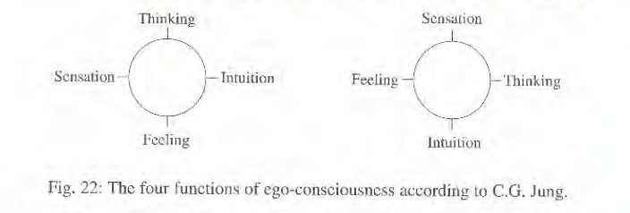
- INTROVERSION: First impression & 4 questions based on initial subjective look: What is my gut reaction? Try not to censor or second guess or rationalize this feeling. Now process this first impression:

  - Sensation [earth]: How does my body react to this picture?

  - Feeling [water]: Do I like/dislike this picture? Does it drain or boost my energy?

  - Thinking [swords]: Does this picture leave me with an ordered, peaceful mind? Are things compatible?

  - Intuitive [fire]: Who would make this picture? Describe their personality? Does this picture ooze health or disturbance? Does the picture hint at something sublime or alarming?

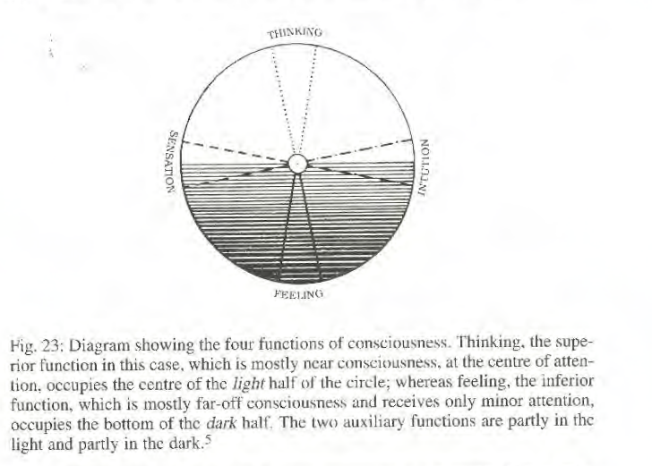

- EXTROVERSION: First Circumambulation with 4 functions, an objective look at picture, applying scales and criteria as applied by our gaze. “Floating the boat of our ego on the sea of the unconsciousness.” Respect picture. Analytical. Based on the tools we have studied. Consult tools outline for details.

  - Sensation function [earth]: Quality of picture, paper, medium, frame, space, color, format.
    - How do the elements cohere as a sensibility?

  - Feeling function [water]: What established value order does the picture exhibit?

    - What is important/unimportant/central/peripheral to this picture?

    - Or where are the energies in this picture?

  - Thinking function [swords]: Look at the structure and order among the different elements of the picture.

    - Are the elements proportional How are they arranged?

    - How do they move? How is the space symbolism connected to color symbols etc.?

d Intuitive function [fire]: What sort of energizing hints does the picture suggest?
What seems missing? How would it change?

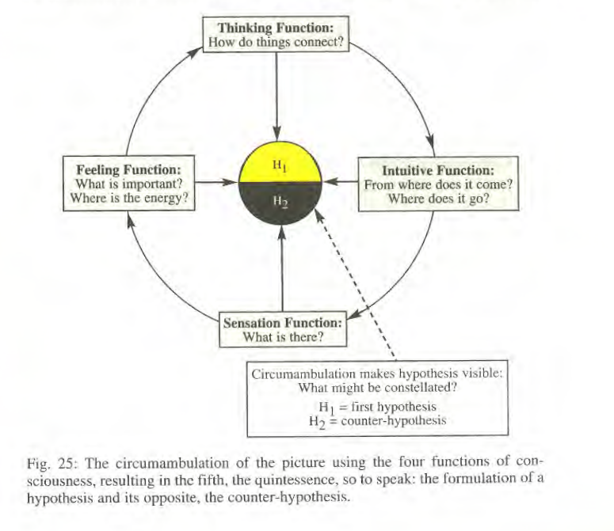
- Create Hypothesis and Counter-Hypothesis
  - Hypothesis: What does it all mean now? How does it add up? Justify your story.
One or two sentences.]

  - Counter-Hypothesis: In divergence what might it mean otherwise? Tell the contrasting story. [One or two sentences.]

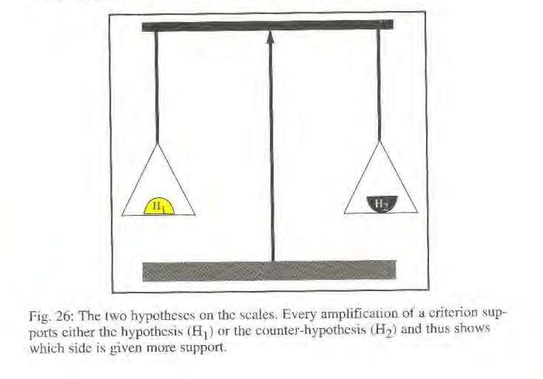
- Second Circumambulation with 4 functions with both hypotheses in mind. Respect picture, synthetical

  - Sensation function [earth] What do you see now in picture with contrasting Hypothesis and Counter-Hypothesis in mind.

  - Feeling function [water]: What feels important in picture viewed through contrasting Hypothesis and Counter-Hypothesis energy tones.

  - Thinking function [swords]: Through contrasting Hypothesis and Counter-Hypothesis how do the stories connect elements of the picture?

  - Intuitive function [fire]: Where does the picture come from and where does it go, given the divergent Hypothesis and Counter-Hypothesis stories?

- Goal of picture interpretation, a sense of consciousness and time with the 5 questions

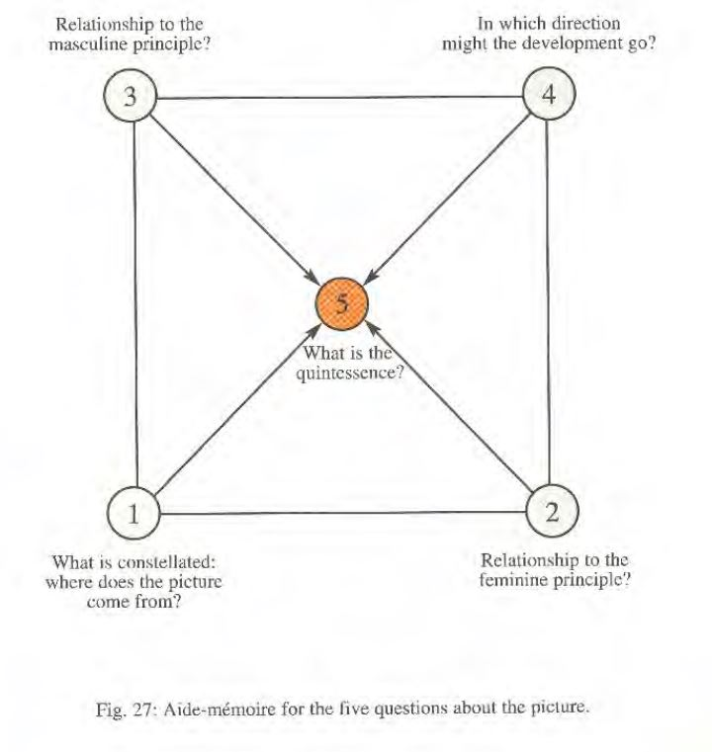
  - Where does this picture come from? Where is its inner unconscious logic, constellation coming from?

  - What is the relationship to the feminine principle in this picture? How does this relate to the Hypothesis and Counter-Hypothesis? The nurturing elements of earth and water?

  - What is the relationship to the masculine principle in this principle? What is the spiritual orientation and value maintenance of Hypothesis and Counter-Hypothesis? What is masculine elements of air and fire?

  - Where does the picture go? What is its goal? In what way do hints of Hypothesis and Counter-Hypothesis suggest negative or positive, destructive or constructive potentials?

  - What is the quintessence of the picture? How is it all summed up given, origin, gender balance and polarity, goal to jell into a total picture? How might this picture become a whole now?

The purpose of this method is to take time with picture to let it speak in its own language. If we do it well, the picture should reveal many levels of significance it did not do before.
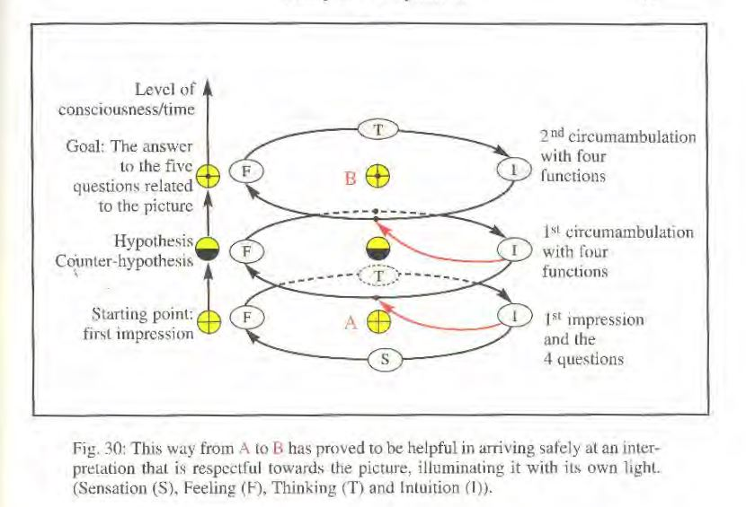
Name the picture:

Discuss its derivation, attributions, date, history, mythology, cultural context.

Share personal associations about picture.

